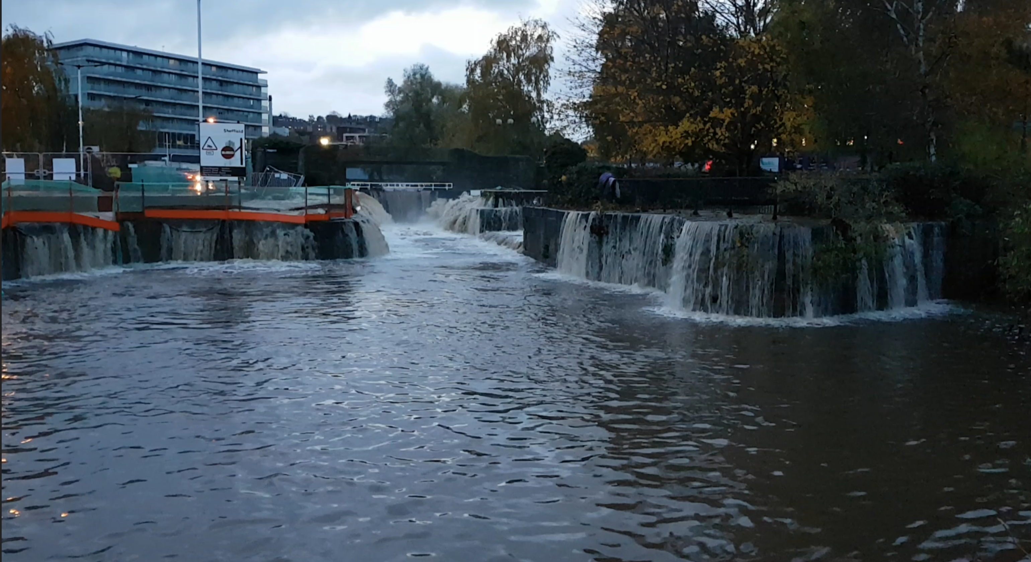

Local Flood Risk
Management
Strategy

February 2022


Produced: Drainage Team
File: 17/187/46
Issued: 16/02/2022
Edition: 2
Revision: 2

CONTENTS
1 INTRODUCTION 1
1.1 Overview 1
1.2 Sources of Flooding 2
1.3 Introduction to the Area 3
2.0 LEGISLATIVE CONTEXT 4
3.0 LINKS TO OTHER STRATEGIES 5
3.1 National Plans 6
3.2 Regional Plans 6
3.3 Rotherham Local Plans – (Flood related) 8
3.4 Rotherham Local Plans – (non flood related) 8
4.0 ASSESSMENT OF LOCAL FLOOD RISK 10
4.1 Past flood events 10
4.2 Environment Agency Surface Water Flood Risk Modelling 10
5.0 GOVERNANCE AND PARTNERSHIP ARRANGEMENTS 11
6.0 OBJECTIVES OF THE STRATEGY 13
7.0 ACTION PLAN 13
8.0 FLOOD RISK MANAGEMENT FUNDING 14
9.0 THE POTENTIAL IMPACTS OF CLIMATE CHANGE 15
9.1 Effects of Climate Change 15
9.2 Implications for Flood Risk 16
9.3 Adapting to Change 16
9.4 Long Term Developments 17
10.0 ENVIRONMENTAL OBJECTIVES AND STRATEGIC ENVIRONMENTAL ASSESSMENT 17
11.0 CIVIL CONTINGENCIES AND COMMUNITY RESILIENCE 18
12.0 THE ROLE OF THE PLANNING AUTHORITY 18
13.0 ADDRESSING THE SKILLS GAP 18
14.0 DATA MANAGEMENT 19
15.0 THE ROLE OF SCRUTINY AND OVERVIEW COMMITTEES 19
16.0 REVIEWING AND REVISING THE STRATEGY 20

17.0 GLOSSARY AND ACRONYMS

APPENDICES

Appendix A – Update on Objectives

1 INTRODUCTION

1.1 Overview
In June 2008, Sir Michael Pitt published his final report, Learning Lessons from the 2007 Floods, which called for urgent and fundamental changes in the way the country is adapting to the increased risk of flooding, the need to provide consistent and co-ordinated management of flood risk, communication with communities, identification of those responsible in the local management of flood events, and adaptation to climate change. The report states that local authorities should play a major role in the management of local flood risk, taking the lead in tackling problems of local flooding and co-ordinating all relevant agencies.

The Flood Risk Regulations 2009 and Flood and Water Management Act 2010 are an important part of the Government’s response to the Pitt Report. The Act is intended to create a more integrated, comprehensive and risk-based regime for managing the risk of flood and coastal erosion, including identifying clear responsibilities. In light of this, local authorities are being granted new powers and existing responsibilities for local flood risk management are being extended.

This Local Flood Risk Management Strategy was originally produced by Rotherham Metropolitan Borough Council in 2014 and is now to be updated taking into consideration the recent devasting flods of 2019 and recent changes from climate change. This is to set out how the local flood risk within the borough will be managed. The brief for the strategy was approved by Cabinet on 19 March 2012.

The general principles of the Local Flood Risk Strategy are:
- Community focus & partnership working
- Sustainability
- Risk Based Approach
- Multiple benefits

The Strategy identifies objectives that have recently been achieved and how they have been achieved. Including new objectives more suited to the ever changing climate.

This Strategy is a living document and will be subject to amendments and additions year on year.

1.2 Sources of Flooding
This Strategy considers local flood risk, namely the following sources of flooding:

Surface water runoff – rainwater (including snow and other precipitation), which is on the surface of the ground (whether or not it is moving), and has not entered a watercourse, drainage system or public sewer. Flooding from surface runoff is sometimes called pluvial flooding. Note that the term 'surface water' is used generically to refer to water on the surface.

Ordinary watercourse – any river, stream, ditch, cut, sluice, dike, culvert which is not a main river.

Artificial water bearing infrastructure – includes reservoirs (see below), sewers, water supply systems and canals. The strategy does not assess flooding from sewers, unless wholly or partly caused by rainwater or other precipitation entering or otherwise affecting the system. Floods of raw sewage caused solely, for example, by a sewer blockage do not fall under the Regulations. The Regulations also do not apply to floods from water supply systems, e.g. burst water mains.

Groundwater – water which is below the surface of the ground and in direct contact with the ground or subsoil. It is most likely to occur in areas underlain by permeable rocks, called aquifers. Within Rotherham, deep flows within aquifers do not generally cause flooding. Whilst flow of groundwater underground at shallow depths may contribute to localised flooding where it emerges as springs or issues, the flow closely mirrors surface flows and is not related to a widespread rise in groundwater levels. Groundwater flooding has therefore not been addressed separately to surface water flooding in this strategy.

This Strategy does not consider the following sources of flooding, except where there is an interaction with surface water flooding for example where high water levels within river impede the discharge from an ordinary watercourse:

Main river – watercourses legally defined and marked as such on the main rivers map. Generally they are larger streams or rivers, but can be smaller watercourses. The Environment Agency has flood risk management responsibility for them.

Large reservoirs – Under the Reservoirs Act 1975, the owner is responsible for regulating large raised reservoirs with a capacity exceeding 10,000 m³. The owner must also have a flood plan, flood map and on-site emergency flood plans.

1.3 Introduction to the Area
The Borough of Rotherham is situated in South Yorkshire and covers an area of 286km² and has a population of approximately 257,280 (2011 census).
Rotherham is generally underlain by the middle coal measures with predominantly impermeable soils and underlying strata. Consequently, the hydrology of the area is dominated by surface or shallow depth flows.

The north-west and central areas of the Borough drain to the river Don, which runs from Sheffield, through Rotherham town centre, where it is joined by the River Rother, then to the north east where it is joined by the River Dearne near the Boundary with Doncaster, and are within the Rotherham sub-area of the Don Catchment in the Humber river basin district.

The south east third of the Borough drains towards the River Ryton, is hydrologically independent of the Don catchment and is within the Sherwood sub-area of the River Trent Catchment Flood Management Plan in the Humber river basin district. The boundaries between two water companies and Environment Agency (EA) regions reflect these catchment boundaries, the south east being Severn Trent Water Ltd and EA Midlands region, the remainder being Yorkshire Water Services Ltd and EA Yorkshire & North East region.

The rivers classed as “main river” are shown on Figure 1 below.

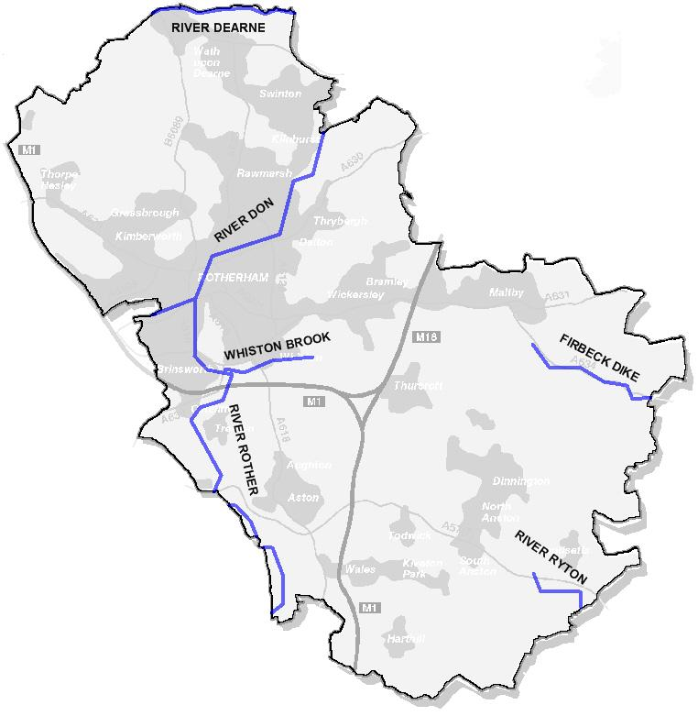
Figure 1 - Main Rivers

2.0 LEGISLATIVE CONTEXT
The EU Floods Directive, was passed as a result of widespread flooding in Europe, and has been transposed into UK law by the Flood Risk Regulations 2009.

In June 2008, Sir Michael Pitt published his final report, Learning Lessons from the 2007 Floods, which recognised that there were significant gaps in the powers held by various bodies in trying to reduce and respond to the risk of flooding and called for urgent and fundamental changes in the way the country is adapting to the increased risk. The report includes 92 recommendations, of which 21 are specifically designated to local authorities.

The Governments response to the Pitt Review included the Flood and Water Management Act 2010, which puts in place many of the changes recommended by Sir Michael Pitt. Lead Local Flood Authorities (LLFAs) have been designated and have taken on new powers and duties extending their organisation’s previous responsibilities for flood risk management and will therefore need to take resource and organisational decisions to deliver the new legislative requirements.

The Water Framework Directive (WFD) 2000 is European legislation with the primary aim of improving water quality. The Directive requires the creation of river basin management plans and flood risk management plans.

3.0 LINKS TO OTHER STRATEGIES
This strategy must be consistent with national and regional strategies, the most important of which are listed below.

3.1 National Plans
National Flood and Coastal Erosion Risk Management Strategy for England

In accordance with the Flood and Water Management Act 2010 this strategy builds on existing approaches to flood and coastal risk management and promotes the use of a wide range of measures to manage risk.

The strategy encourages more effective risk management by enabling people, communities, business, infrastructure operators and the public sector to work together to:

- Ensure a clear understanding of the risks of flooding and coastal erosion, nationally and locally, so that investment in risk management can be prioritised more effectively;

- Set out clear and consistent plans for risk management so that communities and businesses can make informed decisions about the management of the remaining risk;

- Manage flood and coastal erosion risks in an appropriate way, taking account of the needs of communities and the environment;

- Ensure that emergency plans and responses to flood incidents are effective and that communities are able to respond effectively to flood forecasts, warnings and advice;

- Help communities to recover more quickly and effectively after incidents.

The strategy shows how communities can be more involved in local flood and coastal erosion risk management. It also emphasises the need to balance national and local activities and funding. In setting out future approaches to flood risk management, this strategy considers the level of risk and how it might change in the future, the risk management measures that may be used, roles and responsibilities, future funding and the need for supporting information.

3.2 Regional Plans

South Yorkshire Catchment Plan

Following the 2019 flood event in South Yorkshire, Mayor Dan Jarvis and Local Authority Leaders submitted a South Yorkshire Business and Infrastructure Resilience Priority Flood Programme to Government, which included the proposal to prepare a catchment wide flood plan covering the whole of South Yorkshire.

The aim of this proposal was to develop a new more effective and integrated approach to future flood policy and investment, taking a holistic ‘South Yorkshire’ approach to cover all rivers and watercourses, rather than continuing to consider flood policy and investments in a piecemeal way. It would also enable the potential future impacts of climate change to be taken into account and better understand the contribution that Natural Flood Management can play in building resilience and reducing future flooding.

The Board has commented at various stages in the preparation of the Catchment Plan and these comments have informed a final draft version (attached at Appendix A), along with the comments of the South Yorkshire Flood Risk Partnership (which has jointly overseen its preparation with this Board), and those of wider stakeholders. Members views are invited on this final draft Plan.

Key Issues
The aim is for the ‘Connected by Water’ Catchment Plan to be a ‘living document’ to facilitate the development of a long-term strategy for flood risk management and climate resilience.

The Catchment Plan outlines the actions to be undertaken to reduce flood risk, mitigate climate change and support climate resilient communities across South Yorkshire. It will support better joint working; provide a compelling programme to attract potential investors; and demonstrate that measures are being put in place to protect local communities. Importantly, it provides a clear programme of welldeveloped projects to help secure the remaining investment required across South Yorkshire to alleviate and mitigate future flooding.

The Catchment Plan is arranged around the following four Key Workstreams which have been developed in partnership by the MCA Executive, Environment Agency, the four South Yorkshire Authorities and Yorkshire Water:
1. Responding to the climate emergency.
2. Ensuring investment is prioritised, smart and based on evidence using the best available data and intelligence.
3. Strengthening the use of technology and operational management to build the capacity of Local Authorities and other Risk Management Authorities to work together more effectively on an operational basis.
4. Community engagement and resilience.

The Catchment Plan encompasses activities already underway as well as new innovative actions, with lead and supporting organisations identified for each action and an indicative timescale for completion.

The South Yorkshire Flood Risk Partnership have endorsed the draft Catchment Plan, and subject to approval by the MCA in January, it is intended to formally launch the Catchment Plan on the 28 January 2022.

Work is underway to identify and secure resources and funding to deliver the Catchment Plan over the coming years. There are a number of immediate actions over the next year that will require additional funding to progress. There is previously committed but unallocated MCA Gainshare funding to support flood resilience and mitigation, some of which could be allocated to support delivery of some of these immediate actions. Other partners are similarly considering how they may be able to support delivery. It is therefore intended to work up a proposal for the next Board meeting for use of some of the unallocated Gainshare funding to support the implementation of the Catchment Plan. The proposals will need to meet the conditions of funding, namely matching capital activity to capital funding.

3.3 Rotherham Local Plans – (Flood related)
Strategic Flood Risk Assessment (SFRA) Level 1, Published June 2008
The level 1 Rotherham SFRA was carried out primarily to inform planning policy. It is a high level policy document which delineates areas into high, medium and low flood risk.

Strategic Flood Risk Assessment Level 2 - Central Rotherham Only
This particular Strategic Flood Risk Assessment is one of three documents produced by Jacobs consultants in December 2010. It provides a flood risk toolkit for the Rotherham Regeneration and Flood Alleviation Area.

Preliminary Flood Risk Assessment, (PFRA)
The Flood Risk Regulations 2009 implement the requirements of the European Floods Directive. The regulations impose new duties on Lead Local Flood Authorities including responsibility for managing local flood risk in particular from ordinary watercourses, surface runoff and groundwater.
The PFRA is a high level exercise based on existing and available information.
- Over 8,500 residential properties in Rotherham have been identified as potentially at risk from surface water flooding, compared with less than 300 at risk of flooding from rivers.
- 106 areas have been identified for prioritisation in subsequent flood risk management planning, bullet points 3&4 above.
- The unaltered Flood Map for Surface Water produced by the Environment Agency was used to define Locally Agreed Surface Water Information.
- This document does not consider flooding from main rivers, reservoirs or as a consequence of sewer blockages.

Rotherham MBC Final PFRA was submitted to Defra in December 2011.

3.4 Rotherham Local Plans – (non flood related)

Rotherham’s Local Plan (2013)
The Local Plan (previously called the Local Development Framework or LDF) will provide a long-term development strategy for Rotherham, setting out policies and proposals for new housing, shopping and employment, and how you travel throughout the borough.

The Local Plan will eventually replace the existing Unitary Development Plan and will help to streamline the local planning process and promote a proactive and positive approach to managing development. It will help the Council decide on planning applications and promote Rotherham's continued regeneration whilst protecting and enhancing the natural environment. The current program for producing the Local Plan is set out in our Local Development Scheme.

Rotherham Emergency Plan, Multi-Agency Flood Plan and Flood Action Plans
The Council’s Emergency Plans are published on the Council’s intranet. The Plans consist of a corporate Borough Emergency Plan and various Service Emergency Plans. The Environment and Development Services Emergency Plan has Flood Action Plans which identify areas at high risk of flooding such as Catcliffe.

The Plans are living documents and are amended and updated regularly.

Community Risk Register
The Community Risk Register is published by South Yorkshire Local Resilience Forum in compliance with the Civil Contingencies Act 2004 and the Civil Contingencies Act 2004 (Contingency Planning) Regulations 2005. It is updated annually.

The purpose of the Register is to identify possible hazards which could impact on the communities of South Yorkshire, to assess the likelihood of each of these hazards occurring, and to thereby inform contingency planning arrangements within South Yorkshire.

Yorkshire Water and Severn Trent Water Drainage Area Plans
The Water Companies have a statutory duty to maintain and manage public sewers and maintain a register of properties at risk from hydraulic overloading in the public sewerage systems.

The Water Companies have a duty to assist LLFA in sharing of information and data and have an understanding of flood risk from the public sewerage systems.

City Region Sustainable Transport Settlement (CRSTS)
This new City Region Sustainable Transport Settlement (CRSTS), which is an unprecedented investment in local transport networks, is a major driver for significant change.
This new fund stems from the announcement we made in 2019 that the 8 eligible English city regions would receive £4.2 billion of additional funding for local transport networks. That new money is at the core of this fund and should allow city regions to commence transformational change.

Highways Asset Management Plan (HAMP)
The HAMP sets out how the highways infrastructure is managed within Rotherham. Highways assets may be receptors at risk of flooding, or drainage assets such as culverts and highway drains which must be maintained to manage flood risk.

4.0 ASSESSMENT OF LOCAL FLOOD RISK

4.1 Past flood events
Rotherham has experienced 4 flooding events of major local significance since 2000, the nationally significant flood event in June 2007 and November 2019 and by more localised events in November 2000 and June 2009.

The most recent flood event on the 7th November 2019 was on scale and not witnessed since 2007 and had not been seen for many decades before that, the consequences for residents, businesses and communities were very significant with over 150 households flooding, including numerous business and in the excess of 45 major road closures making manoeuvring around the Borough extremely difficult. Fortunately, no one within Rotherham lost their life or were seriously injured directly as a result of the floods. However the financial and emotional costs of both the immediate impact and long term consequences have been huge.

www.rotherham.gov.uk/downloads/file/1691/section-19-flood-investigation-report-november-2019

Recent flooding incidents are generally well reported and documented. Records of older floods do exist in some cases, but are incomplete and difficult to verify. The easily accessible records have been extracted and mapped. As further historical information becomes available, the flooding records will be updated.

A desk study of historical flooding confirms that there have been many significant floods on the Don and Rother for hundreds of years, including before the catchment was significantly developed. The development of the catchment and changes to the watercourses and sewers mean that the older historical information is not useful for assessment of current flood risk.

4.2 Environment Agency Surface Water Flood Risk Modelling
Surface water flood modelling has been carried out by the Environment Agency to indicate the broad areas likely to be at risk of surface water flooding. However, the Environment Agency surface water flood maps are not suitable for identifying whether an individual property will flood. This is because information on floor levels, construction characteristics or designs of properties is not considered.

The modelling was carried out by applying rainfall to a digital terrain model and this was done using 3 different methodologies, namely Flood Map for Surface Water (FMfSW), Areas Susceptible to Surface Water Flooding (AStSWF) and Risk of Flooding from Surface Water (RFfSW). FMfSW and AStSWF were carried out before the draft LFRMS was produced and were used to identify areas at risk and in particular the 106 areas in Rotherham prioritised for further investigation. During the consultation period, the RFfSW information became available. This is considered superior to both previous methodologies and supersedes both. The 106 areas have therefore been reprioritised using the updated modelling and environmental information.

Drawing 187/46/DR002A in Appendix B shows the 106 areas and the revised rankings.
Maps showing flood risk, including surface water risk, are available on the Environment Agency website.

 | River Flooding | Surface Water (RFfSW)
Dwellings at risk | 273 | 2321

Table 2 - Comparison between river flooding and surface water flooding
The above figures show that the threat to residential properties numerically is overwhelmingly from surface water flooding. Non residential flooding affecting industry and infrastructure is more at risk from river flooding due to its geographical concentration along river corridors. See drawing 187/46/DR001A in Appendix B for a comparison of the areas at risk from the two types of flooding.

5.0 GOVERNANCE AND PARTNERSHIP ARRANGEMENTS
An organogram of governance and partnership arrangements is provided in Figure 3 below.

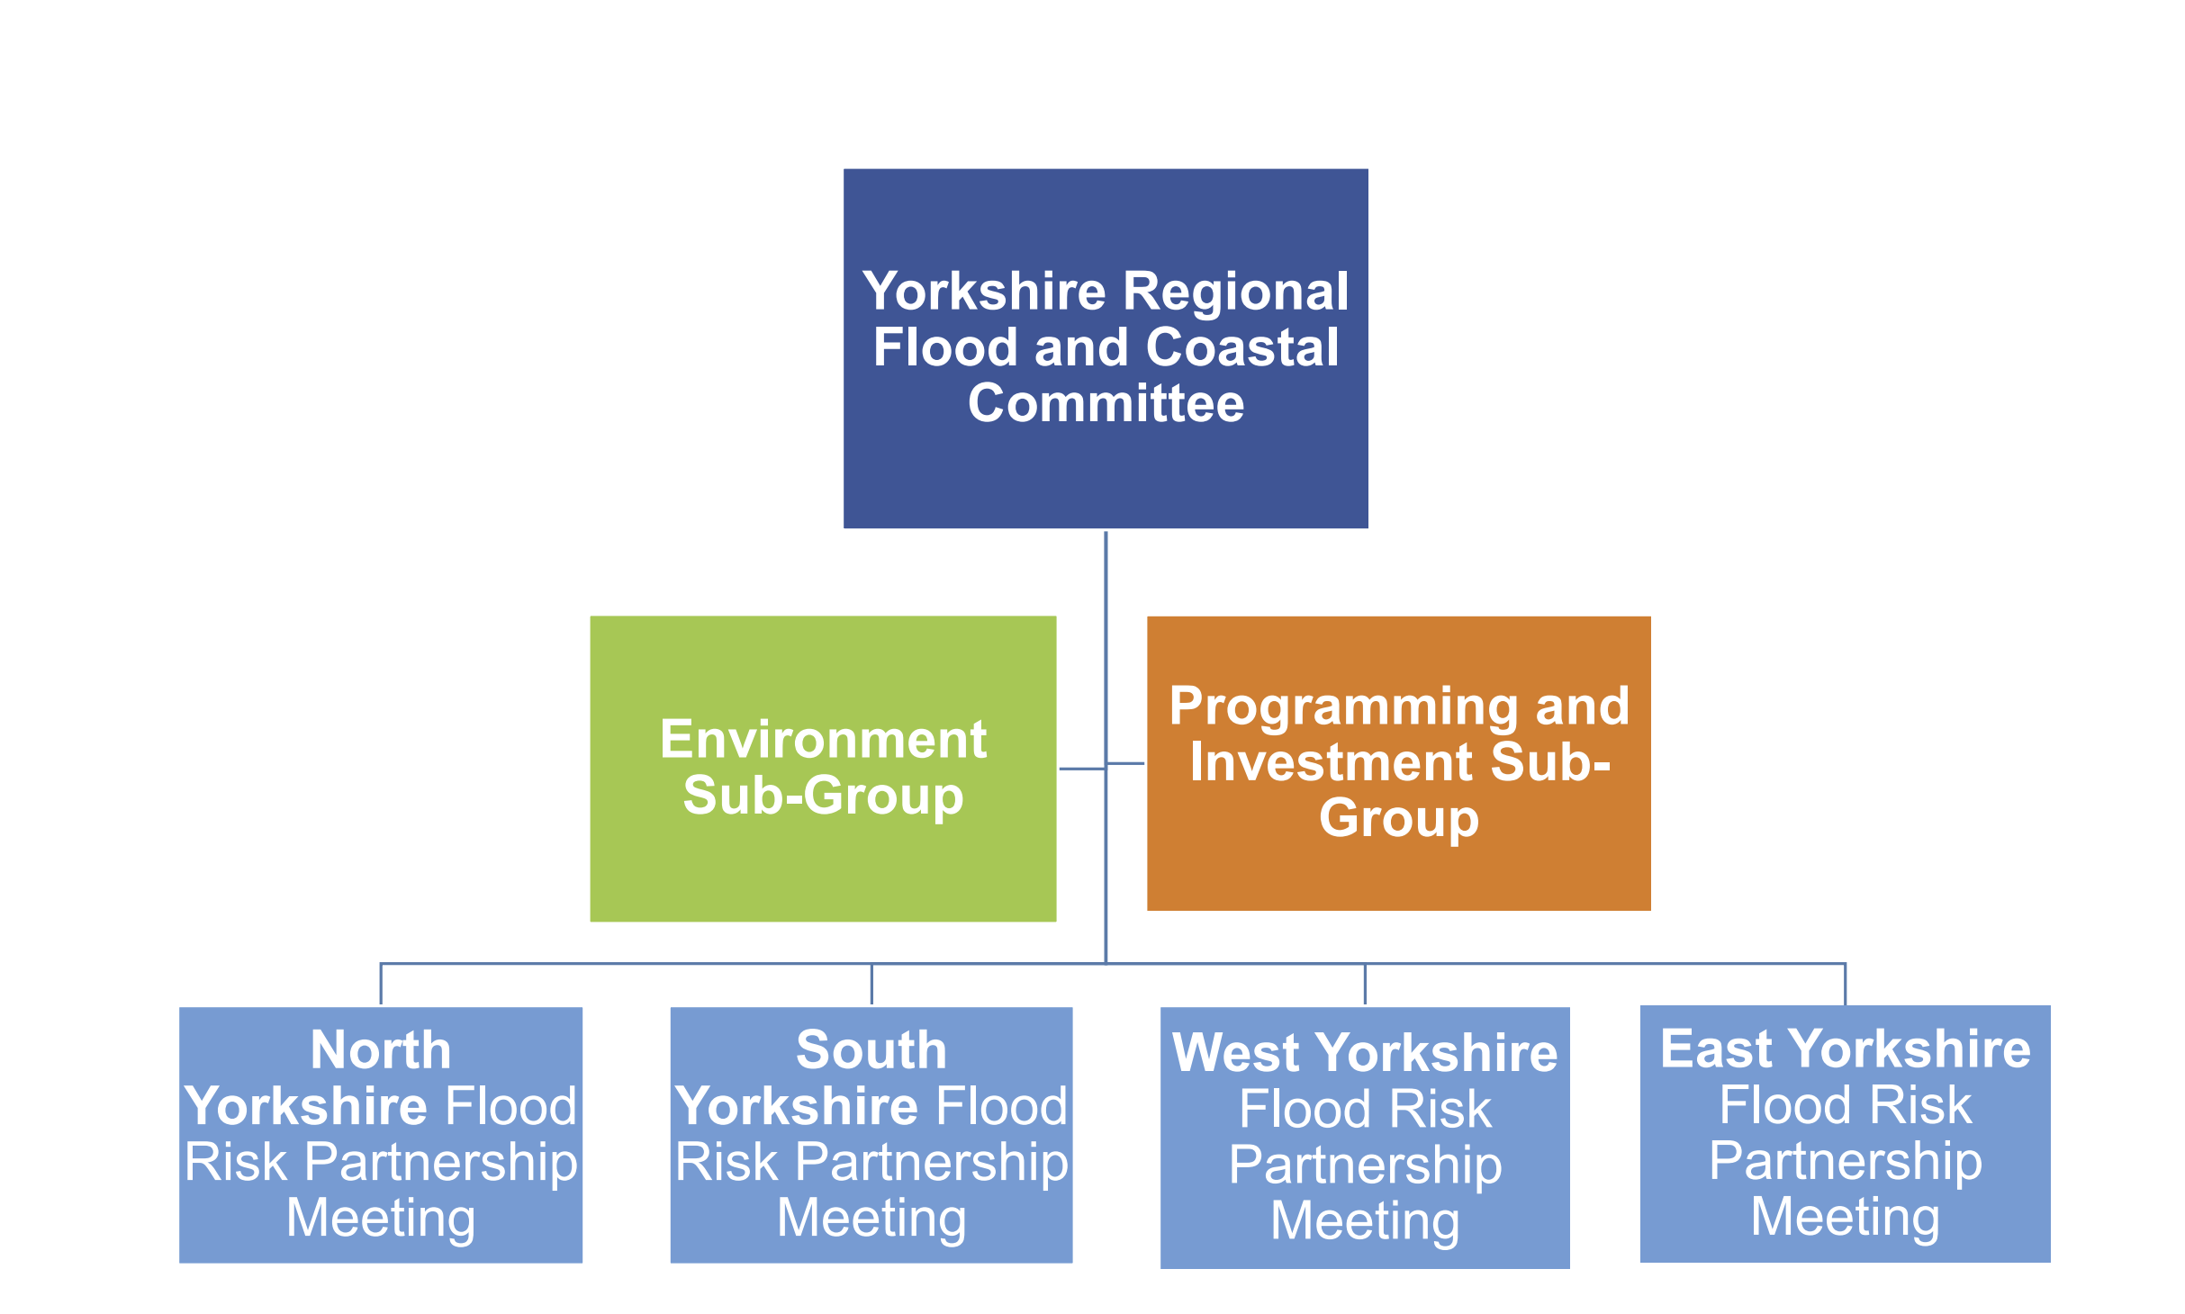

6.0 OBJECTIVES OF THE STRATEGY
Objective 1

Continue to Build on the asset database, ensuring all drainage assets are mapped on a GIS platform.

Objective 2

Complete all 6 priority schemes to shovel ready status to reduce flood risk in key areas across Rotherham Borough.

Objective 3

Formalise arrangements and partnerships with Parish Council, Flood Action Groups and communities that have been affected by flooding.

Objective 4

Create a risk-based approach to gully cleansing and set up new cyclical programs for linear drainage and watercourses.

Objective 5

Create a new SuDS adoption policy, commuted sums policy and operational manual to help reduce flooding and increase maintenance of existing assets.

Objective 6

Continue to work on catchment approach to flooding, engaging in the South Yorkshire Catchment Plan looking at source to sea defences.

Objective 7
All planning applications are to be consulted on within 21 days to ensure no additional flood risk is created through new developments within the Borough.

Objective 8
Encourage, develop and implement long-term, cost-effective and environmentally sound mitigation assets related to flood defences.

7.0 ACTION PLAN
The SWMP provides a methodology to identify the most appropriate measures to use in locations identified as being at risk of flooding. Measures can be “structural” such as planning controls and improved community engagement, or “non-structural” such as physical improvement or maintenance works. It is impractical and unaffordable to carry out every measure for every situation. The Strategy will help to determine which measures are most appropriate for individual areas, which measures offer best value for money and how a blend of structural and non-structural measures can be used to give a balanced approach to mitigating risk.

A detailed action plan which addresses the objectives of the Strategy as detailed in item 7 above is contained in Appendix A.

8.0 FLOOD RISK MANAGEMENT FUNDING
Source of Funding | Description | Indicative budget | Administered By | Appropriate For
Flood Defence Grant-in-Aid (FDGiA) | Central government funding for flood (and coastal) defence projects – recently revised to encourage a partnership approach to maximise match-funding, work towards achieving specified outcomes with a requirement to evidence a reduction in flood risk to properties | £5.2billion | Environment Agency | Medium to large capital FRM projects
Local Levy | Annual contributions from Councils to a regional “pot”, smaller than the FDGiA budget but offers more flexibility on the type and size of project it can fund. | £2.5million per year(Yorkshire) | Environment Agency | Smaller FRM projects or as a contribution to FDGiA projects
Asset Replacement Fund | The ARA is intended essentially to support Capital Maintenance (CM) type schemes, in particular those where eventual asset failure would increase risk to communities and impose an emergency demand on FDGiA funding. It is not available for improvement, withdrawal of maintenance or asset transfer schemes. | £240million | Environment Agency | Replacement of existing asset defences.
Other Government Depart Funding (OGD) | OGD remains an element of the FDGiA funding but can be treated as partnership funding. The funding is being allocated to support the delivery of FCRM outcome measures across the six-year capital programme (2021/22 to 2026/27), by contributing financially to schemes which benefit OGD assets and have a Partnership Funding gap. It improves stability and deliverability in the programme | £400million | EA/RMA’s | Funding to aid Flood risk management schemes.
Department for Education Funding (DfE) | Since 2019 we have successfully secured £7.15m in partnership funding from Department for Education (DfE). This investment has contributed to FCRM schemes that, better protect schools, properties and communities, and help to create a nation resilient to flooding and coastal change. 33 flood schemes have received funding, and better protected 39,720 homes, prevented 44,000 lost teaching days and, most importantly, protected the education of huge numbers of school children across England. | £7.15million | RMBC | DfE funding is in addition to the OGD funding mentioned above, and is aimed at providing funding to bridge PF gaps for schemes that protect schools.
Council Capital Funding | The Councils infrastructure programme prioritising capital improvement projects. In recent years the programme has included funding for several flood alleviation schemes but future funding is uncertain. | £5.8million | RMBC | Measures which are small to medium capital projects
Council Revenue Funding | The Council currently funds maintenance of existing assets via the revenue budgets of the departments where liability falls, including Streetpride, Neighbourhoods, Resources.  Defra funding of £156.3k per annum has been provided to finance the execution of the Council’s new duties. Funding at this level is expected to continue until 2015. Funding for financial year 2015/16 and beyond will be subject to government spending review. | Highway Drainage & Land Drainage Maintenance (£143k)  Gully cleansing (£159k)  Waste Disposal (£48k)  Flood Management Team (£156k) | RMBC | Measures requiring officer time and/or maintenance activity

Table 3 - Potential Sources Of Funding

9.0 THE POTENTIAL IMPACTS OF CLIMATE CHANGE

9.1 Effects of Climate Change
There is significant scientific evidence that suggests that global climate change is happening and this cannot be ignored (UK Climate Projections 2009).
Over the past century around the UK we have seen sea levels rise and more of our winter rain falling in intense wet spells. Seasonal rainfall is highly variable. Recent evidence suggests that it has decreased in summer and increased in winter. Some of the changes reflect natural variation; however the broad trends are in line with projections from climate models.

Greenhouse gas (GHG) levels in the atmosphere are likely to cause higher winter rainfall in future. Past GHG emissions mean that some climate change is inevitable in the next 20-30 years. Lower emissions could reduce the amount of climate change further into the future, but changes are still projected at least as far ahead as the 2080’s.

We have enough confidence in large scale climate models to say that we must plan for change. There is more uncertainty at a local scale but model results may help us plan to adapt. For example, we understand that rain storms may become more intense, even if we can’t be sure about exactly where or when. By the 2080’s, the latest UK climate projections (UK Climate Projections 2009) are that there could be around three more days in winter with heavy rainfall (defined as more than 25mm in a day). It is plausible that the amount of rain in extreme storms (with a 1 in 5 annual chance, or rarer) could increase by 40%.

Key Projections for Humber Basin District

If emissions follow a medium future scenario, UKCP09 projected changes by the 2050’s relative to the recent past are:

  - Winter precipitation increases of around 12% (very likely to be between 2 and 26%)
  - Precipitation on the wettest day in winter up by around 12% (very likely to be more than 24%)
  - Relative sea level at Grimsby very likely to be up between 10 and 41cm from 1990 levels (notincluding extra potential rises from polar ice sheet loss)
- Peak river flows in a typical catchment likely to increase between 8 and 14%

9.2 Implications for Flood Risk
Climate changes can affect local flood risk in several ways. Impacts will depend on local conditions and vulnerability. Wetter winters and more of this rain falling in wet spells may increase river flooding. More intense rainfall causes more surface runoff, increasing localised flooding and erosion. In turn, this may increase pressure on drains, sewers and water quality. Storm intensity in summer could increase even in drier summers, so we need to be prepared for the unexpected.

Drainage systems in the district have been modified to manage water levels and could help in adapting locally to some impacts of future climate on flooding, but may also need to be managed differently. Rising river levels may also increase local flood risk away from major rivers because of interactions with drains, sewers and smaller watercourses. Where appropriate, we need local studies to understand climate impacts in detail, including effects from other factors like land use. Sustainable development and drainage will help us adapt to climate change and manage the risk of damaging floods in future.

9.3 Adapting to Change
Past emission means some climate change is inevitable. It is essential we respond by planning ahead. We can prepare by understanding our current and future vulnerability to flooding, developing plans for increased resilience and building the capacity to adapt. Regular review and adherence to these plans is key to achieving long-term, sustainable benefits. Although the broad climate change picture is clear, we have to make local decisions based on a degree of uncertainty. We will therefore consider a range of measures and retain flexibility to adapt. This approach, embodied within flood risk appraisal guidance, will help to ensure that we do not increase our vulnerability to flooding.

9.4 Long Term Developments
It is possible that long term developments might affect the occurrence and significance of flooding. However current planning policy aims to prevent new development from increasing flood risk.

In England, National Planning Policy Framework (NPPF) aims to "ensure that flood risk is taken into account at all stages in the planning process to avoid inappropriate development in areas at risk of flooding, and to direct development away from areas at highest risk. Where new development is, exceptionally, necessary in such areas, policy aims to make it safe without increasing flood risk elsewhere and where possible, reducing flood risk overall."

Adherence to Government policy ensures that new development does not increase local flood risk. However, in exceptional circumstances the Local Planning Authority may accept that flood risk can be increased contrary to Government policy, usually because of the wider benefits of a new or proposed major development. Any exceptions would not be expected to increase risk to levels which are "significant" (in terms of the Government's criteria).

10.0 ENVIRONMENTAL OBJECTIVES AND STRATEGIC ENVIRONMENTAL ASSESSMENT
The Strategy considers that the LFRMS is a significant local strategy and, consequently has been appraised under the Strategic Environmental Assessment (SEA) Regulations. Reprioritisation of flood risk areas has been carried out taking into account environmental factors assessed in the SEA report. More detailed assessment of flood risk management actions, including revenue works and capital schemes will be undertaken using the SEA findings.

Where possible, opportunities should be sought to enhance the river corridor habitats, landscape, access and amenity facilities to support the local planning policy drive to develop green infrastructure and increase access to the riversides.
The effect of the strategy on the Council’s carbon emissions, and hence climate change, are part of the Strategic Environmental Assessment.

The Councils Climate Change Adaptation Plan identifies specific measures which are targeted at managing the consequences of more frequent severe rainfall events. These measures have been addressed by complementary measures in this Strategy.

Funding applications for flood defence works are assessed against criteria which also assess benefits unrelated to flood risk and projects which deliver environmental improvements score more highly and are therefore more likely to obtain funding.

The full Communication strategy can be found in the link below

https://www.rotherham.gov.uk/transport-streets/rotherham-highways-communications-strategy/5

11.0 CIVIL CONTINGENCIES AND COMMUNITY RESILIENCE
The Emergency Planning Shared Service, Rotherham & Sheffield have responsibility for the planning for and management of the Council’s response to emergencies, through the Borough Emergency Plan and any other relevant Plans.

The increasing knowledge of flood risk will be used to feed into the Rotherham Multi-Agency Flood Response Plan, particularly in the following areas:

- Production of flood hazard maps combining depth and velocity information.

- Improved assessment of flood risk to critical infrastructure utilities, i.e. gas, electricity, water and telecommunications installations and the consequences of the loss of these installations during flooding.

- Principal highways. Major flooding incidents

- Business continuity.

- Reservoir inundation plans, including reservoirs outside of Rotherham.

- Determine in greater detail the risk of flooding to residential and non residential buildings.

12.0 THE ROLE OF THE PLANNING AUTHORITY
To meet the requirements of the Strategy the role of the Planning Authority is as follows (refer also to item 6.9 above):

- Responsibility to consider flood risk in Local Plans.

- Responsibility to consider flood risk when assessing applications for development.

- Consider SuDS through Planning.

13.0 ADDRESSING THE SKILLS GAP

All aspects of flood risk management is becoming more difficult to recruit into over the past several years there has been a shortage of engineers with drainage and flood risk as a discipline, specifically within the public sector. To address the issue local authorities have had train junior members and adapt to the way of working with new graduates with limited experience.

14.0 DATA MANAGEMENT
Satisfying the objectives of the Strategy will entail the collection, creation and recording of large amounts of data.

A policy to control the storage and use of this data has been produced and is included in Appendix C. The policy, which is specific to flood risk management functions is compatible with the Council’s data management policies, licensing agreements and legislation such as the Data Protection Act and The Freedom of information Act.

It is recognised that in order to achieve the maximum benefit from the available data, it should be freely available. The policy considers the most appropriate format for the data to be made available, taking into account the restrictions above. Modelled predictions of flood extents and similar data should not be presented in a format which implies a greater accuracy than can be achieved in practice.

15.0 THE ROLE OF SCRUTINY AND OVERVIEW COMMITTEES
The Flood and Water Management Act requires LLFAs to ensure that adequate scrutiny arrangements are put in place, including arrangements to review and scrutinise the exercise by risk management authorities of flood risk management functions or coastal erosion risk management functions which may affect the local authority’s area.

Risk management authorities must comply with a request made by an overview and scrutiny committee for information and/or a response to a report, and must have regard to reports and recommendations of an overview and scrutiny committee. In effect, the Act extends Local Authority scrutiny to cover the full range of flood risk management activities carried out within the local authority area.

The Local Government Association Framework to assist the development of the Local Strategy for Flood Risk Management identifies the following areas to be considered for the strategy.

- What existing expertise exists among elected members in the locality?

- Have there been previous scrutiny exercises on a task and finish select committee approach that could provide a local model?

- Can an existing committee undertake the role, or is an entirely new grouping required? Does the area wish to focus on specific priorities, or to take a broad overview of the whole range of water management activities?

- How can the scrutiny process be developed as a two-way dialogue between committee members and risk management authorities, such that the expertise and knowledge of Members is enhanced and deepened?

- Member support can be developed through proactive briefing and workshops, especially in developing an understanding of the roles of different risk management authorities; and

- The rationale for, and scope of the Local Flood Risk Management Strategy needs to be explained clearly, particularly its local relevance in relation to other existing priorities.

16.0 REVIEWING AND REVISING THE STRATEGY
The Flood Risk Regulations 2009 stipulate a six year cycle of flood risk planning based on a four stage process of:

- Undertaking a Preliminary Flood Risk Assessment (PFRA) (2011).

- Identifying flood risk areas (2011).

- Preparing flood hazard and risk maps (2013).

- Preparing flood risk management plans (2013).

The strategy has currently fell behind on its reviews due to staffing issues and recent flood events taking precedent. The full list of documents are due to be reviewed over the next 12 months and will be issued as an appendix to this document.
GLOSSARY AND ACRONYMS

Assets | Structures, or a system of structures, used to manage flood risk.
Areas Susceptible to Surface Water Flooding (AStSWF) | A method of surface water flood modelling carried out by the Environment Agency to indicate the broad areas likely to be at risk of surface water flooding. Now superseded by Risk of Flooding from Surface Water Map. See also FMfSW & RFfSW.
Catchment | An area that serves a watercourse with rainwater. Every part of land where the rainfall drains to a single watercourse is in the same catchment.
Catchment Flood Management Plan (CFMP) | A strategic planning tool through which the Environment Agency works with other key decision-makers on the large scale of a River Basin District to identify and agree overarching policies for sustainable flood risk management.
Critical Infrastructure | Infrastructure which is considered vital or indispensable to society, the economy, public health or the environment, and where the failure or destruction would have large impact. This would include emergency services such as hospitals, schools, communications, electricity sub-stations, water and waste water treatment works, transport infrastructure and reservoirs.
Defence | A structure that is used to reduce the probability of floodwater affecting a particular area, for example a raised embankment.
Defra | Department for Environment, Food and Rural Affairs. The government department with overall responsibility for flood risk management.
FRM | Flood Risk Management.
FCERM | Flood and Coastal Erosion Risk Management.
Flood | The temporary covering by water of land not normally covered with water.
Flood Map for Surface Water (FMfSW) | A method of surface water flood modelling carried out by the Environment Agency to indicate the broad areas likely to be at risk of surface water flooding, now superseded by Risk of Flooding From Surface Water Map. See also AStSWF & RFfSW.
Flood Risk Area | An area determined as having a significant risk of flooding in accordance with guidance published by Defra.
Flood and Water Management Act 2010 (FWM Act) | The Flood and Water Management Act clarifies the legislative framework for managing surface water flood risk in England.
Fluvial flooding | Flooding of main rivers.
Floods Directive | The EU Floods Directive came into force in November 2007 and is designed to help Member States prevent and limit the impact of floods on people, property and the environment. It was transposed into English law in December 2009 by the Flood Risk Regulations.
Groundwater | Water which is below the surface of the ground and in direct contact with the ground or subsoil.
Hazard | A potential source of harm.
Hydrology | The study of the effects of water on and below the earth’s surface.
Internal Drainage Board  (Danvm IDB in Rotherham) | Drainage Board who are legally responsible to ensure that flows are maintained in ordinary watercourses within their domain.
Local Development Framework (LDF) | Local Planning Authority documents which comprises of community involvement, local development scheme and the annual monitoring report.
Lead Local Flood Authority (LLFA) | Local Authority with Flood Risk Management Functions as defined in the Flood and Water Management Act.
Local flood risk | Flood risk from sources other than main rivers, the sea and reservoirs, principally meaning surface runoff, groundwater and ordinary watercourses.
Main River | A watercourse shown as such on the Main River Map and for which the Environment Agency has flood risk management responsibilities and powers.
Ordinary watercourses | A river, stream, ditch, cut, sluice, dike or non-public sewer that is not a designated Main River and for which the Lead Local Flood Authority has flood risk management responsibilities and powers.
Pluvial flooding | Pluvial flooding (or surface runoff flooding) is caused by rainfall and is that flooding which occurs due to water ponding on, or flowing over, the surface before it reaches a drain or watercourse.
Preliminary Flood Risk Assessment (PFRA)  (Rotherham PFRA submitted to Defra December 2011) | Assessment of surface water flood risk in the area covered by a Lead Local Flood Authority describing both the probability and harmful consequences of past and predicted future flooding.
Flood Risk Regulations | UK legislation implementing the European Floods Directive 2009.
Resilience | The ability of the community, services, area or infrastructure to withstand the consequences of an incident.
Riparian owner | A riparian owner is someone who owns land or property adjacent to a watercourse. A riparian owner has a duty to maintain the watercourse and allow flow to pass through their land freely.
Risk | Measures the significance of a potential event in terms of likelihood and impact. Risk is the likelihood that a person may be harmed or suffers adverse health effects if exposed to a hazard.
Risk assessment | A structured and auditable process of identifying potentially significant events, assessing their likelihood and impacts, and then combining these to provide an overall assessment of risk, as a basis for further decisions and action.
Risk of Flooding From Surface Water Map (RFfSW) | A map showing results of surface water flood modelling carried out by the Environment Agency to indicate the broad areas likely to be at risk of surface water flooding. See also FMfSW & AStSWF.
River basin district | There are 11 river basin districts in England and Wales, each comprising a number of contiguous river basins or catchments.
Strategic Flood Risk Assessment (SFRA) | Documents prepared by local planning authorities assessing broad areas of flood risk to inform planning decisions.
Surface runoff | Rainwater (including snow and other precipitation) which is on the surface of the ground (whether or not it is moving), and has not entered a watercourse, drainage system or public sewer.
Surface Water Flooding | In this context, surface water flooding describes flooding from sewers, drains, groundwater, and runoff from land, small water courses and ditches that occurs as a result of heavy rainfall.
Surface Water Management Plan (SWMP) | A plan which outlines the preferred surface water management strategy in a given location.
Sustainable Drainage Systems (SuDS) | A sequence of management practices and control measures designed to mimic natural drainage processes by allowing rainfall to infiltrate and by attenuating and conveying surface water runoff slowly compared to conventional drainage.
Water Framework Directive (WFD) | A European Community Directive (2000/60/EC) of the European Parliament and Council designed to integrate the way water bodies are managed across Europe. It requires all inland and coastal waters to reach “good status” by 2015 through a catchment-based system of River Basin Management Plans.

