Bomb Threat Policy
And
Response Procedures

Contents

INTRODUCTION 3
TELEPHONE BOMB THREAT CALL 4
PERSONAL SAFETY 5
PROCEDURES ON SUSPICIOUS ITEMS BEING FOUND 6
HOW TO SEARCH 7
BOMB THREAT EVACUATION PROTOCOL 8
SUSPICIOUS PACKAGES / PARCELS / LETTERS 10
WHITE POWDER INCIDENTS 13
APPENDIX 1 – BOMB THREAT CHECKLIST 14
APPENDIX 2 - BOMB SEARCH PLAN 18
APPENDIX 3 - SEARCH AREA CHECK LIST 19
APPENDIX 4 – INTERNAL SEARCH PATTERN 20
APPENDIX 5 - BOMB THREAT EVACUATION MODEL 21

INTRODUCTION

The purpose of this document is to provide guidance on how to deal with Telephone Bomb Threat Calls, Suspect Packages and ‘White Powder’ incidents.

It is important to encourage staff members to protect themselves, customers and visitors through vigilance and good housekeeping.

Test these plans regularly, and evaluate the response.

Plan for
    - Evacuation
    - Search
    - Recovery

TELEPHONE BOMB THREAT CALL

Should you receive a bomb threat call:

1. Listen….

- Stay calm and listen carefully to what you are being told, don’t interrupt,
Pay attention to the words used.
- Listen for any accent in the voice (real or faked).
- Listen for any background noises.
- Think – do they sound like children or hoaxers?
- Think – do they sound intoxicated?
- Make a note if any Password or Code word given.

2. Ask…

- Where has the bomb been put?
- What time is it due to go off?
- What does it look like?
- Why are they doing this?
- DO NOT ASK THE CALLER FOR A CODEWORD IF ONE IS NOT GIVEN.

3. What to do next…

- It is good working practice for members of staff who deal with external telephone calls to have a knowledge and availability of the ‘Bomb Threat’ checklist. (see appendix 1)

- Dial 1471 (if facility available and no automatic number display) to see if you can get their number – then take the receiver off the telephone so that it cannot be used further until the Police have completed their enquiries.

- The recipient of the call should immediately inform the Duty Manager. The Duty Manager should assess the threat (if the caller was a giggling child, you may assume it is a hoax and adopt the ‘do nothing’ approach. If there is the slightest doubt you should consider your policy and procedures on search and evacuation)

- Making telephone Bomb Calls is a criminal offence. The Police must be notified of the circumstances.

- In the event a suspicious device is located on or near the premises personnel MUST NOT use a mobile phone or any form radio communication to transmit any information.

Personal Safety:

- Communications: before transmitting by radio or mobile phone move away:
  - Hand held radio - 15 metres
  - Radio fitted in vehicles - 50 metres
  - Mobile phones switch off or retreat 15 metres
  - Do not take photographs in particular by means of a mobile phone

Please be aware, all the above points could activate a real device when used.

PROCEDURES ON SUSPICIOUS ITEMS BEING FOUND

When dealing with a call to a potential suspicious package then consider the 5 C’s

Confirm - that the package is suspicious

Clear- the area

Cordon- put a cordon in place at an appropriate distance

Control - control entry into the cordon

Check - the area for secondary devices and that the cordon is in place correctly

The Bomb in the Building

Terrorists in particular have a long history of leaving hand-carried devices and holdalls in public places or places to which access is simple. A device of this size can kill or maim anyone close to the seat of the blast, inflict injury on people and damage to stock in the immediate vicinity, and cause damage to glazing or cladding.

The Bomb outside the Building

The hand-carried bomb may also be a feature of terrorist attacks in the street or other public places like station concourses. More frequent in recent years, we have become accustomed to Vehicle Improved Explosive Devices (VIED), and particularly the lorry packed with homemade explosive.

Who Should Search?

The main qualification for a searcher is familiarity with the place he or she is searching.

The police will not normally search premises following receipt of a bomb threat. They are not familiar with the premises and layout, and will not be aware of what should be there and what is out of place.

Search Sectors

The first step in preparing a search plan (see Appendix 2) is to divide the building into sectors. If the business is organised into departments, sections and so on it will be convenient for these to be search sectors. Cloakrooms, stairs, corridors and lifts must be included in the search plans.

Each sector must be of size for one or two searchers to tour within 15 minutes.

Initiating a Search

- Sending a message to the search teams over a public address system. It should be coded to avoid unnecessary disruption and alarm;
- Use of personal radios/pager (remember the 15 metre rule as previously explained)
- A telephone ‘cascade’ system: the Senior Manager rings three members who in turn each ring further three members and so on until all the teams have been alert

HOW TO SEARCH

The overriding principle is that it be conducted in a systematic and thorough manner so that no part is left unchecked (see Appendices 3 and 4)

HOT CHARACTERISTICS

H Has the item been hidden? Has any attempt been made to conceal it from view or place it where accidental discovery is unlikely? Innocent items are not usually hidden deliberately. Explosive devices, because of the consequences of the device being found before it functions, are not usually left in the open.

O Is the item obviously suspicious? Does it look like a bomb? Visual check only (Can you see wiring; circuitry; or batteries or something attached to it that may be explosive material?)

T Is the item typical? Of what you might reasonably, expect to find in the given location? For example, lost property is often found in locations where people congregate or wait before moving to a new location.

What Happens when something is found?

The searcher who finds a suspicious item must not move it or interfere with it in any way. He or she will need a pre-planned method of communicating what has been found to Senior Manager.

- Do not touch it or move it;
- Move away from the device immediately;
- Communicate what has been found to the co-ordinator, using hand-held radios only once out of the immediate vicinity of the device (15 metres); and
- The person finding the device must remain on hand to brief the police on the exact location and description.
- Initiate evacuation to safe location.

BOMB THREAT EVACUATION PROTOCOL

The purpose of evacuation is to move people from an area where they might be at risk to a place of lesser risk. The biggest dilemma is how to judge where might constitute a place of safety.

The decision to evacuate will normally be taken by the Senior Manager in consultation with the manager of the area/on-call manager and Search Co-ordinator but the Police will be ready to advise.

In exceptional circumstances, when the Police have received specific information, they may themselves order an evacuation, if necessary, overruling the Senior Manager.

Evacuation may need to take place in response to:
- A threat call directly to the site venue;
- A threat call received elsewhere and notified to site venue by the police;
- Discovery of a suspicious package in the building;
- Discovery of a suspicious item or vehicle outside site venue building; or
- Discovery of an external device, notified to you by the police.

The Evacuation Plan

The evacuation plan must involve:
- Full evacuation outside the building; or
- Evacuation of part of the building if the device is small and thought to be one-off confined to one location;
- Evacuation of all staff and guests apart from designated searchers; or
- Full evacuation to an internal safe area.

NOTE: The size and type of suspect package will depend on the location of the assembly point.

Small items (handbag/briefcase size) - 100 metres
Medium Items (small car) - 200 metres
HGV’s & Vans - 400 metres

The above relates to ‘Cordon’ distances in the event of a suspicious incident.

DO NOT USE FIRE EVACUATION ASSEMBLY POINTS

Re-occupancy

Must always be discussed with the police and as necessary the other emergency services for approval and agreement.

Rehearsals

Evacuation procedure must be rehearsed at regular intervals at least once a year.

SUSPICIOUS PACKAGES / PARCELS / LETTERS

Preparing for the Possibility

Based on two simple features that the mail will already have undergone some rough handling, by the postal service, uncertainty over exact delivery times, the weight and complexity of reliable timing devices, all makes it very unlikely that a timer will trigger the device. Handling delivered mail is therefore not generally dangerous itself.

Possible indicators of that a delivered item may be of concern

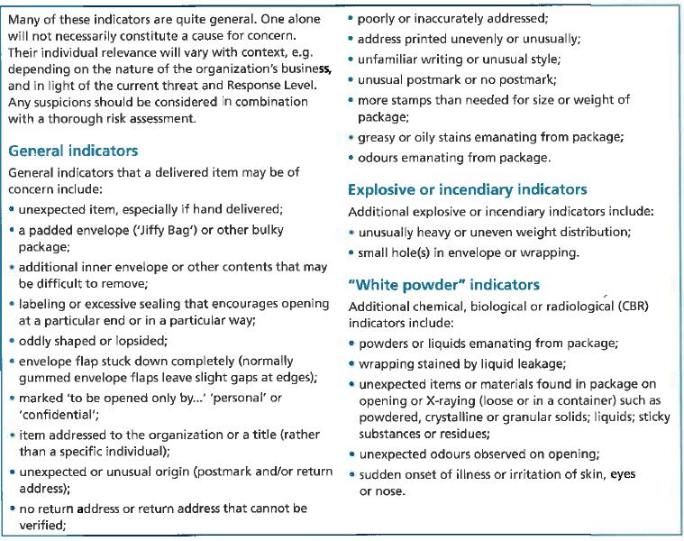
extract from PAS 97

Action upon discovery of any suspicious delivered items

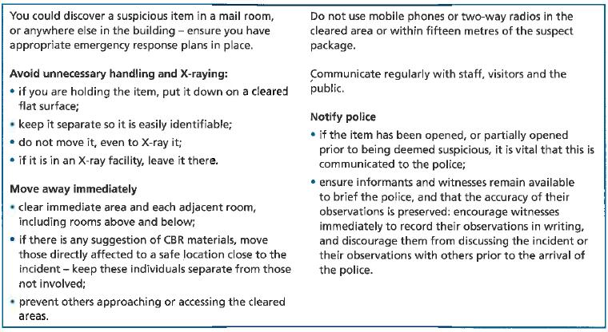
extract from PAS 97

Other considerations re – Suspect Mail:

- All incoming mail and deliveries should be accepted and processed in a separate room away from main office accommodation.
- Only permanent office staff to handle mail.
- Only accept mail for current staff members.
- Encourage regular correspondents to put their return address on each item.
- All incoming mail should be included in the screening process (royal mail, couriers, hand delivery)
- Open mail with letter openers.
- Open mail with minimum of movement. Do not shake or blow into unidentified letters/packages
- Wash hands after handling mail.
- Consider using latex gloves / face mask – contamination purposes or forensic issues (obscene / threatening mail)
- Packages suspected of containing unidentified material / substance, i.e. WHITE POWDER incidents. Item should be left intact. (see white powder incidents)
- Alternative uniform is available in case staff should need to remove contaminated clothing.
If you are suspicious ... THINK:

- What concerns you & why? Check for the classic visual features of hazardous devices.
- Contact the addressee – are they expecting a package containing wiring etc?
- After evaluation, isolate the suspect package from other mail immediately.
- Do not over-handle. Do not shake or attempt to open the package.
- Leave in-situ. Do not place in a filing cabinet or bucket of water/sand. Contact your Line Manager and inform of circumstances.

WHITE POWDER INCIDENTS

Firstly, it is important to remember that incidents involving chemical or biological attacks have been extremely rare. Hoax calls are a possibility. Most emergency services are highly skilled in the event of an incident.

Considerations for staff in the event of a suspicious package as described being found.

  - Reassure! Ask them to remove any contaminated outer clothing. (retain modesty) and leave in room. Do not remove clothing over the head, cut clothing off where possible) Allow those involved to remove any powder contamination from body /clothing by wiping with a dry clean absorbent material to dabs hands and face. Unless burning caustic substance, in which case wipe and rinse the area.
  - Reassure those directly involved and move away from the substance and preferably in the open air. (LOOKOUT: for sudden onset of illness or irritation of skin, eyes or nose).
  - Those directly involved to Blow Nose.
  - Turn off any air conditioning systems in room/building.
  - Secure and isolate in a room.
  - Prevent further access to area.
  - Reassure and monitor the person(s) involved for health & safety reasons.

APPENDIX 1 – BOMB THREAT CHECKLIST

Remember: the more information you get, the easier it will be to decide if the call is genuine.

Immediately inform your Line Manager
It is important to write down as much as you can remember. You are the only link between the caller and those assessing the call.

- Even the slightest change can affect the meaning of the message. Write it down as accurately as you can, BUT if you realise you have made a mistake, do not be afraid to say so. Correct wording can make a difference. Especially note any inconsistencies if the message is repeated.

- Try to find out exactly where a devise is. Any ambiguity could mean persons being evacuated towards the devise instead of away from it.

- Time is an important factor. How long do we have to assess, decide and take action?

- A good description may help a device to be identified more quickly.

- It will help bomb disposal officers decide the best way to deal with a devise if you can tell them what sort it is. This can also be important later, when trying to trace the persons who planted the devise.

- If we know whom the caller represents, we will know what code words to look for in the message. DO NOT ASK FOR A CODE WORD – only record one if provide voluntarily.

- Knowing the leader of a cause is important, especially if the faction is a breakaway group.

- The name of the group/faction, or the code word will help decide if the call is genuine or otherwise.

- The address given could also give clues as to the real identity of the caller/group.

- The precise time of the call is very important. Assessors need this as a base time to work from.

- Accurate information about the caller may help later identification.

- Every inflection could be important – there is a difference between a prepared message and a spontaneous one.

- Information about the telephone, line and quality of call is of use to assessors

- Background noises can give clues as to where the call is coming from

- It is vital to note who took the call and how to contact you in case investigators need to speak to you later.

- The number, which was called, is also important, especially if it is an extension number or an ex-directory line.

APPENDIX 2 - BOMB SEARCH PLAN

- The Duty Manager is to make the decision to search for suspect packages and declaring that the search is complete.

- It is vital that if a threat is received by a telephone call, or other form of verbal communication, a description of the package is obtained.

- Consider which members of staff are to be tasked with carrying out the search. Remember that staffing levels will differ at different times of the day.

- Consider training and testing members of staff in basic search methods.

- Consider training and testing staff in recognition of what is a suspect package and what is unattended baggage.

- Consider what actions staff or members of the public should take if they discover a suspect package during the search?

- What actions staff or members of the public should take if they observe suspicious activity during the search?

- Consider what information, is communicated to guests and members of the public during the search. It is unlikely that a search can be carried out without the realisation of guests.

- Consider what form of communication is delivered when the search is complete.

- Consider whether and at what stage emergency services are informed of a threat and that a search is being conducted.

- Search sheets (example follows) must be carefully completed for all areas of the building and kept with other emergency information.

APPENDIX 3 - SEARCH AREA CHECK LIST

- COMPLETE SIMILAR SHEETS FOR ALL AREAS OF BUILDING
SEARCHER:
 |  | TICK IF CLEAR
1 | ENTRANCE DOORS
2 | PUBLIC CLOAKROOMS
3 | MAIN GENERAL OFFICE
4 | CORRIDOR TO RECEPTION & RECEPTION DESK
5 | RECEPTION PUBLIC AREA
6 | FEMALE PUBLIC TOILETS
7 | MALE PUBLIC TOILETS
8 | TOILET FOR THE DISABLED
9 | FOYER BAR AREA – INCLUDING CHECKING UNDER TABLES / CHAIRS
10 | FOYER BAR SERVERY
11 | TICKET OFFICE
12 | ARTISTS CHANGING ROOMS
13 | STAGE & AUDITORIUM

PRINT NAME ___________________ SIGNATURE: ________________________

DATE: TIME:

APPENDIX 4 – INTERNAL SEARCH PATTERN

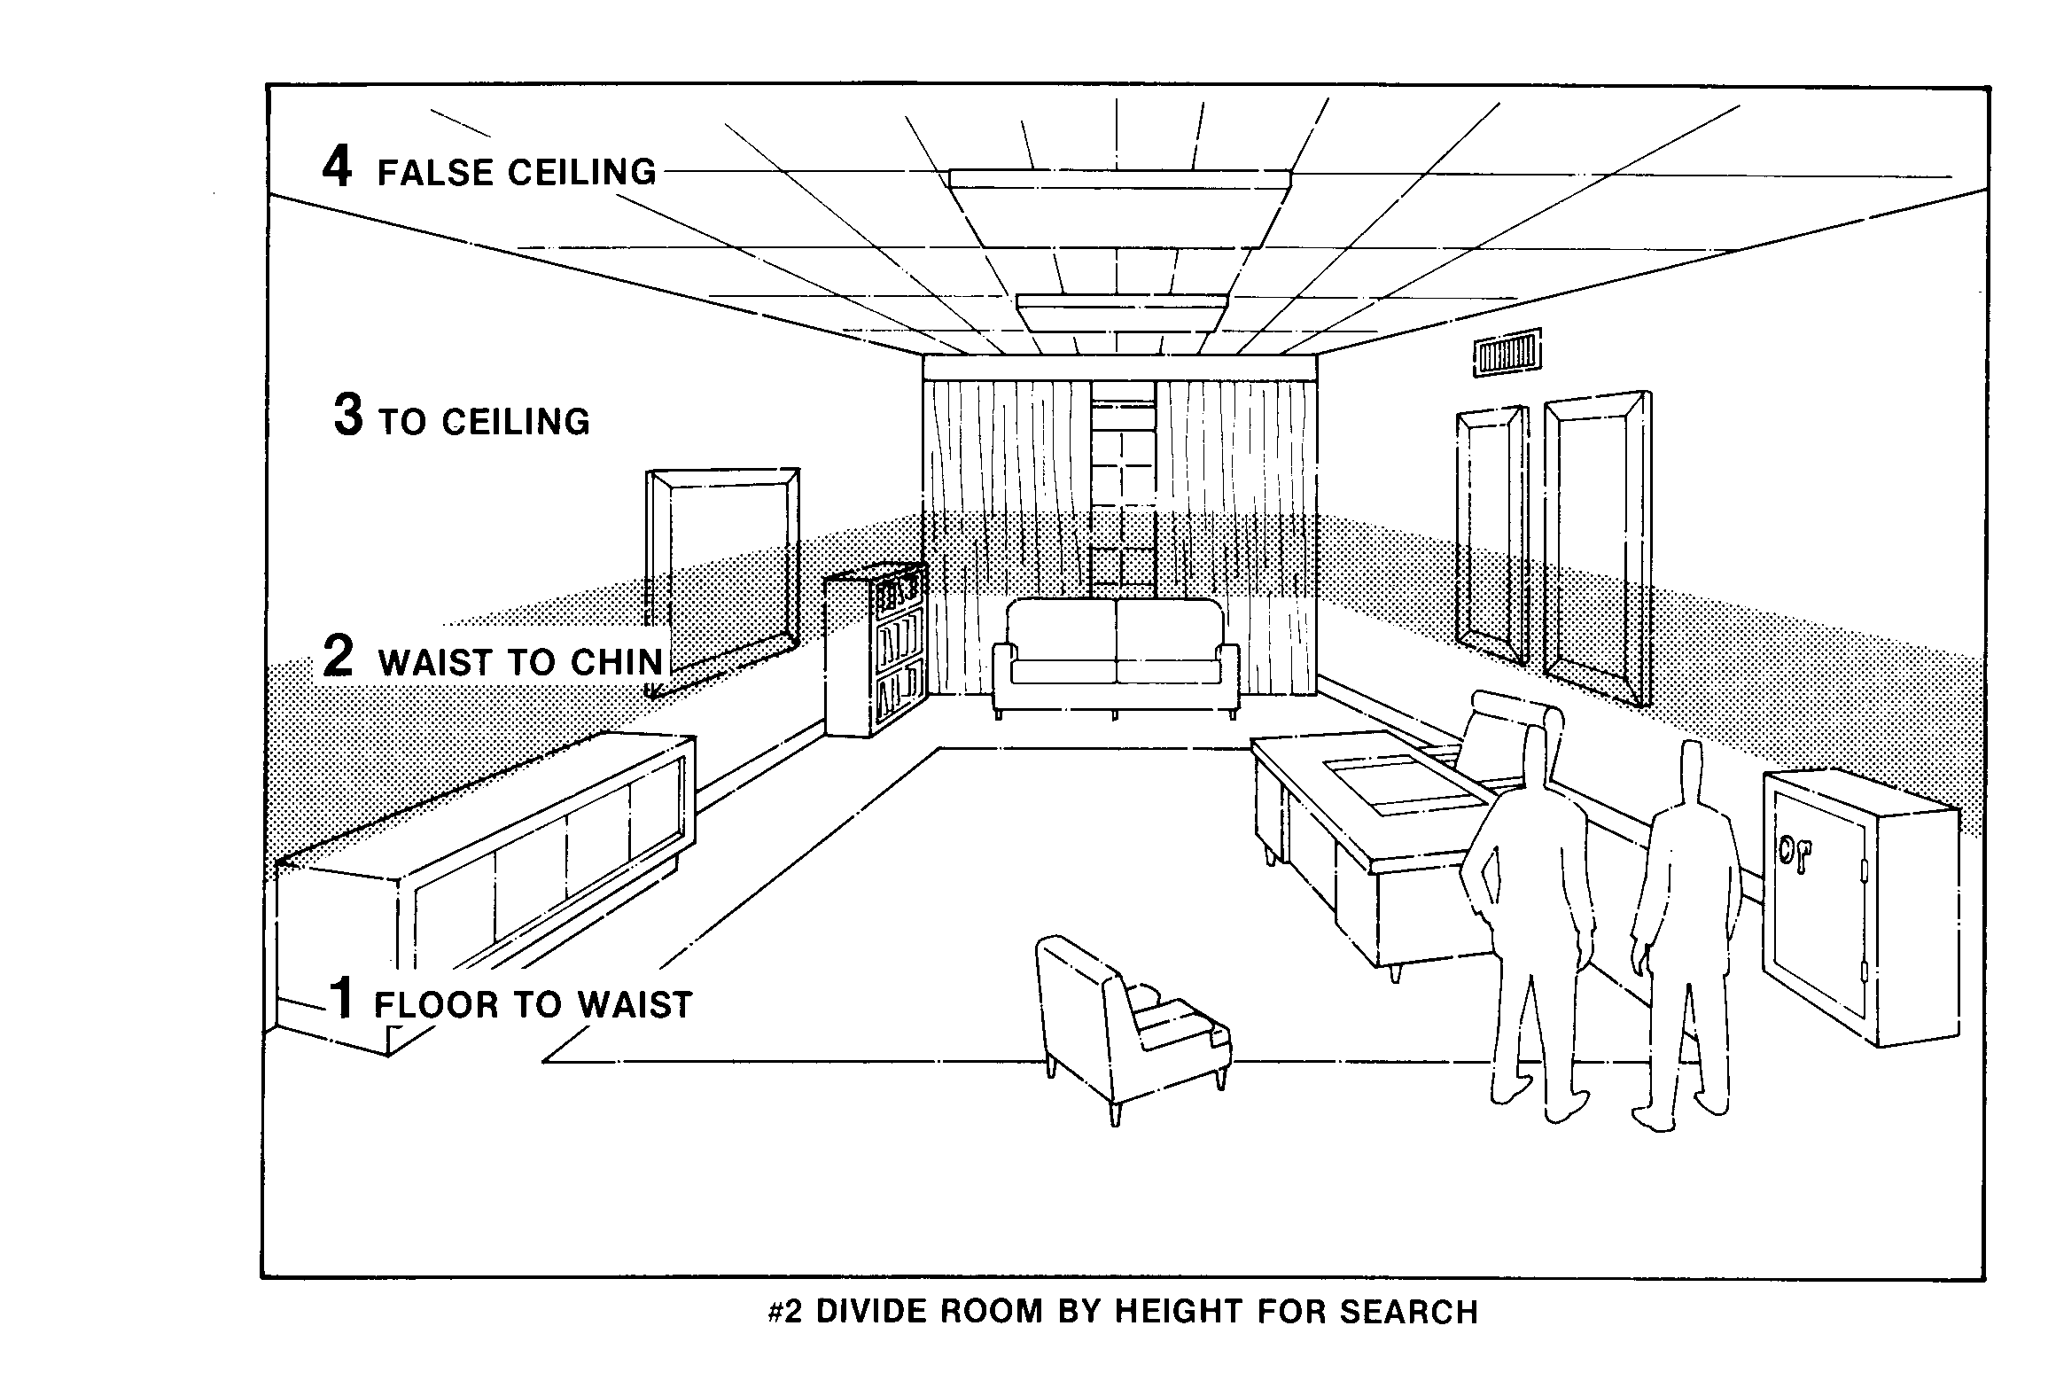

APPENDIX 5 - BOMB THREAT EVACUATION MODEL

Our objective is to evacuate the premises quickly and efficiently and provide safe routes of escape.

The Duty Manager in the building will assume the role of Evacuation Co-ordinator, and will direct the operation.

1. All members of Management will be contacted by Reception, and report to Reception Desk or Ticket Office Reception.

- Evacuation Co-ordinator meets with members of management and briefs them of the situation. Bomb Threat Search Lists to be available.

- Tannoy announcement in all public areas of evacuation team members to tour areas and verbally instruct evacuation via identified safe escape route.

"Good Morning / Good Afternoon, this is Reception, we have an emergency situation. The local Police (or we) have received a Bomb Warning for this area, please leave via the nearest fire escape, and assemble at the identified point (100yrds or Fire Assembly Points)".

- IF TIME DOES NOT PERMIT THE ABOVE ACTIONS TO BE CARRIED OUT, ACTIVATE FIRE ALARM AS EVACUATION METHOD. REDIRECT FROM FIRE ASSEMBLY POINTS ON ARRIVAL. USE EXTERNAL TANNOY TO RELAY ITEM 5 MESSAGE.

- Hand-held radios, mobile phones can be used, but persons with such equipment should not be near a suspicious package found to ensure safety i.e. 15 metres.

