APPENDIX 1 – BOMB THREAT CHECKLIST

If a Bomb Threat call is received follow these procedures which are in 3 parts.

Part 1: Taking the call and recording the threat.
Part 2: Informing the Duty Manager or Buildings Manger.
Part 3: Completing the information.

Part 1 Taking the call and recording the threat:
Record the exact wording of the threat, the exact time and duration of the call:

Time and Wording ____________________________________________________________________

_____________________________________________________________________

PASSWORD or CODE: (Do not ask for a code, but write down if given)

_____________________________________________________________________

Which building is it in? ____________________________________________

Where is the device right now? ____________________________________________

What time is it going to go off? ____________________________________________

What will cause it to explode? _____________________________________________

What does it look like? __________________________________________________

What kind of device is it? (Type of explosive) _________________________________

Did you place the device? ________________________________________________

Why? ________________________________________________________________

What is your name? ____________________________________________________

What is your address? __________________________________________________

What is your telephone number? __________________________________________

When the call has finished, give this form to the Duty Manager who will decide what to do. See part 2 for this procedure. Remember the more information you get, the easier it will be to decide if the threat is genuine or not.

Part 1 Taking the call and recording the threat:

To be filled in by the Duty Manager:

Action Taken: _________________________________________________________

_____________________________________________________________________

_____________________________________________________________________

Comments: ___________________________________________________________

Signed: ______________________________________________________________

Part 2 Informing the Management

- Following receipt of a bomb threat call. Call the Duty Manager on the radio using the codeword ‘……….’ asking them to report to your location or send someone with the form to them. Ensure the information gets to the Duty Manger immediately.

- The Duty Manager should decide who will Dial 999 and inform the Police of the threat giving them the information from part 1 of the form.

- The Duty Manager will inform front of house staff to be on standby as per the evacuation procedures.

- The Duty Manager will use the information given to decide if a search will be carried out or a full evacuation will take place. In the event of a search being called for follow the search plan in Appendix 2.

- In the event of the Duty Manager deciding to evacuate the building the bomb evacuation procedures should be followed in Appendix 3, and also the standard evacuation procedures. In the event of the Police acting on authenticated codeword a full evacuation may be ordered.

- The Buildings Manager or if not available a member of the Senior Management Team should be informed on the situation as soon as possible.

- In the event that there is no Duty Manger as there are no shows on etc, the Buildings Manger should be called or if also not available a member of the Senior management team.

Part 3: Completing the Information

To be completed by the person that took the call after the caller has hung up and the Duty Manager or Buildings Manager and Police have been informed

Record the exact time date and duration of the call: Date: _________Time__________

DETAILS OF CALLER

Man ooo Woman ooo Child ooo Old/Young ooo

Not known ooo Approximate Age oO

Nationality ________________________

SPEECH

Drunk ooo Irrational ooo Rambling ooo Laughing ooo

Well spoken ooo Taped Message ooo Offensive ooo Calm ooo

Crying ooo Angry ooo Nasal ooo Excited ooo Stutter ooo

Slow ooo Lisp ooo Disguised ooo Deep ooo Hoarse ooo

Familiar ooo Speech Impediment ooo Serious ooo Accent ooo

Was the speech read or spontaneous? ________________________________

Additional information __________________________________________

DISTRACTIONS

Any noise on the line ooo Telephone box ooo

Operator ooo Interruptions ooo Anyone in background ooo

OTHER NOISES

Traffic ooo Talk ooo Typing ooo Machinery ooo

Aircraft ooo Music ooo Children ooo Other ooo

House noises ooo Crockery ooo PA system ooo

Anything else ________________________________________________

When complete give this to the Duty Manager.

Further Guidance notes:
It is important to write down as much as you can remember. You are the only link between the caller and those assessing the call.

- Even the slightest change can affect the meaning of the message. Write it down as accurately as you can, BUT if you realise you have made a mistake, do not be afraid to say so. Correct wording can make a difference. Especially note any inconsistencies if the message is repeated.

- Try to find out exactly where a devise is. Any ambiguity could mean persons being evacuated towards the devise instead of away from it.

- Time is an important factor. How long do we have to assess, decide and take action?

- A good description may help a device to be identified more quickly.

- It will help bomb disposal officers decide the best way to deal with a devise if you can tell them what sort it is. This can also be important later, when trying to trace the persons who planted the devise.

- If we know whom the caller represents, we will know what code words to look for in the message. DO NOT ASK FOR A CODE WORD – only record one if provide voluntarily.

- Knowing the leader of a cause is important, especially if the faction is a breakaway group.

- The name of the group/faction, or the code word will help decide if the call is genuine or otherwise.

- The address given could also give clues as to the real identity of the caller/group.

- The precise time of the call is very important. Assessors need this as a base time to work from.

- Accurate information about the caller may help later identification.

- Every inflection could be important – there is a difference between a prepared message and a spontaneous one.

- Information about the telephone, line and quality of call is of use to assessors

- Background noises can give clues as to where the call is coming from

- It is vital to note who took the call and how to contact you in case investigators need to speak to you later.

- The number, which was called, is also important, especially if it is an extension number or an ex-directory line.

APPENDIX 2 – BOMB SEARCH PLAN

Initiating a Search

- The Duty Manager OR Buildings Manager will make the decision to search the building for suspect packages using the information about the threat and description of the package, and declaring when the search is complete.

- The Duty Manager OR Buildings Manager will hand out the search plan zone checklists to the staff that are most familiar with those areas. They will be able to identify things out of place or unusual items where there should not be and report back. The zone checklists have examples of the most suitable staff members for searching the areas to aid issuing them on conducting a search.

How to Search

REMEMBER HOT
The overriding principle is that it be conducted in a systematic and thorough manner so that no part is left unchecked.

HOT CHARACTERISTICS

H Has the item been hidden? Has any attempt been made to conceal it from view or place it where accidental discovery is unlikely? Innocent items are not usually hidden deliberately. Explosive devices, because of the consequences of the device being found before it functions, are not usually left in the open.

O Is the item obviously suspicious? Does it look like a bomb? Visual check only (Can you see wiring; circuitry; or batteries or something attached to it that may be explosive material?)

T Is the item typical? Of what you might reasonably, expect to find in the given location? For example, lost property is often found in locations where people congregate or wait before moving to a new location.

If you find something suspicious

Do not move it or interfere with it in any way. You will need a pre-planned method of communication to alert the Duty Manager

Personal Safety: Do not touch it or move it;

Move away from the device or package immediately.

Communicate: before transmitting by radio or mobile phone move away the below distances:
  - Hand held radio - 15 metres
  - Radio fitted in vehicles - 50 metres
  - Mobile phones switch off or retreat 15 metres
  - Do not take photographs in particular by means of a mobile phone

Please be aware, all the above points could activate a real device when used.

Communicate what has been found to the co-ordinator; using hand-held radios only once out of the immediate vicinity of the device (15 metres)

The person finding the device must remain on hand to brief the police on the exact location and description.

The duty manager will initiate an evacuation to safe location if deemed necessary.

NOTE: The size and type of suspect package will depend on the distance the cordon will need to be from the building.

Small items (handbag/briefcase size) - 100 metres
Medium Items (small car) - 200 metres
HGV’s & Vans - 400 metres

The above relates to ‘Cordon’ distances in the event of a suspicious incident.

Re-occupancy

Must always be discussed with the Buildings Manager and the Police and as necessary the other emergency services for approval and agreement. If the Buildings Manager is not available contact a member of the Senior Management Team.

Consider what information, is communicated to guests and members of the public during the search. It is unlikely that a search can be carried out without the realisation of guests.

Consider what form of communication to deliver when the search is complete.

Search Area: There could be a number of search areas, use the forms below, depending on how many - Reception, Café area, box office area etc etc………………………..

Examples of who could do this: Cloakroom Person, Box Office staff/Customer Service Assistants

 | Where (see examples of locations within building – site specific) | TICK IF CLEAR/ COMMENTS
1 | - ENTRANCE DOORS
2 | - PUBLIC CLOAKROOMS
3 | - MAIN GENERAL OFFICE
4 | - RECEPTION AREA & RECEPTION DESK
5 | - RECEPTION PUBLIC AREA
6 | - TICKET OFFICE
7

8

9

10

Any Comments: _______________________________________________________

Name and Signature of searcher: ________________________________________

Date and Time:________________________________________________________

EXAMPLE SEARCH AREA CHECKLIST

Search Area: Café (OTHER AREAS MAY HAVE MORE AREAS TO SEARCH)
Examples of who could do this: Cafe Staff, Customer Service Assistants

 | Where | TICK IF CLEAR/ COMMENTS
1 | - All bins and cutlery/condiments stand.
2 | - The seating area, including underneath tables and chairs.
3 | - Behind the counter including shelves and storage units.

Any Comments:_______________________________________________________

Name and Signature of searcher:_________________________________________

Date and Time:_______________________________________________________________

INTERNAL SEARCH PATTERN

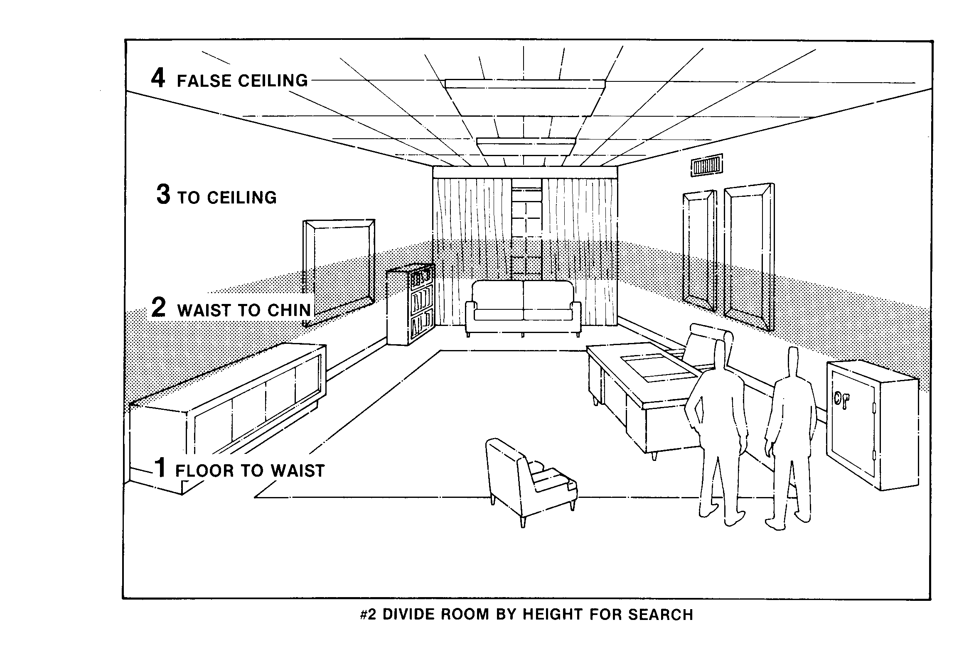

APPENDIX 3 - BOMB THREAT EVACUATION PLAN FOR IDENTIFY LOCATION (Page 1 of 2)

This procedure should be read in conjunction with the IDENTIFY LOCATION standard evacuation procedures.

Our objective is to evacuate the premises quickly and efficiently and provide safe routes of escape and not causing alarm and panic.

The Duty Manager in the building will assume the role of Evacuation Co-ordinator, and will direct the operation.

If the Duty Manager or Buildings Manager or Police decides a full evacuation is necessary the standard evacuation procedures should be followed.

In the event of the Police acting on an authenticated codeword the Police may take control and give specific orders such as a full evacuation or invacuation.

If a suspicious package is found the Duty Manager will inform front of house staff to be on standby. If a evacuation is called the package should be treated as dangerous and avoided, the coordinator will inform all staff to avoid routing people to the area where the package is located as per the standard procedures for fire.

The Duty Manager can (If they deem appropriate) make a tannoy announcement in all public areas, and verbally instruct team members to guide public to the identified safe escape routes.

Example a of Front of House announcement

‘Ladies and Gentlemen, a situation has occurred where we need to ask you to leave the building. All staff are situated by the exit doors, please follow their instructions and leave when asked to do so. There is no cause for alarm”.

Example of a Back of House announcement

“Important message to all staff, a situation has occurred where we need to ask you to leave the building, please make your way out of the building to the assembly point”

IF THE SITUATION IS SERIOUS AND TIME DOES NOT ALLOW AN ANNOUNCEMENT

Determine a safe exit for public
Identify and decide on the Muster point, will it be ***IDENTIFY LOCATION***
Determine if the evacuation can be done via verbally instructing all public and staff or the Fire alarms should be sounded
No emergency situation will be the same and and the Duty Manager or Senior manager have the authority to use their judgement on the best course of action to take based on the information they have.

REMEMBER-Hand-held radios, mobile phones can be used, but persons with such equipment should not be near a suspicious package found to ensure safety i.e. 15 metres.

The Buildings Manager should be informed on the situation as soon as possible if not on site.

Re-occupancy Must always be discussed with the Buildings Manager and Police and the and as necessary the other emergency services for approval and agreement.

If the Buildings Manager is not available contact a member of the Senior Management Team.

In the event that there is no Duty Manger as there are no shows on etc, The Buildings Manger should be called or if also not available a member of the Senior management team.

Assembly Points for Bomb Threats….. IDENTIFY LOCATIONS A MAP WOULD ASSIST

APPENDIX 4 - Firearms Attack Policy - ***IDENTIFY LOCATION***
Although attacks involving firearms and weapons are still infrequent, it is important to prepare a plan. The essentials are to stay safe:
- Keep high standards of security, keep fire doors and exits closed, loading bay door and vulnerable areas locked where practicable?
- Make sure you know the building your working in and all routes / fire escapes and possible hiding places.
- Escape from the building if it’s safe to do so.
- Find Cover from Fire (E.g Behind solid structures such as concrete walls) over cover from View (E.g behind cupboards).
- Under immediate gun fire: take cover initially, but leave the area as soon as possible, if safe to do so.
- Nearby gun fire: leave the area immediately, if it is safe to do so.
- Leave your belongings behind.
- Do not congregate at the evacuation point.
- Put phones onto silent mode and turn off vibrate.
If you cannot escape, you should consider locking yourself and others in a room or cupboard. Barricade the door, and then stay away from it. If possible keep hidden behind solid structures such as concrete walls, choose a room where escape or further movement is possible. Silence any sources of noise, such as mobile phones.
Know your building! (Where to hide/ How to escape)

SEE, TELL, ACT
If our organisation or an organisation in the area has been attacked, the more information you can pass to police the better.

See
KEEP YOURSELF SAFE. Do not risk your own safety or that of others to get information. Use the CCTV to check the area if safe to do so. You should think about:
- the exact location of the incident
- the number of gunmen
- descriptions of the gunmen
- the firearms they are using (for example, long-barrelled or handguns)
- what they are carrying
- their communication methods
- the number of casualties
- the number of people are in the area

Tell
Call the police immediately (999). Provide them with the information you have gathered. Use all channels of communication available to inform staff, visitors, or neighboring premises of the danger. DO NOT sound the fire alarms as this may send people towards danger and this will deactivate the access control doors in secure areas.

Act
Secure your local area (Close and lock doors if possible/ barricade). Stay out of public areas, such as the foyers. Move away from doors and remain quiet until told otherwise by appropriate authorities, or if you need to move for safety reasons, such as fire.
Secure Doors Command
The evacuation coordinator or member of the emergency response team can order that all access control doors be secured which will be done electronically via stage door security on receiving the “Secure Doors” command. This will ensure all magnetic locks activate on the auditoriums and back stage doors creating a secure zone to help prevent gunmen entering the auditoria and backstage. If you are within a secure zone consider if there is sufficient cover and hiding places to remain, if not escape to safety. All doors will still enable persons through from secure side to escape/ non secure side via pressing the green break glass.

Armed police
In an ongoing attack, the police may not be able to distinguish you from the gunmen. They may point guns at you. Follow their instructions and keep your hands in view. Avoid pointing, screaming or shouting, or any quick movement towards the police.

APPENDIX 5 - Vehicle-Borne Explosive Devices Policy

Penetrative and non penetrative- ***IDENTIFY LOCATION***

Mitigation measures for potential attack on main entrance via Vehicle Borne explosive device
The guard staff should;
- Not allow unchecked vehicles to enter (LOCATION)
- Have details of all scheduled deliveries in advance for any contract vehicles
- Deny access to any vehicle that arrives without prior notice.
- be briefed on this policy
Other control measures to mitigate against VBIEDs
- Keep the loading bay shutter closed at all times.
- Do not allow vehicles park directly outside the loading bay and main entrances
- Security to carry out regular patrols of vulnerable areas to check for suspicious vehicles. IDENTIFY AREAS.
- Security to regularly monitor CCTV.
- In the event of a bomb threat or blast keep away from glass and glazing.
- Consider secondary devices checking escape routes before evacuation.
- Consider in-vacuation.

APPENDIX 6- Suicide Attack Policy –

Penetrative and Non Penetrative- ***IDENTIFY LOCATION***
Bag Checks
Access to upper foyer via main entrance
- All bags will be checked before entry
- A table will be positioned at a suitable location to place bags on
- People with bags larger than a handbag will be directed to store them in the cloakroom by security.
Cloakrooms
- Suitcases and larger bags will not be permitted to be stored in the cloakroom (See size guide displayed in the cloakroom).
- The cloakroom attendant will ask to see a valid ticket for the current session, if the person does not have a ticket the bag should NOT be allowed.
- It is VITAL Each and every bag that is stored in the cloakroom MUST be searched
- Note, If there is a threat of a placed Bomb in the building and just 1 bag has not been searched it will mean all the bags will be deemed suspect devises and may prompt full evacuation.
Lift Control between floors
- Lifts will be locked down and used on request
Secure Doors Command
- The evacuation coordinator or member of the emergency response team can order that all access control doors be secured which will be done electronically via stage door security on receiving the “Secure Doors” command. This will ensure all magnetic locks activate creating a secure zone to help prevent entry If you are within a secure zone consider if there is sufficient cover and hiding places to remain, if not escape to safety. All doors will still enable persons through from secure side to escape/ non secure side via pressing the green break glass.
Other control measures
- Keep the loading bay shutter closed at all times.
- Do not allow vehicles park directly outside the loading bay and main entrances
- Security to carry out regular patrols of vulnerable areas to check for suspicious vehicles IDENTIFY AREAS
- Security to regularly monitor CCTV
- In the event of a bomb threat or blast keep away from glass and glazing Consider secondary devices, check area before evacuation
- Consider in-vacuation.

