THE SAFE USE OF ACCESS EQUIPMENT

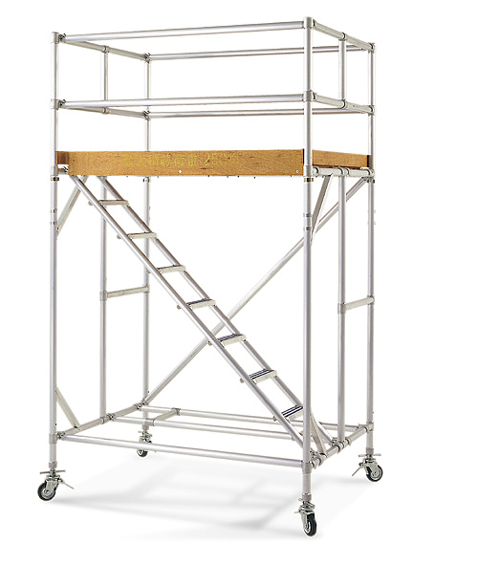
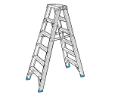
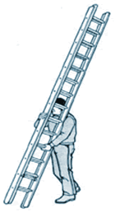

Relevant legislation:
Health and Safety at Work Act 1974
Management of Health and Safety at Work Regulations 1999
Provision and Use of Work Equipment Regulations 1998
Construction (Health, Safety and Welfare) Regulations 1996
Work at Height Regulations 2005

SUMMARY

The Management Guidelines on the safe use of access equipment aim to make managers aware of the legal requirements to be applied when access equipment is purchased and used. These guidelines also provide users of such equipment with some basic safety advice when access equipment is used, and the steps to be taken to ensure that it is adequately maintained.

Contents

- Introduction

2.0 Responsibilities

2.1 Managers Responsibilities
  - Employees Responsibilities

3.0 Safe Use of Ladders

3.1 Length of Ladder
3.2 Checking Ladders
3.3 Putting up Short ladders (one person)
3.4 Putting up Long Ladders
3.5 Securing a Ladder
3.6 Using a Ladder

- Safe Use of Stepladders

- Storage of Ladders

6.0 Safe Use of Tower Scaffolds

6.1 Erecting a Tower Scaffold
  - Using a Tower Scaffold
  - Moving a Tower Scaffold
  - Protecting Other People
6.5 Inspecting a Tower Scaffold

7.0 References and further reading

- Introduction

Work at height is work in any place, including a place at, above or below ground level, where a person could be injured if they fell from that place. Access and egress to a place of work can also be work at height.

RMBC shall ensure that a ladder is used for work at height only if a risk assessment under regulation 3 of the Management Regulations has demonstrated that the use of more suitable work equipment is not justified because of the low risk and existing features on site which he cannot alter.

Examples of work activities that are classified as working at height include:

Working off bandstands;
Working on a flat roof;
Erecting false work and formwork;
Working from a ladder;
Working at ground level adjacent to an open excavation;
Working on formwork within an excavation;
Working near or adjacent to fragile materials.

Some examples of where the Regulations will not apply:

Walking up and down a staircase in an office;
Working in the upper floors of an office block or a portacabin;
An operator sitting in a seat on an excavator;
Sitting in a chair.

Every year many people are injured, some fatally, whilst using a range of access equipment such as ladders, trestles and tower scaffolds. The causes of accidents vary; with ladders it is often a failure to ensure that they are securely placed and fixed, climbing with a load, overreaching and overbalancing. Accidents also occur when recognised methods of gaining access are substituted with such equipment as chairs, tables, boxes etc.

In the case of tower scaffolds accidents can be caused by not using internal ladders to gain access to the working platform, failing to ensure that outriggers are fitted when the equipment is used at a certain height, particularly outside, where wind can adversely affect its stability, and using a ladder on the platform to extend its height.

To comply with the Health and Safety at Work etc Act 1974 employers must ensure that equipment is safe for use, ensure that employees are provided with sufficient information, such as the suppliers manual, undertake risk assessments and provide training for those using access equipment.

This guidance note covers some of the main issues that should be addressed when such equipment is purchased and put into use.

2.0 Responsibilities

2.1 Managers Responsibilities

The manager shall ensure the following:

That all ladders (or stepladders) comply with the British or European Standard and Class, which is a rating of safe working load, as follows:

BS 1129: 1990 (British) Class 1 for wooden ladders.

BS 2037 1994 (British) Class 1 for metal ladders.BS EN/131 (European) applies to both wooden and metal ladders.

DO NOT USE - Ladders / steps complying with BS 1129 (class 3) or BS 2037 (class 3).These are for domestic use only and are not permitted for work activities by RMBC employees.

That no employee undertakes work involving a ladder or tower scaffold without having received the appropriate training. Details of the training that is available can be obtained from the safety section.

That risk assessments are completed for all work involving ladders and tower scaffolds. Generic assessments are acceptable for routine tasks but a specific assessment must be completed for those tasks where there is a significant risk of injury and/or the circumstances are not routine.

The risk assessments should be completed in conjunction with the user/s of the access equipment and should be regularly reviewed.

That the use of access equipment is carefully monitored to ensure that the safe working practices identified in the risk assessments are understood and implemented.

That all access equipment is properly maintained in accordance with manufacturer’s instructions and recorded in a logbook.

That a comprehensive inventory is maintained of all access equipment that is available for use on the premises.

2.2 Employees Responsibilities

Employees who use access equipment must ensure the following:

That only access equipment provided by their line manager should be used.

That they do not use any access equipment without having received suitable and sufficient training.

That where a risk assessment has been undertaken they understand and implement the identified control measures.

That they check the access equipment before each use and report any faults immediately to the line manager.

That any responsibilities relating to access equipment, such as checks and storage arrangements are understood and carried out.

3.0 Safe use of Ladders

3.1 Length of Ladder

The overall length of a ladder is not the same as its useable length. An additional 1.05 metres should be allowed above the highest rung that will be used. Under no circumstances should the top three rungs be stood on.

3.2 Checking Ladders

The following must be checked before use:

- That the ladder has not been painted as this could conceal dangerous defects.

- That the general condition is sound, that it is clean, dry, and free from oil, mud or wet paint and there are no cracks or signs of damage, corrosion, etc.

- That there are no missing rungs and all rungs are secure. This can be checked by twisting with the hand, do not use a hammer or apply body weight.

- That, in the case of metal ladders, rungs are not bent.

- That the stiles (outside uprights) are not damaged or bent.

- That there are no sharp edges or splinters.

- That footpads at the base of ladders are secure and not damaged. All metal ladders must have slip resistant rubber or plastic feet.

3.3 Putting up Short Ladders (one person)

With the ladder lying face down, place the base against a solid surface.

Lift the top of the ladder and ‘walk down’ it rung by rung and ‘hand in hand’ moving towards the base until the ladder is vertical.

Rest the top of the ladder against the wall or similar firm surface, and lift or slide the base out to its final safe position. This should be one metre out for four metres up. Most ladders will have this indicated on the stile.

3.4 Putting up Long Ladders (two or more persons)

With the ladder lying face down, ensure the base is placed where it is to stand.

The heaviest person should stand at the base and place one foot on the bottom rung.

The person at the other end starts to raise the ladder as described above, whilst the person at the other end reaches forward to grasp the stiles, taking care not to pull while the back is in an arched position.

Once the ladder is vertical, allow it to rest against the wall or similar firm surface.

3.5 Securing a Ladder

Make sure that the base of the ladder is on firm, dry and level surface. When a ladder is placed on a soft surface, e.g. grass, tie the feet of the ladder to stakes in the ground to prevent it slipping and place a large wooden board underneath to prevent it sinking.

Ladders should be secured at both top and bottom by tying from the stiles, not rungs, to a fixed and stable object. The base for example can be tied to stakes as in a) above, or fixed blocks, or sandbags to help in preventing the ladder slipping. It is also possible to purchase stabilisers.

In cases where fixing is not possible an adult can foot a ladder by placing one foot on the bottom rung of the ladder and holding a stile in each hand. Footing is only permissible for ladders under 5 metres.
Rest the top of the ladder against a solid surface, never against guttering or other narrow or plastic features. Where this is not possible use a ladder stay or stand–off, which must rest on a firm surface this must be bolted or attached in accordance with manufacturers' instructions prior to putting up the ladder.
Where it is intended to step off the ladder onto a flat roof or platform there must be is at least 5 rungs, 1.05 m (3ft 6ins) above the landing place, or above the highest rung on which the user has to stand, unless there is a suitable handhold to provide equivalent support.

3.6 Using a Ladder

The following safety precautions should be followed when using a ladder: Keep the body facing the ladder at all times, centred between the stiles.

Do not reach too far forwards or sideways, or stand with one foot on the ladder and the other on something else, e.g. a windowsill. Instead move the ladder to a new position.

Use both hands when climbing a ladder, and carry tools in a suitable shoulder bag, belt holster or belt hooks. Do not carry heavy items or long lengths of materials.

When working from a ladder hold the stile firmly with one hand, and use a specially designed tray which fits between the stiles for a paint pot, tools etc.

Strong, flat shoes or boots should be worn with dry soles and a good grip.

Where a ladder is positioned in front of a door it must be securely locked and a system put in place to ensure that other key holders are informed.

Ladders must not be used in strong winds or near power lines.

Employees suffering from certain medical conditions, such as vertigo, heart problems etc, should seek advice from their GP before undertaking work involving ladders. Similarly those who have a fear of heights should make this known to their line manager.

Children under the age of 16 should not use a ladder unless it is for educational purposes.

4.0 Safe Use of Stepladders

Line managers throughout the authority should refer to this guidance and direct any queries they have to the safety section.

Departments may decide to add to this information sheet with specific guidance relevant to departmental activities.
Stepladder accidents

Stepladders provide a free-standing means of access, but must be used carefully. They are not designed to take any degree of side loading and are relatively easily overturned. Most stepladder accidents are the result of human error, not the result of stepladders collapsing.

Different types of stepladders

All Stepladders should meet the requirements of the appropriate British or European standards.

BS 1129:1990 (British) applies to wooden ladders and stepladders.

BS 2037:1990 (British) applies to metal ladders and stepladders.

BS EN 131:1993 (European) applies to both metal and wooden ladders and stepladders.

In addition to the standards that relate to the material the stepladder is made from, there are three British and European standards that relate to their safe working loads:

Aluminium ladders/steps

Type of use | By Whom
BS 2037 (class) | Heavy Duty, Construction Industry
BSEN 131 (class 2) | General/Occasional Caretakers
Timber ladders/steps
Type of use | By Whom
BS 1129 (class 1) | Heavy duty, Construction Industry
BSEN 131 (class 2) | General/Occasional Caretakers

DO NOT USE - Ladders / steps complying with BS 1129 (class 3) or BS 2037 (class 3).These are for domestic use only and are not permitted for work activities by RMBC employees.

Class1 (Industrial) - Maximum static vertical load 175 kg (27.5 stone). . BS EN 131 - Maximum static vertical load 150 kg (23.5 stone).

(This replaces the Class 2 [Light Trade] standard.)

Always check for the relevant standard when buying, hiring or using stepladders. If it is not marked on the stepladder, or detailed in the manufacturer’s guidance, contact the manufacturer or supplier to ensure that the stepladder has been manufactured to the required British or European standard.

Actions - what you must do

Planning the job

When working at height a risk assessment under regulation 3 of the Management Regulations has demonstrated that the use of more suitable work equipment is not justified because of the low risk and existing features on site which he cannot alter.

Do you have to use a stepladder?

Stepladders should only be used for uncomplicated work with a short duration. If a stepladder is not suitable then consideration should be given to the use of a ladder, scaffolding, tower scaffold systems, Mobile Elevating Work Platforms, etc.

Has a risk assessment of the task been undertaken?

Questions to ask include:

- Are measures required to protect other people (e.g. barriers, second person to act as look out, etc.)?

- Will the stepladder be positioned on a level and stable surface (e.g. concrete)?

- How long will the task take?

- Have the person(s) carrying out the work received adequate information, instruction or training enable them to carry out the work safely?

- Do the person(s) carrying out the work suffer from vertigo or fear of heights?

Some stepladders may be too short for high work and some (just as dangerously) are too long for lower work. You must be able to work comfortably without over reaching up, down or sideways. Has the right class of stepladder been selected?
Before Use

- Always visually inspect a stepladder before it is used.

- Check for damage to the stiles (the outside uprights), steps and top platform.

- Check that the stays, hinges, chains or cords (used to keep the stepladder from spreading) are of sufficient and equal length and are in good condition.

- Check that rubber or plastic non-slip feet are not missing (replacements can usually be obtained from the supplier or manufacturer).

- Never use a stepladder that is defective.

- Do not attempt to repair damage. Always report damaged equipment immediately to your supervisor.

- Make sure the steps are clean and dry.

- Beware of wet, greasy and icy steps.

- Wear flat firm soled shoes/boots with clean soles and a good grip.

- Check that there are no overhead hazards near where you are going to work, e.g. overhead electric lines.
Setting up
- Always follow the manufacturer’s instructions when setting up equipment.
- Do not use, or carry metal stepladders (or wooden ladders when wet) beneath low power lines.
- Check that the stepladder is locked into its correct position. Usually this will be with the legs positioned as far apart as the retaining cords/hinges allow.
- Never use stepladders in the closed position.
- Position the stepladder on a firm and level base. If you are working on soft ground, place the stepladder on a large flat board to provide a suitable base.
- Always position at right angles to the work you are doing, i.e. when you climb up the stepladder you are naturally facing the wall or item you are going to work on.
- If stepladders are used in front of a doorway, the doors should be securely wedged open. (Please note: Fire doors must not be left open when the immediate work area is unattended.)
- Never have more than one person on the stepladder at any one time.
- Do not use stepladders outside in strong winds.

On the stepladder
- Always face the stepladder and use both hands when climbing up and down the steps.
- If you need to carry tools up the steps use a shoulder bag, tool belt, etc.
- Hold the stepladder with one hand while you work.
- Always keep both feet on the steps whilst working. Never have one foot on the stepladder and your other foot on something else (e.g. wall, bookcase, window ledge, etc.).
- Do not leave tools on steps where you could trip over them.
- Never work from the top step of a stepladder, unless it has been specifically designed for this purpose and there is a secure handhold (always check the manufacturers guidance). As a general rule, keep your knees below the top step of the platform.
- Do not use the rear supports of steps for foot holds.
- Do not over-reach. Move the stepladder! Keep you body within the uprights while working.
- Do not lend stepladders to non-RMBC employees.

Storage and records of inspection
- Stepladders should be stored in a covered, well-ventilated place where they are protected from excessive damp, heat and the weather.
- Wooden stepladders should be kept off the floor (to avoid contact with damp). Stepladders should not be stored on a position where they are hung from their stiles or rungs.
- Stepladders should be stored out of sight, under lock and key.
- As an alternative, if stepladders are stored in corridors, public areas, etc. they should be secured to a wall, or suitable actions taken to ensure they do not fall over.
- A formal system should be instituted for recording stepladder inspections.
- Visual inspections should be carried out before and after normal use. Inspections should also be carried out at other set intervals. The frequency of these set inspections will depend on the amount a stepladder is used.
- As part of a system of inspection and maintenance, stepladders should be individually identified.
- This identification may include marking or painting small areas of the stepladder. However, painting should be kept to an absolute minimum, as painting may hide defects.
- Stepladders found to be defective should be clearly labelled or marked and withdrawn from service until repaired, or disposed of.
- The following should be read in conjunction with the advice relating to ladders:
- When setting up a stepladder ensure that the fittings designed to prevent it from over spreading (stays, chains or cords) are of sufficient and equal length and in good condition. If recommended by the manufacturer these can be renewed, or alternatively dispose of the ladder.
- Check that rubber or plastic non-slip feet are correctly fitted, replace if damaged or missing.
- Ensure that the stepladder is spread, and where appropriate locked, to its fullest length, and properly levelled for stability.
- Whenever possible a step ladder should be positioned at right angles to the work being carried out.
- The top platform should not be stood on; neither should it be used as a foot support, unless there is an extension handrail to provide support.
- Adequate safety arrangements must be put in place when using a step ladder to prevent injury, particularly where there are people circulating in the area where work is being undertaken.
5.0 Storage of Ladders
- Ladders should be stored on racks, supported on the stiles only to prevent sagging. Under no circumstances should they be hung from the rungs or stiles.
- Aluminium ladders must not be stored adjacent to wet lime or cement, which causes corrosion.
- Ensure that ladders are kept in a secure building to prevent unauthorised use.
6.0 Safe Use of Tower Scaffolds
There are a number of different types of prefabricated towers available and it is most important that the manufacturer’s instruction manual is readily available. This applies whether the equipment is purchased or hired. Instruction manuals are particularly important in providing information on the sequence to be adopted when erecting a tower scaffold.

6.1 Erecting a Tower Scaffold
Only competent persons are permitted to erect a tower scaffold, that is, someone who has received appropriate training. When purchasing a tower scaffold training will normally be provided by the supplier.
All components used in the construction of a tower scaffold must be compatible, and the interchange of components is not permitted.

The tower must rest on firm level ground with the wheels or feet properly supported. Bricks or building blocks must not be used to take the weight of any part of the tower.
There are a variety of methods that manufacturers use for means of access to working platforms, e.g. integral/vertical ladders, stair ladders, inclined ladders. These must be erected in accordance with supplier’s instructions.
EXTERNAL LADDERS MUST NEVER BE USED WITH ALUMINIUM TOWERS.
Where the vertical distance between platforms exceeds 4metres (13ft) a rest platform with double guardrails must be provided.
The taller the tower, the more likely it is to become unstable. As a rule of thumb, if a tower is to be used outside or likely to be exposed to windy conditions, the height of the working platform should be no more than three times the minimum base dimension. Using this guide if the base is 2m by 3m, the maximum height would be 6m.
If the tower is to be used inside a building and is not exposed to adverse conditions, the height can be increased to 3.5 times the minimum base dimension.
That is 7m, using the above dimensions. Outriggers and stabilisers may be attached to increase the EFFECTIVE BASE AREA and to improve stability.
Remember that the stability of a tower scaffold will be affected if it is:
Sheeted or exposed to strong winds.
Loaded with heavy equipment or materials. (See supplier’s instructions for Maximum Design Load).
Used to hoist materials or support rubbish chutes.
Used for operations involving heavy or awkward equipment, e.g. blasting operations, drilling into masonry etc.
In the above circumstances, extra support or alternative height to base ratios may be required.
Under no circumstances should access be gained by climbing on the outside, or using the tower as a support for a ladder in order to gain additional height.
Incomplete towers should never be left unattended. In an emergency a suitable warning notice must be displayed.
6.2 Using a Tower Scaffold
Before using a tower scaffold check that it is vertical and that wheel brakes and outriggers are locked on.
Access should only be gained using an appropriately designed built-in ladder, or a purpose made ladder which can be attached safely to the inside. Any other means of access must be approved by the manufacturer.
Secure handholds must be provided at each landing place.
Suitable edge protection must be provided where a person could fall more than 2m. Guardrails should be at least 950mm high, and tow boards, (these prevent equipment on the working platform falling to the ground), at least 150mm high.
An intermediate guardrail, or suitable alternative, e.g. brick guard, should be provided so that the unprotected gap does not exceed 470mm. Under no circumstances must a guardrail be used to stand on in order to gain extra height.
6.3 Moving a Tower Scaffold
When moving a tower scaffold:
- Check there are no power lines or other overhead obstructions.
- Check that the ground is firm, level, and free from obstructions.
- Do not push or pull from the base. A powered vehicle must not be used under any circumstances.
- Do not move a tower when there is equipment or people on the working platform.
- Never move it in windy conditions.

6.4 Protecting other People
Employees and contractors carrying out their work have a responsibility towards other people who may be affected by what they are doing. In respect of tower scaffolds the following should be considered:
The storage of equipment and materials on the working platform should be kept to a minimum.
Whenever possible tower scaffolds temporarily not in use should be positioned away from walkways and areas of activity. When this is not possible, barriers, e.g. portable screening, should be erected at ground level to prevent passers-by from walking into the tower or work area.
Ensure that unauthorised access is prevented when the tower scaffold is left unattended.
6.5 Inspecting a Tower Scaffold.
Tower scaffolds must be inspected by a ‘competent person.’ That is a person who has been fully trained.
Before first being used.
After substantial alteration.
After any event that could have affected its stability.
If the tower remains erected in the same place for more than seven days, at which time it should be inspected at regular intervals, (not exceeding seven days), and a written report made. Any faults must be put right.
7.0 Access to Heights by None employees
Pupils should not use ladders or tower scaffolds unless this is a curriculum requirement e.g. drama or a specific project under close supervision.
Managers should ensure:
Those persons using tower scaffolds are briefed by a fully trained and competent person on its working application and dangers, and they should be sufficiently senior to be able to exercise the right degree of responsibility.
Schools where the curriculum requirements demand that pupils use ladders as a means of access e.g. drama; the teacher must be competent in the use of a ladder and pupils provided with sufficient information and instruction, as well as being adequately supervised.

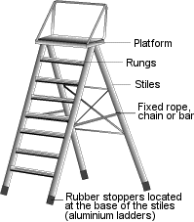

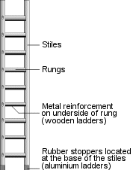

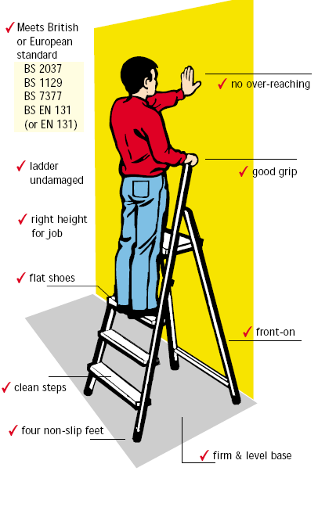

See also:
EDSHS71 Working at Heights Regs
EDSHS73 Safe Use of ladders and stepladders
EDSHS74 A toolbox talk on leaning ladders and stepladder safety

