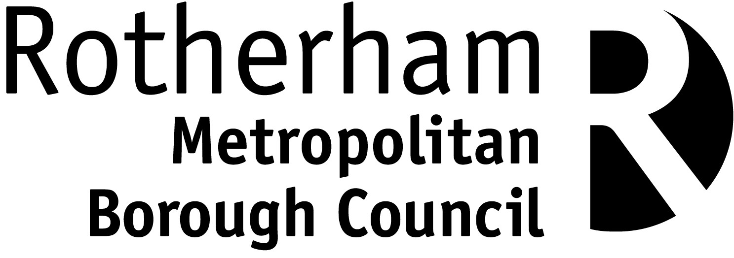
Rotherham Metropolitan Borough Council
Community Safety & Street Scene
Highway Inspection & Enforcement Team
Riverside House, Floor 3, Wing A,
Main Street, Rotherham, S60 1AE

Telephone 01709 336003
Email: streetworksenforcement@rotherham.gov.uk

Dear Sir / Madam

Vehicle Access Crossing over the Highway - Highways Act 1980 (Section 184)

I thank you for your recent enquiry regarding the above matter. Please would you provide the necessary information requested below and return to Rotherham Council.

Title: Mr Mrs Miss Ms Other

Name:

Address:

Post Code

Telephone Email:

Address for vehicle
access crossing:

The property is: Private owned property Council owned property

I would like: Estimate for the Council Licence to use a private contractor to carry out the works¹ to carry out the works²

¹The Council’s minimum construction fee for a standard sized crossing is £3,000.00 (Standard size is approx. 5 kerbs wide over a 1.8 metres / 6 feet wide footway).

²Should you choose an alternative contractor not on the attached list, you must provide:
- Copies of the contractor’s ‘Street Works Qualification Register’ cards (Operative & Supervisor).
- The contractors’ name, address, telephone numbers and email address.
- Evidence of the contractors’ public liability insurance certificate to the value of five million pounds (£5,000,000).

Should you reside in a Council owned property, then a photocopy of the ‘General conditions for alterations, improvements and installations to Council properties’ form showing council approval to create a hard standing must be forwarded along with this completed form.

Application Fee
A non-refundable application fee of £137.00 is charged to cover the Council’s administration and site investigation costs where planning approval is not required. Please tick one of these payment options below:

I enclose a cheque payable to RMBC for £137.00 along with this form.
Please do not send cash through the post.

I wish to be invoiced for £137.00.
(An invoice will be sent to your address to allow you to pay by various methods. E.g. Debit / Credit card, Online, Direct Debit, BACS, Post Office, Automated Telephone Service. You may also pay your invoice at the payment kiosk at a Council Customer Service Centre.)

Additional Information / Chosen Contractor:

Applicant’s Signature:

Form valid from 1st April 2024 to 31 March 2025
Office Use: Income Code: 514050/52760

