**HOW DID WE DO?**

**Adult Social Care Local Account**

**2023 – 2024**

*People are safe, healthy and live well*

**Foreword**

Our Local Account for 2023/24, provides the opportunity to reflect on everything we have done over the last 12 months and see the impact we have made to lives of residents who need care and support.

It provides an opportunity to celebrate everything that has been achieved and outline our priorities for the coming year so that residents can hold us to account and ensure we deliver on the aspirations set out in our strategy for Adult Social Care.

At the heart of everything we do is the person, adopting person-centred practices and strength-based approaches that enable them to live their best lives. We are proud to continue to make a real difference and impact on the lives of our residents across the borough.

Looking forward, it will be more important than ever that people with lived experience can truly have their voices heard and that we empower them to work in partnership with us. I am excited by how our Adult Social Care Co-Production Board will shape and hold us to account. Whilst in its infancy, and therefore a priority over the coming year to really embed this approach in the way we grow our services, it reflects how we want residents to be empowered.

Over the next year, we will also continue to work with partners from the voluntary sector, health, police, fire and rescue and many others, as well as other internal council departments, to ensure residents receive high quality services.

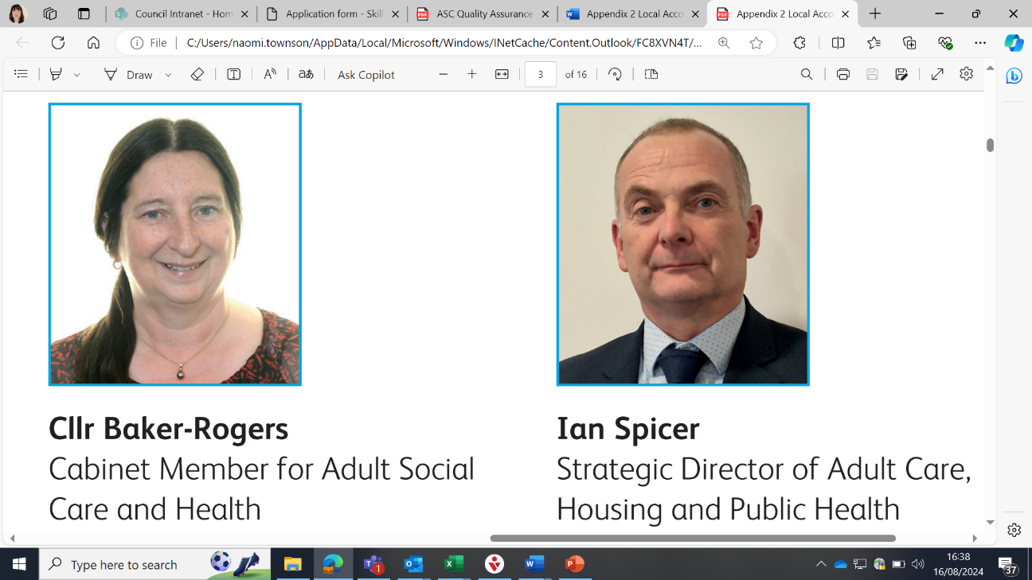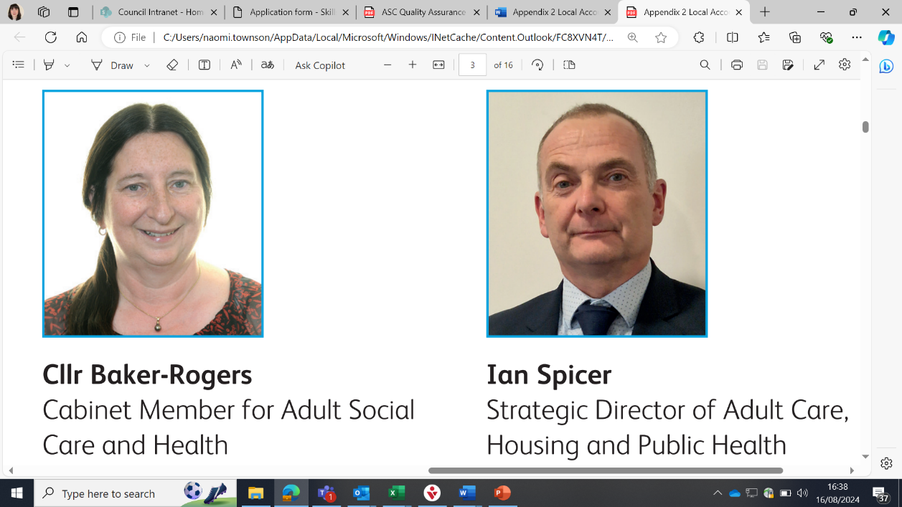

**About the Local Account**

The Local Account aims to summarise our achievements and celebrate the hard work and dedication from our teams over the last year. The Local Account sets out our priorities for the coming year and highlights where we still need to improve and how we plan to do that.

**The Adult Social Care Context**

Our ambition is to support our residents to be ‘safe, healthy and live well’ and our vision for Rotherham residents is to:

*‘Enable every resident with care and support needs to live their best lives, with the people they value, close to home and with access to the right support at the right time’.*

To achieve these things we will ensure that all residents have access to:

* The right information, at the right time, to help them make informed choices about their care and support needs.
* Support and services tailored to them, which are focused on the persons strengths, abilities and aspirations.
* Local communities and are enabled to maintain relationships which are the most important to them.
* The right services, at the right time, which enables them to live healthier lives for longer and maximises their independence.

There have been many achievements in the last 12 months and we have a number of key priorities for the coming year to support in achieving our ambition and vision for residents.

**Our Purpose**

Adult social care works with people with care and support needs, their families, friends and unpaid carers to enable them to live independently, safe and well. This includes people who are frail, have disabilities, are neurodiverse or experience mental ill health, provide unpaid care, as well as young people preparing for adulthood.

Our approach focuses on ‘doing with’ and not ‘doing to’ or ‘doing for’ people, utilising our resources in the most effective way for people to achieve their personal outcomes. Adopting a person-centred approach acknowledges that fulfilment and independence mean different things to different people, and therefore our interventions need to be proportionate, with a clear understanding of the person, their needs and the outcomes they want to achieve.

Our themes for delivering adult social care are:

* Wellbeing and Independence: enabling people to live their best life.
* Informed Choices: having the right information at the right time.
* Connected to People: support to maintain relationships with people that matter the most to them.
* My Support, My Way: focused on strengths, abilities and cultural needs of the person.

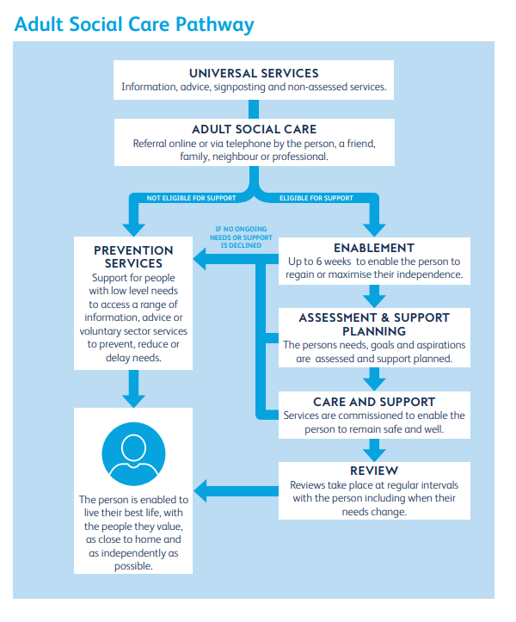

**Safeguarding Adults**

Safeguarding is about protecting people from abuse or neglect and educating those around them to recognise the signs and how they can report their concerns. We work together with partner organisations and people in our communities so that adults can live the best lives they can with their wellbeing and rights being supported, safe from abuse and neglect.

Our work follows the six Safeguarding Principles which are:

1. Empowerment - you are asked what you want to happen and services plan safeguarding round this.
2. Protection - you can get help and support to tell people about abuse and can get involved in the safeguarding as much or as little as you want.
3. Proportionality - services think about what is best for you and only get involved when they need to.
4. Prevention - you will get clear and simple information about what abuse is and who to ask for help.
5. Partnership - staff look after your personal information and only share it when this helps to keep you safe.
6. Accountability - you know what all the different people should do to keep you safe.

The Safeguarding Adults Board (SAB) is a multi-agency partnership which has statutory functions under the Care Act 2014. The main focus of the SAB is to ensure that in Rotherham safeguarding arrangements work effectively so that Adults at risk are able to live their lives free from abuse or neglect.

As a Council we have a Safeguarding Adult Pathway which protects vulnerable residents and ensures we make safeguarding personal to the person at risk of harm or abuse. Our pathway was refreshed in February 2023 to further strengthen our practice and legal compliance with the Care Act 2014.

During the 2023/24 year, 558 people were subject to a new safeguarding enquiry and 525 enquiries were completed. Most enquiries relate to older adults and occur in a person's own home.

At the end of 2023/24, 96.5% of adults involved in a safeguarding enquiry felt their personal outcomes were at least partially or fully met.

**Supporting Our Residents**

During the last 12 months we provided support services for 5,630 individual people.

At the end of March 2024 there were 3,740 people accessing 4,253 services (meaning some people access multiple services) from adult social care.

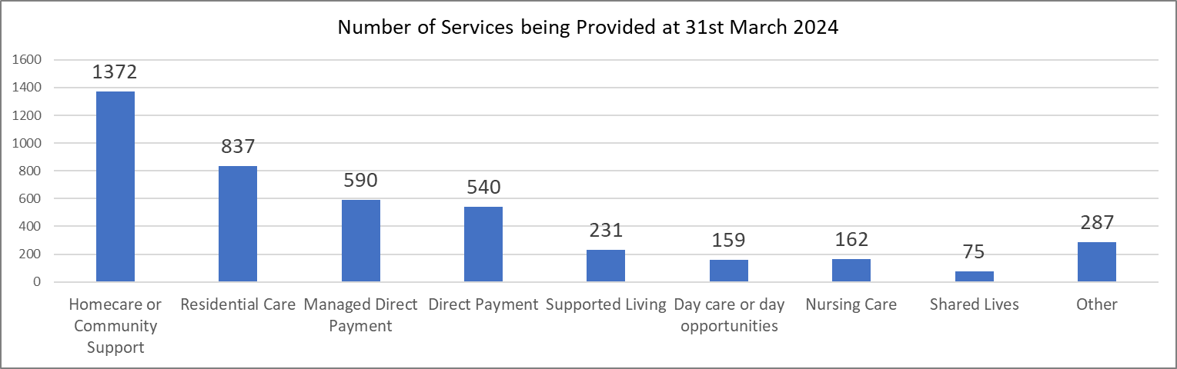

32% of people being supported were aged 18-64

and 68% were aged 65+.

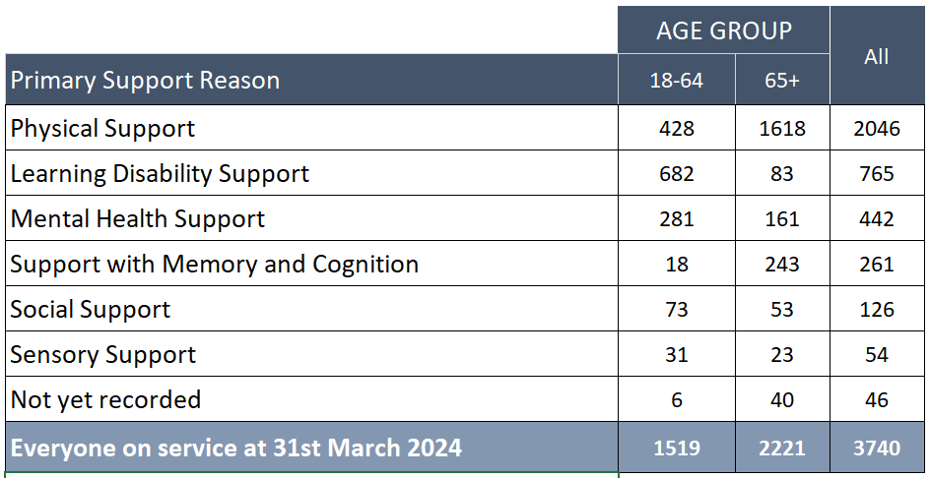

During the 2023/24 year, 58% of people receiving support identified as female and 42% identified as male.

Of the 3,740 people accessing services at the end of March 2024, 53% also received support from an unpaid carer.

**Inclusive Communities**

There is under-representation of people from Ethnic Minority Communities for residents who access our services. 5% of people who received services are from these communities (a small increase of less than 1% from 2022/23).

This remains low compared to the ethnic minority population rate of 10% in Rotherham. One of our areas of focus is to ensure more representative take up of adult social care from across our local communities.

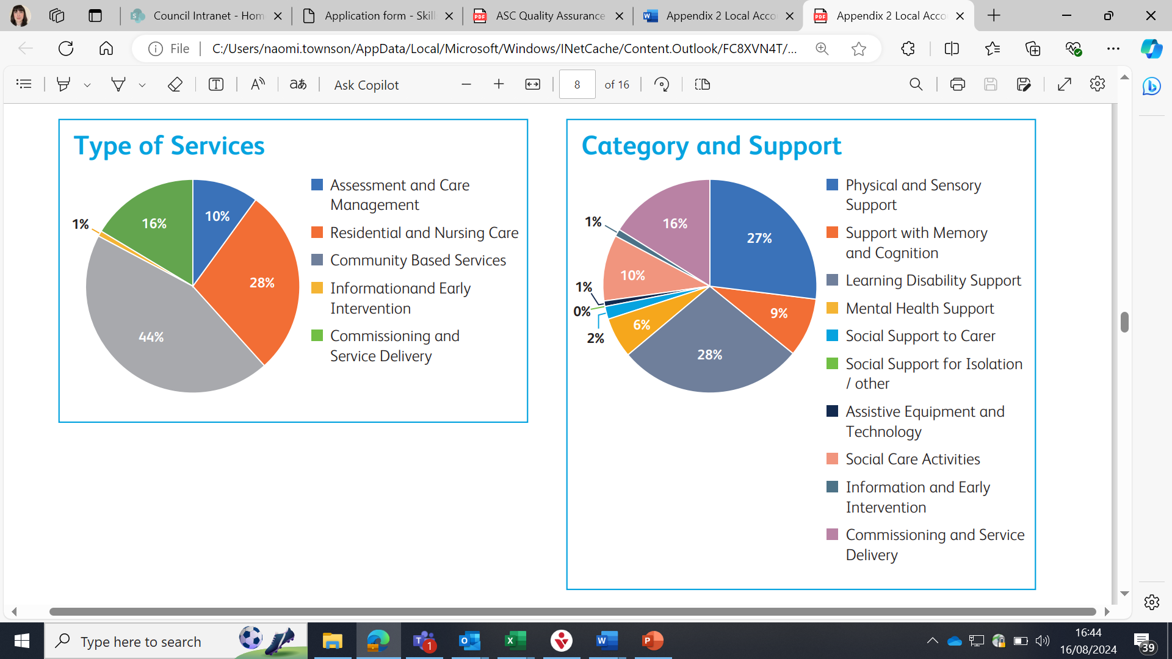**How We Use Our Resources**

Our latest financial data shows Rotherham spent a total of £86.6 million on Adult Care and Support services in 2022/23 (the latest year for which figures are available).

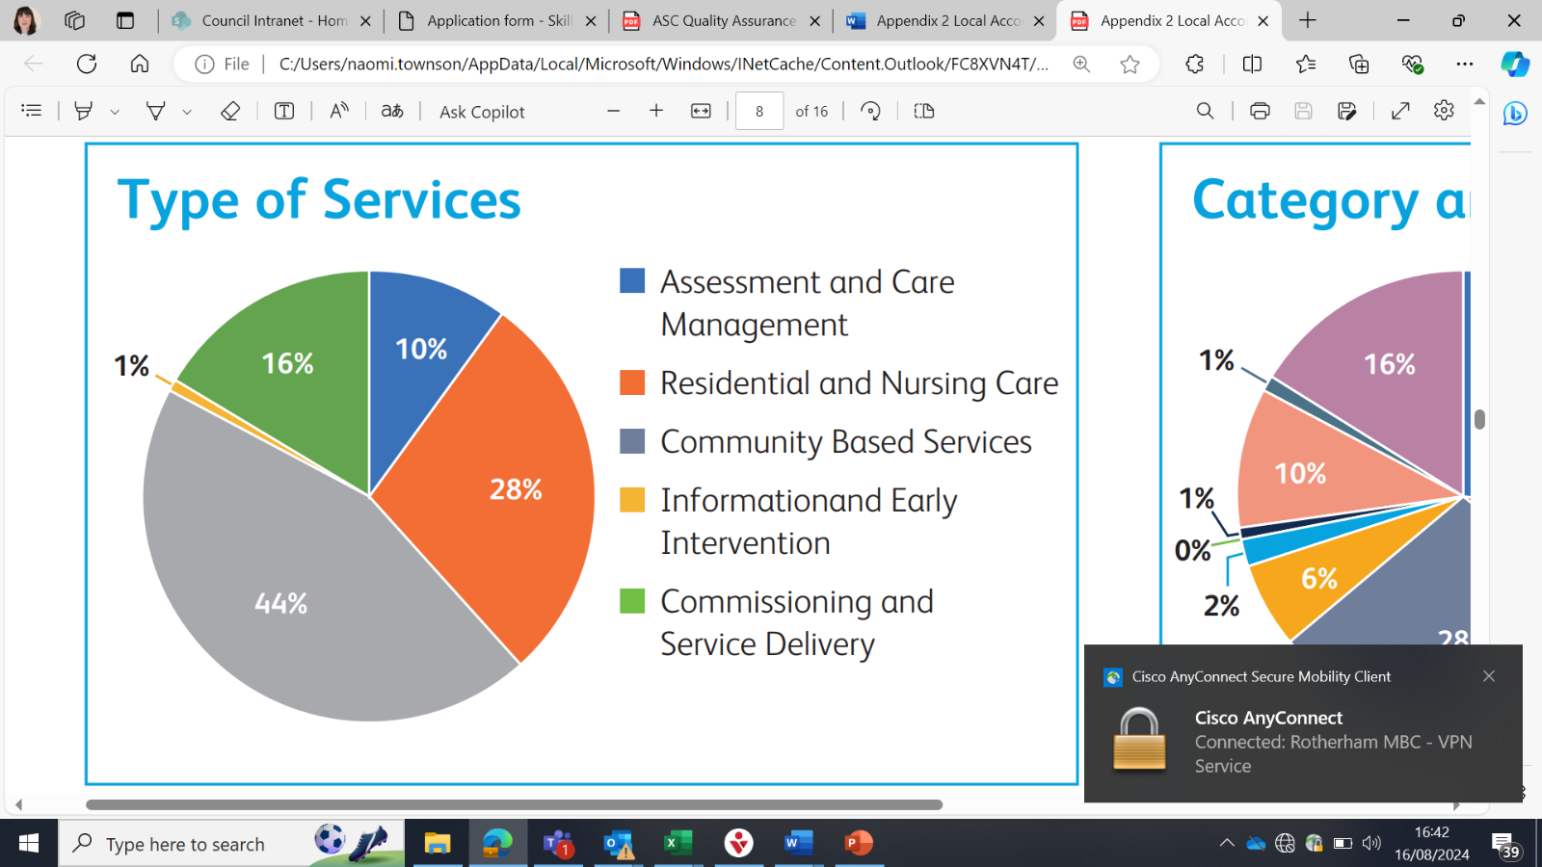

**Our Achievements in 2023/24**

The following tables explain what adult social care achieved in 2023/24 and the impact this had for local residents.

| **Achievement** | **This means that…** |
| --- | --- |
| Launched our new Adult Social Care Strategy for Rotherham which was shaped by local residents. | The strategy sets out how we intend to make a real difference to the lives of local people. The priorities, and which were the most important, were decided through consultation with local people enabling them to hold us to account on delivering them. |
| Worked with partners to develop a new prevention offer. The prevention team will formally launch in early Autumn. | There is a dedicated team who will aim to prevent, reduce and delay a person’s need for formal care. The team will offer support earlier than would have been possible before and this will benefit local people. |
| Reduced the wait times for care act assessments (from a maximum wait time of 595 working days April 2023 to 168 working days in April 2024) and community occupational therapy assessments (from 26 weeks to 13 weeks over the last 12 months). | People’s needs are being assessed sooner and the right advice, support and information is given at the right time. |
| Implemented over 2,000 pieces of new assistive technology such as digital alarm devices and other technology to enable people to live independently at home. | People can live independently for longer whilst feeling safe and supported within their own home. |
| Worked with the Local Government Association to complete a Peer Review to identify areas of good practice and areas for improvement in our services. | We are celebrating our strengths and making progress in areas for improvement. The peer review process means that we are held to account in terms of improving our services. |
| Implemented our Adult Social Care Co-Production Board – Rotherham Adult Social Care, Always Listening (RASCAL) – to empower the voice of residents in the design and delivery of our services. | Residents have a voice and a channel through which this can be heard and acted on. This board means that residents help to shape and design our services so that they reflect what local people need. |
| Co-designed new strategies for autistic people and people with a learning disability. | There are clear strategic priorities, designed with autistic people and people with a learning disability, that will improve the information, support and service available to them, their families and unpaid carers. |
| Finalised the design of Castle View, our new day opportunities centre and gained planning permission to commence the works. | We will be able to deliver services closer to home for people with complex needs. |
| Continued to build on our priorities in our Borough that Cares framework to strengthen the support for unpaid carers in Rotherham. | The support that we offer to unpaid carers is more timely and of a high quality, with an increased number of unpaid carers being supported in their caring role. |
| Developed and implemented new commissioning approaches including a flexible purchasing system for people with a learning disability and / or autism. | There is a greater choice of services available to people, closer to home, and that the standard and quality of care is assured through our commissioning framework. |
| Successfully launched our Supported Employment Team for neurodiverse people and people with a learning disability and helped over 25 people find employment. | Long-term, paid and meaningful employment is possible for individuals who may have previously struggled to find the right roles for them. |
| Improved the outcomes for people being discharged from hospital by developing a Transfer of Care hub with health and voluntary sector partners. | People are returning home from hospital sooner. People receive the right advice and support from the most appropriate professional along with any equipment and assistive technology to support them to be independent and prevent future hospital admissions |
| Completed a redesign of our Mental Health Service to better respond to people experiencing mental ill health. | People can access support to reduce the need for long-term mental health support. This means that people can focus on their strengths to maximise their independence and improve their own mental health. |

**Our Priorities for the Year Ahead**

The following tables outline our priorities for the coming year and identify whether they come from our Adult Social Care Strategy or the Council’s Year Ahead Delivery Plan.

| **Priority** | **This means that…** |
| --- | --- |
| Review and redesign our public information for young people preparing for adulthood, vulnerable adults and unpaid carers. (ASC Strategy) | Information will be easy to understand, accessible and enable a person to make an informed decision about their care needs. |
| Redesign the adult social care web pages. (ASC Strategy) | Online information will be reviewed, redesigned, and improved so that it is easily accessible. |
| Provide a range of information on direct payments and being a responsible employer. (ASC Strategy) | People will have the right information to understand the responsibilities of using a direct payment to meet their care needs. |
| Implement a new prevention service which will support both vulnerable adults and young people preparing for adulthood. (ASC Strategy) | People will receive care and support earlier than would have been previously possible to promote independence. This early intervention aims to prevent, reduce, or delay a person’s need for formal care and support. |
| Invest in prevention services in the voluntary sector. (ASC Strategy) | People will be able to access a range of support services through voluntary sector partners to meet their care and support needs. |
| Review and expand our out of hours support offer for people in crisis. (ASC Strategy) | People in crisis can access support when they need it most. |
| Embed the co-production board and other feedback mechanisms to understand how well we are meeting people’s needs. (ASC Strategy & Year Ahead Delivery Plan) | People will have a voice in how we continue to shape services as well as being able to tell us what we are doing well and how we can further improve. |
| Ensure the voice of unpaid carers is heard, listened to and acted on. (ASC Strategy) | Unpaid carers are recognised for what they do, are responded to, and supported in a way that matters to them. |
| Ensure the voice of the person is central to safeguarding adults. (ASC Strategy) | Adults can live their best lives with their wellbeing and rights being supported and their personal outcomes being met. |
| Implement a new prevention service which will support both vulnerable adults and young people preparing for adulthood. (ASC Strategy) | Young people preparing for adulthood who may not be eligible for adult social care support receive support focussed on maintaining their independence. |
| Enable people to self-triage and self-assess their needs. (ASC Strategy) | People are empowered to lead their assessment of their needs, can do this at a time that suits them and with the people that they want to ask for support. |
| Invest in new assistive technologies (AT) and digital solutions supported by an assistive technology strategy. (ASC Strategy) | People will have access to a range of different technologies, enabling them to maximise their independence and live at home for longer. |
| Start the building groundwork for Castle View, Canklow which will provide new day opportunities for people with high support needs. (Year Ahead Delivery Plan) | People with complex needs will have access to care closer to home and in a purpose-built environment that delivers high quality personalised support. |
| Develop a new transitions assessment process with partners for young people preparing for adulthood. (Year Ahead Delivery Plan) | Young people will be fully supported by a range of professionals to access the right support as they prepare for adulthood. |
| Review the impact of the mental health services redesign for residents. (Year Ahead Delivery Plan) | We can understand the impact the new service model is having for people with mental health needs and further refine the model to ensure it achieves the best outcomes. |
| Launch the new Learning Disabilities Strategy which sets out Rotherham’s aspirations for people with a learning disability. (Year Ahead Delivery Plan) | People with a learning disability have a strong voice and can make choices that mean they are included, safe and secure, to ensure they have the best life chances. |
| Launch the new All Age Autism Strategy which sets out aspirations for autistic people living and working in Rotherham. (Year Ahead Delivery Plan) | Autistic people will have access to education, employment opportunities and support in their own home. It also means that the right information, at the right time, will be available so that people can make informed choices. |

**Voice of the Resident**

During 2023/24 we received 225 compliments compared to 59 complaints.

* Compliment for a **Social Worker** in the Access Team: "Thank you for pulling out all the stops even though you have 101 things to do, it's greatly appreciated".
* Compliment for a **Social Worker** in the Localities Team: “We wish to express how grateful we are for your prompt response. It really is so reassuring to know that we are fortunate enough to have a strong support mechanism in place like yourself".
* Compliment for **Davies Court**: "Thank you all of you who cared and looked after [my mum]. You enabled her to enjoy her final months and it was a comfort to us all knowing that she was cared for and treated more like family".
* Compliment for the **Targeted Review Team**: "You have been praised as caring, diligent and a pleasure to work with. They [the individual] were saying how they are confident in approaching you with issues and know that you will give sound advice and signposting to other professionals who may be able to assist".

Complaints reduced by 4.9% on the previous year, with the majority being related to communication or wait times for an assessment. This reflects what we know – demand for support is high and we are working to improve areas such as wait times for assessments.

Of the 59 complaints received, 54 (91.5%) were satisfied at stage one without further escalation.

Compliments increased by 30% on the previous year which shows the work colleagues are putting in to support individuals.

Our Adult Social Care co-production board, (RASCAL), provides a voice and platform to empower local residents to co-design how our services are shaped. We would like to thank RASCAL members for working with us to shape our Local Account for 2023/24.

**The Best Work of our Lives**

**Harry** was matched to a Shared Lives Carer who lives in his local area to develop his confidence and independence in his local community. Harry introduced his new carer to his love of crown green bowls and they now access many events in the local area including visits to the library, pub meals together and trips further afield. They regularly join events organised through Shared Lives and Harry was a top scorer in a recent ten pin bowling evening! Through joining Shared Lives events they have met up with another Shared Lives Carer and the person she supports. They have all planned a local coach trip to Blackpool and Scarborough in the upcoming months.

Harry’s Father says “I cannot believe how much his confidence has grown since being part of Shared Lives. It has made such a difference to our lives.”

Harry says “Love it, I enjoy spending time with my Shared Lives Carer and her family. We do lots of things together that I enjoy and this fits nicely around my bowling league.”

**John** has been receiving support from Supported Employment since August 2023. John lives in supported living so for any work he completed it was important that it did not affect his benefits and living situation. John worked with Michelle from the Supported Employment team to find a stewarding role. Michelle discussed John’s Learning Disability and the support he would need with the employer who was happy for Michelle to attend training sessions and be involved where needed. Michelle attended John’s induction with him to ensure he understood all of the policies and procedures. John completed his first shift at Rotherham United in November and has since worked at Doncaster too. John has gone from strength to strength within his role and the support he has received has enabled him to sustain his role for seven months.

John says “Supported Employment have been brilliant! Michelle, Lauren, and Andy have helped me get a job and helped me with lots of other things, I couldn’t have done it without them”.

**Joseph** had experienced a stroke which affected his sight and memory. He was supported by a Visual Impairment Officer from the Sensory Team to use a white support stick and to practise routes within his local community to regain confidence. This support has allowed Joseph to regularly access, and engage with, his local community independently. Joseph described this support, and the impact it has had on him, as feeling like ‘winning the lottery’.

**Useful Contacts**

Safeguarding (Customer Contact Team) – adults – 01709 822330

Safeguarding (M.A.S.H Team) – children – 01709 336080

Mental Health Crisis Team – 0800 652 9571

RDASH Switchboard – 03000 213000

Housing Services – 01709 336009

Reablement Services – 01709 336096

Shared Lives – 01709 334948

Supported Employment – 01709 249600

Age UK Rotherham – 01709 835214

Citizen’s Advice Bureau – 0808 278 7911