
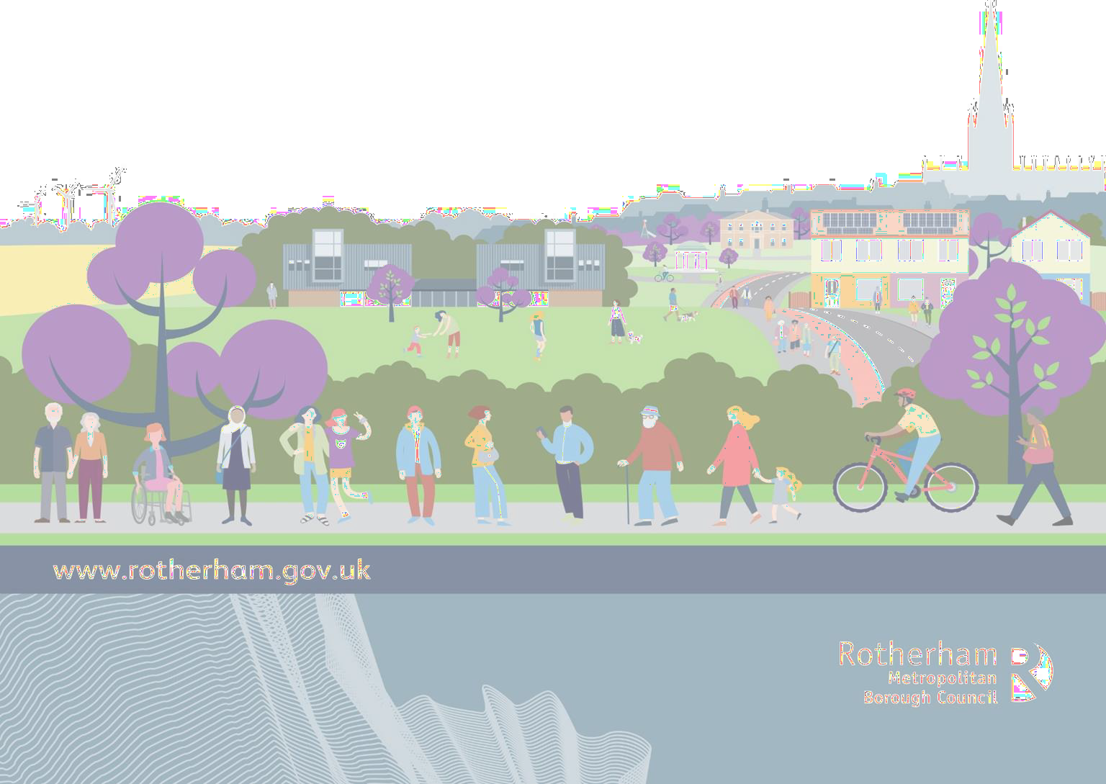



How did we do?
Adult Social Care Local Account 2023 - 2024

About the Local Account


This report will show the good work we did last year. It will also tell you about the hard work from our teams.


We will show you what we will focus on for the next 12 months. We will also say what we need to do better.

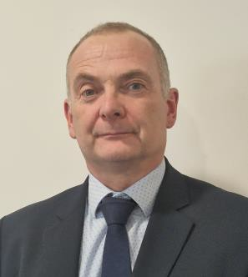
This is Ian Spicer the Strategic Director of Adult Care, Housing and Public Health.

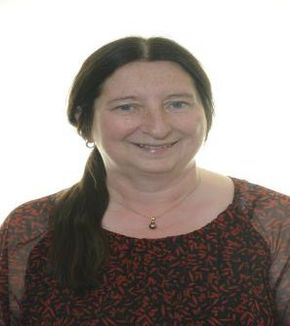
This is Councillor Baker-Rogers the Cabinet member for Adult Social Care.

Councillor Baker-Rogers and Ian Spicers views on the Local Account

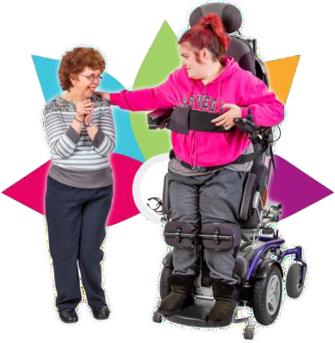
The Local Account looks back at the past year.

It shows how we have helped
people.

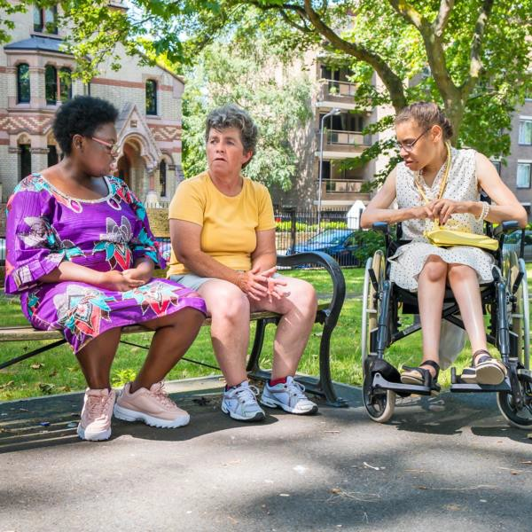
We celebrate the good work done and share our plans for the next year.

The person is at the centre of everything we do.

We aim to help everyone live their best lives.


We want everyone to have a say and be heard.

We are pleased that our Adult Social Care Co-Production Board will help with this.

What we want to do


We will help our residents to be safe,
healthy, and live well.
Resident is someone who lives in
Rotherham.

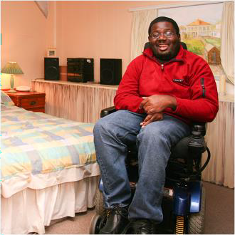
We will support everyone who needs care to live their best lives with people they love, close to home.

We will make sure they get the right help when they need it.


We want everyone to have the right
information to make good choices.

We will make sure they can access support, services, and local communities at the right time.

Safeguarding Adults


Safeguarding means keeping people safe from harm. This includes stopping abuse and neglect.


It also means helping people understand what abuse looks like. People should know how to spot the signs.

Safeguarding helps people speak
up if they see something wrong.

Reporting concerns is important.


In Rotherham, the Safeguarding Adults Board checks that everything is working well. They make sure people are protected.

More Safeguarding Adults


In 2023/24, 558 people had a new safeguarding enquiry.

525 enquiries were completed in total.
Enquiry is another word for a question.


Most enquiries were about older people in their own home.

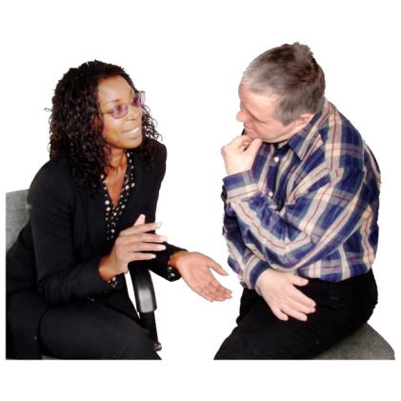
307 of the 525 people told us what they wanted to happen at the end of the enquiry.

297 people said what they wanted to happen at the end of the enquiry had been listened to.

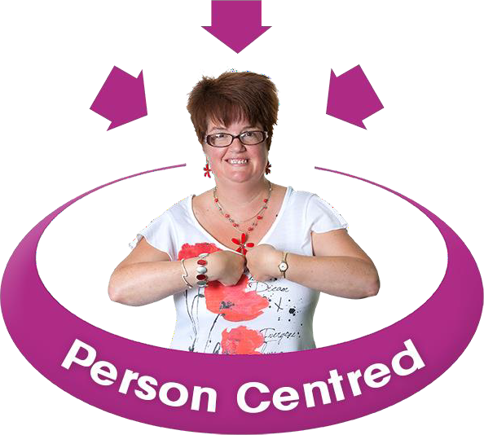
Our Purpose

We know everyone is different and has different needs and wants.

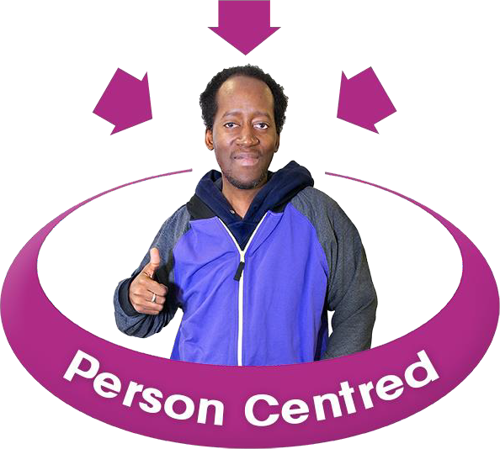
We understand that to help someone, we must know them well.

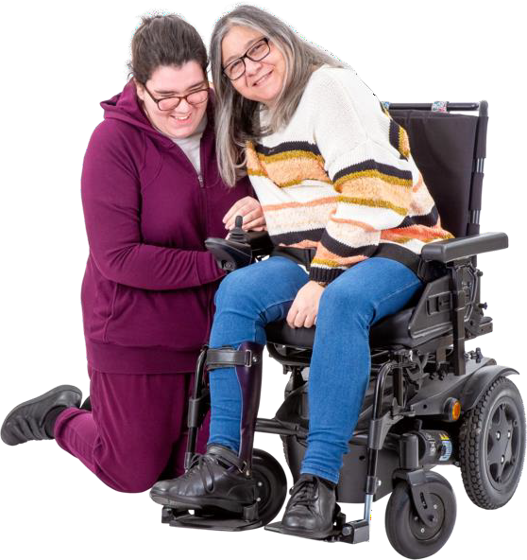
Adult social care helps people who need care and support.

We help them live on their own, safe
and well.

Our Purpose –
Different types of help for people

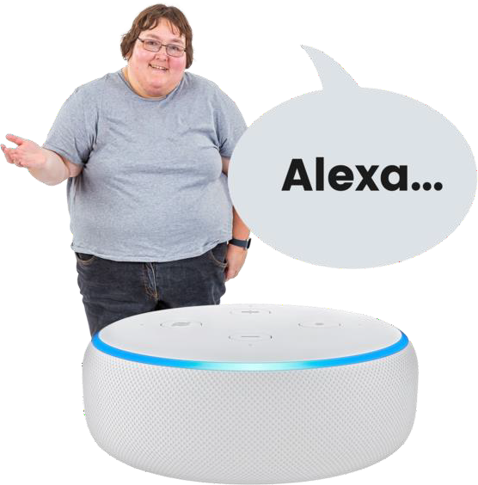
Some help comes from special
tools and gadgets.

This is can be called assistive technology or aids and adaptations.


You can also get advice and information.


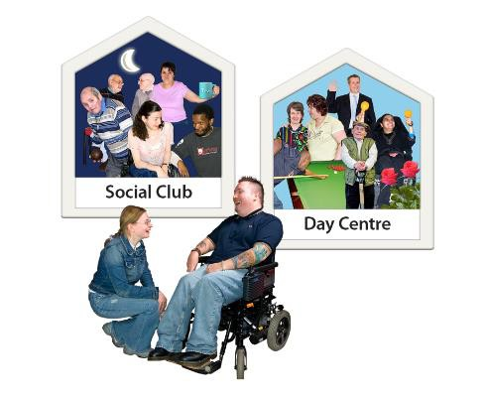
There is help for family members who care for someone without getting paid, sometimes called unpaid carers.

There is help like home care, day
activities, or living in care homes.

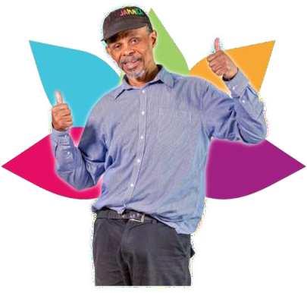
What we will focus on

Wellbeing and Independence:
We will support people to live their best life.


Informed Choices:
We will give people the right information when they need it.


Connected to People:
We will help people stay close to those they care about.


My Support, My Way:
We will support people in ways that suit
them best.

Supporting our residents - People living in Rotherham

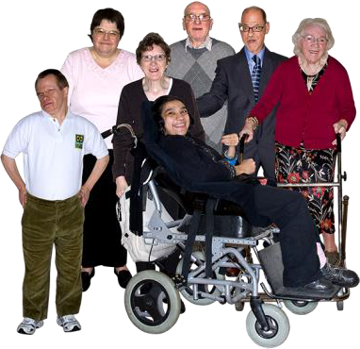
In the year 2023 to 2024, help was given to 5,630 people.

At the end of March 2024, 3,740 people were still getting help.

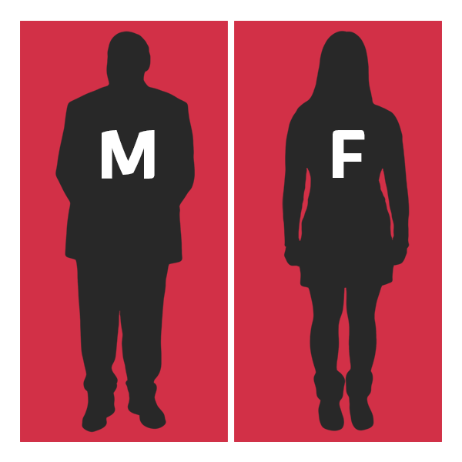
42% of the people getting help said they were male.

58% of the people getting help said they were female.

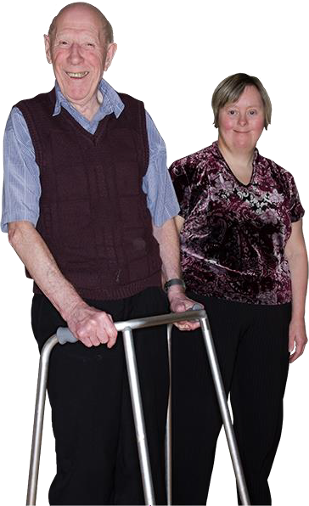
68% of the people getting help are
65 years old or older.

32% are aged between 18 and 64.

More supporting our residents – People living in Rotherham


More people needed help because of a physical disability than any other support reason.

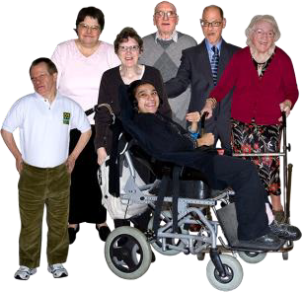
Some people needed help because they have a learning disability.


Others needed help with their mental health.

Some needed help with memory
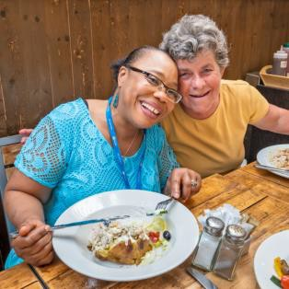
and understanding.

Others needed help with social or sensory needs.

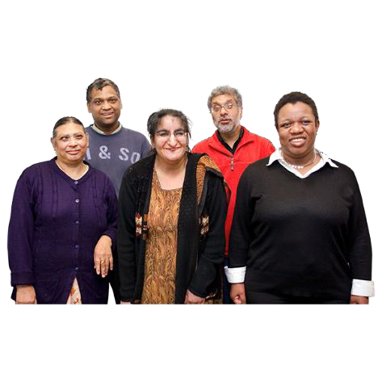
Inclusive communities – Everyone feels included in our community


Most people who get our help are White British. We want more people from other ethnic communitiess to contact us for help.

Ethnicity is your race or background.

Some people did not tell us their

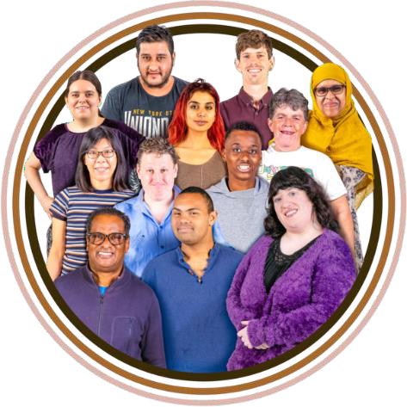
ethnicity.

We work hard to include everyone, no matter their background.

Our goal is to make sure everyone feels they belong.

How we use our resources


In 2022-23, Rotherham spent £86 million
on adult care.

This money helped adults in many ways.

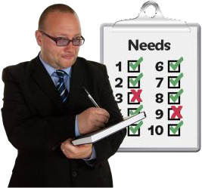
Assessment and care management checks
what care people need.

Some people live in special homes where they get care all the time. This is called supported living or residential and nursing care.

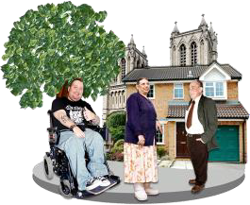
Others get help while living in their own homes. This is called community-based services. They might have someone visit them to help with daily tasks.


It is important to give people information early. This helps them make good choices about their care. Early intervention can stop problems from getting worse.

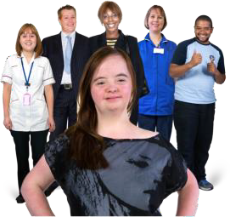
Commissioning and service delivery make sure people get the care they need.
Commissioning means choosing which services are needed and putting them in place.

Good work done in 2023/24

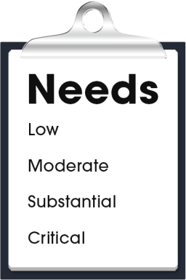
- Rotherham has a new Adult Care Plan.

- New prevention offer.

- Wait times for Care Act Assessments are shorter.

- 2,000 new items of Assistive Technology
have been installed.
Prevention means helping to stop problems before they start.


- We are using more services in the local community.

- We checked how Adult Social Care is doing its job.

- We set up a new Co-Production Board.

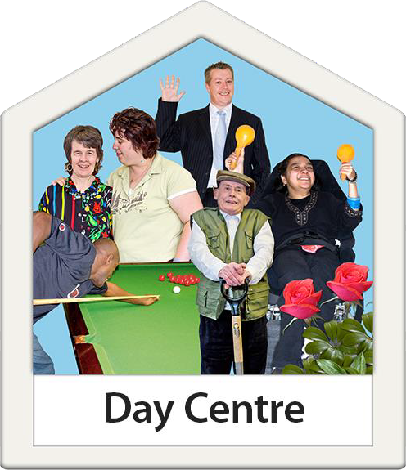
- We helped plan new strategy's for Autistic People and people with a learning disability.

- We started work on the new Castle View centre. This is a new day centre for people with a learning disability and / or Autistic people.

More good work done in 2023/24


  - We kept working on our Borough that Cares plan for unpaid carers.

  - We made a new system to buy services for people with learning disabilities and Autism. This is called a flexible purchasing system.

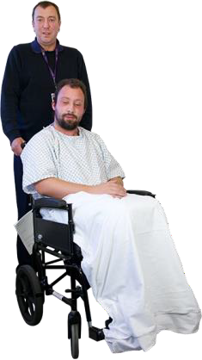
  - We set up a hub to help people leaving hospital. This is called the Rotherham Transfer of Care Hub.

  - The Mental Health Service has changed to help people with mental health problems better.


  - A new team has started to help people with learning disabilities and neurodiverse people find jobs.

  - This team is called the Supported Employment Team. They have already helped over 25 people get jobs.

Neurodiverse is a word used to explain the unique way a person’s brain works. While everyone's brain develops similarly, no two brains function just alike.

What we plan to do next year
This is part of our Adult Social Care Strategy.
It is also in the Council Year Ahead Delivery Plan.

We want to give better information to help young people who are becoming adults.

We will give better information to adults to
make decisions.


We will also support people who care for others without pay with more information. These people are called unpaid carers.



We want to make the Adult Care website easier to use. This will help people find what they need quickly.

We will give clear information about direct payments. This will help people understand how to use them.

More about what we plan to do next year
This is part of our Adult Social Care Strategy.
It is also in the Council Year Ahead Delivery Plan.


We will start a new service to help young people and adults. This will mean they need less help later. This is a prevention service.

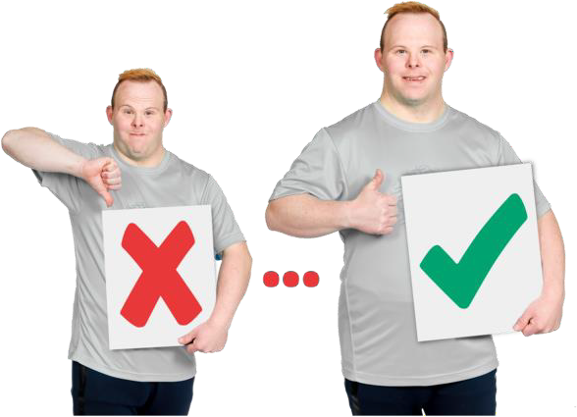
We want to spend more on prevention services run by voluntary sector. This will help people before they need lots of support.

We will offer better help for people in crisis, even at night.


We need to know how well we are helping people. We will do this by listening to what they say.

We will listen to people who care for others. They have important things to tell us.


When we listen, we must also act. This means doing what people ask for.

More about what we plan to do next year
This is part of our Adult Social Care Strategy.
It is also in the Council Year Ahead Delivery Plan.

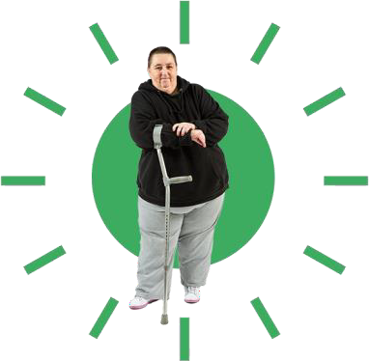
Make sure the voice of the person is at the centre of safeguarding
Safeguarding is helping to keep people safe from abuse or neglect.
There is a website for adult social care. It helps people help themselves.

We want people to be able to check what help they need themselves. This is called self-assessment.


Spend money on new Assistive Technology tools and digital choices to help people. These tools can make life easier for those who need extra help.

Start building Castle View. This place will give
day activities for people who need a lot of help.


Change how we do assessments for young people. This will make it better for everyone who needs help to become an adult.

Look at how mental health services are working. We need to see if any changes are needed to make them better.

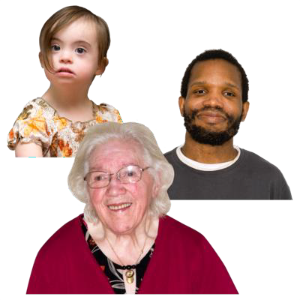
Introduce a new plan for people with autism of all ages.

Introduce a new plan for people with a learning disability.

Voice of the resident – People living in Rotherham
In the last year we received 225 compliments and 59 complaints

Thank you for pulling out all the stops even though you have a 101 things to do, it's greatly appreciated
We wish to express how grateful we are for your prompt response. It really is so reassuring to know that we are fortunate enough to have a strong support mechanism in place like yourself

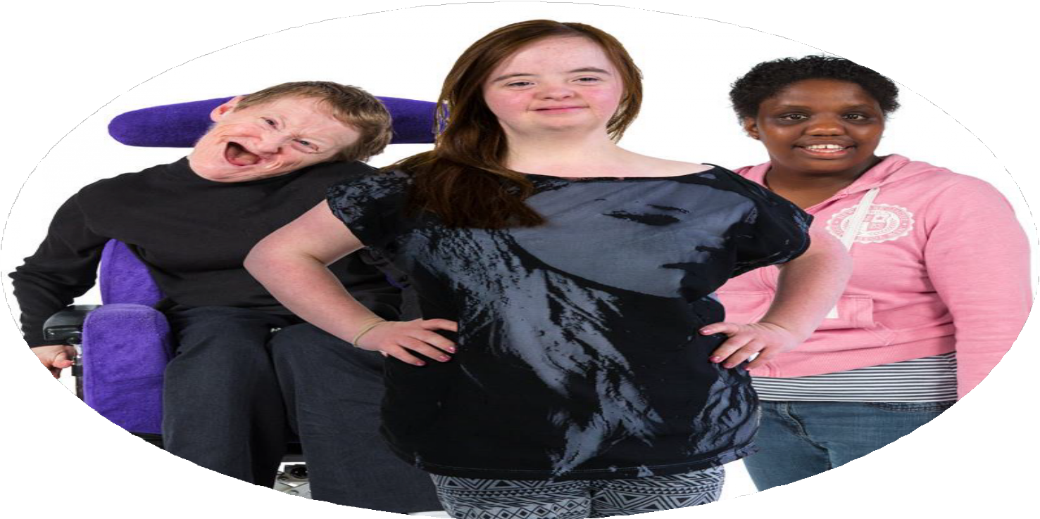


Thank you all of you who cared and looked after [my mum]. You enabled her to enjoy her final months and it was a comfort to us all knowing that she was cared for and treated more like family.
You have been praised as caring, diligent and a pleasure to work with.
They [the individual] were saying how they are confident in approaching you with issues and know that you will give sound advice and signposting to other professionals who may be able to assist.

Voice of the resident – People living in Rotherham


Complaints went down by nearly 5%.

Most people complained about poor communication or waiting too long for an assessment.


Out of 59 complaints, 54 were fixed quickly and did not need more checking.

We got 30% more compliments than last year. This shows we are working hard to help people.


Thank you to our co-production board for helping us with our Local Account.

The Best Work of our Lives

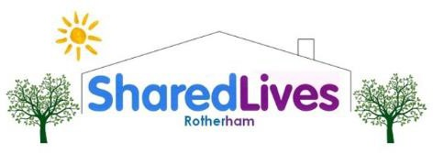
Harry was matched with a Shared Lives Carer who lives nearby. This helps him feel more confident and independent. Harry showed his carer his love for crown green bowls.

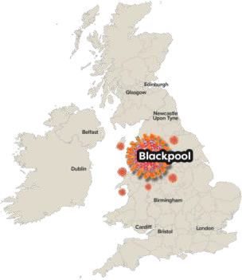
They now enjoy many local events together. They visit the library, have meals at the pub, and go on trips. They also join events organised by Shared Lives. Harry did very well in a recent ten pin bowling evening.

Through Shared Lives events, they met another carer and the person she supports. They have all planned a coach trip to Blackpool and Scarborough soon. They are excited about the trip.

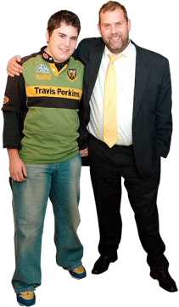
Harry’s father is very happy. He says Harry’s confidence has grown a lot since joining Shared Lives. It has made a big difference in their lives.

Harry loves spending time with his Shared Lives Carer and her family. They do many fun things together. This fits well with his bowling league.

Shared Lives allows you to live as part of a family giving you the opportunities to do the things you would like to do.

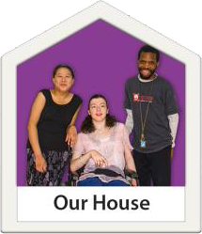
The Best Work of our Lives
John started getting help from Supported Employment in August 2023. He lives in supported housing, so his job needed to not affect his benefits. John worked with Michelle to find a stewarding job.

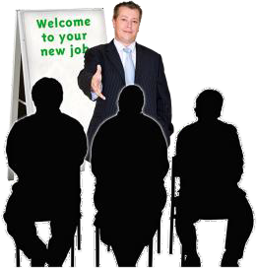
Michelle talked to John's employer about his Learning Disability. The employer was happy for Michelle to help during training. Michelle went with John to his induction to help him understand the rules.

John did his first shift at Rotherham United in November. He has also worked at Doncaster. John has done very well in his job and has kept it for
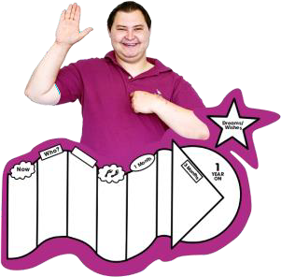
7 months.

John says, "Supported Employment have been brilliant! Michelle, Lauren, and Andy have helped me get a job and with lots of other things. I couldn’t have done it without them.“

John is very happy with the support he has received. He feels proud of his work and the help from Supported Employment.

Supported Employment is a way of helping people with a disability who need extra support to move towards and into work.
A steward is someone who looks after people at a football game.

The Best Work of our Lives


Joseph had experienced a stroke which affected his sight and memory.

He was supported by the Sensory Team to use a white support stick.


The team helped Joseph practice routes within his local community to help his confidence.

This support has allowed Joseph to be part of his local community independently.

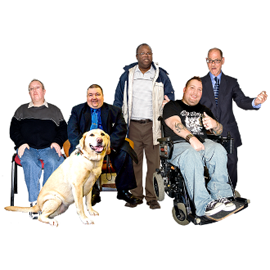
Joseph described this support, and the impact it has had on him, as feeling like ‘winning the lottery’.
Independently means alone and without needing support.
The Sensory Team is a group of people who support people who have difficulties with sight or sound to get the right support.

Here are some useful contacts
- Safeguarding (Customer Contact Team) – adults – 01709 822330

- Safeguarding (M.A.S.H Team) – children – 01709 336080

- Mental Health Crisis Team – 0800 652 9571

- RDASH Switchboard – 03000 213000

- Housing Services – 01709 336009


- Reablement Services – 01709 336096

- Shared Lives – 01709 334948

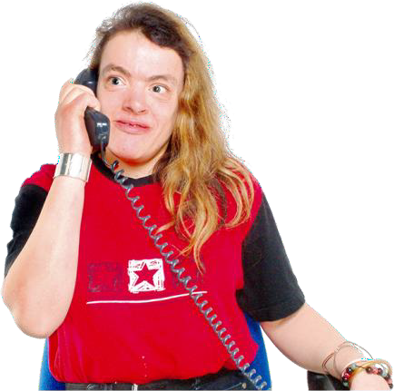
- Supported Employment – 01709 249600

- Age UK Rotherham – 01709 835214

- Citizen’s Advice Bureau – 0808 278 7911



