



**Corporate Parenting Strategy 2024-2027**

***‘If you step in, you must step up’ (What Make Life Good, Coram Voice, 2020)***

**Accountability**

**Partnership**

**Protection**

**Empowerment**

**Proportionality**

**Prevention**

***(Department of Health, six principles of safeguarding)***

**Contents Page**

1. Foreword.
2. Introduction.
3. The Vision: Achieving our Ambition.
4. Corporate Parenting Principles.
5. Our promise.
6. Our Children in Care and Care Leavers.
7. Strategic Priority One: Children and Young People’s Voice.
8. Strategic Priority Two: Placement Sufficiency.
9. Strategic Priority Three: Education and Attainment.
10. Strategic Priority Four: Wellbeing and Independence.
11. Strategic Priority Five: Delivering an Outstanding Leaving Care Service.
12. Strategic Priority Six: Workforce Development
13. Three Year Priorities Summary

About this document

Title: Corporate Parenting Strategy

Purpose: To set out Rotherham’s Corporate Parenting vision and principles for the next 3 years

Updated by: Jane Wood, Head of Service, Children in Care

Approved by: Corporate Parenting Partnership Board

Date: 7.11.23

Version number: 1

Status: Final

Implementation date: Immediate

Review frequency: Refresh every 3 years

Next review date: 7.11.26



**Foreword – Nicola Curley, Strategic Director for Children’s Services**

This three-year strategy sets out how we intend to exercise our corporate parenting responsibility for children in care and care leavers in Rotherham. We know that having the best possible start in life is essential for all children and young people. We also know that many of our children in care and care leavers have experienced adversity throughout their childhoods. This is why we are committed to our legal and moral responsibilities as corporate parents to enable all of our children and young people to thrive and achieve their ambitions.

We take a whole council approach to raising children in care and care leavers, involving officers and elected members, alongside each directorate of the council and partner agencies. This ensures that at the forefront of everyone’s mind is the interests of our children and young people and how to offer them the best opportunities in life.

We will listen carefully to children and young people to shape the services we provide for them. We want to hear what they tell us about their care and use this to continue to be the best corporate parents we can. We will ensure that we do our very best to promote resilience for children and young people, keep them safe from harm and support them to achieve their ambitions.

**Foreword – Cllr. Victoria Cusworth, Cabinet Member for children and young people.**

The children, and young people in our care and those who are care experienced are the responsibility of all elected members and officers at RMBC. We whole-heartedly recognise this, and we are committed to providing an excellent standard of care that firmly puts children and young people at the front and centre of all we do. We are investing in our foster carers, having reviewed fees and allowances and recruitment and retention of foster carers is at the top of our list of priorities. We have also opened 4 children’s homes so far in Rotherham because we know children are, where it is safe to do so, better placed within their communities and where possible we return children home to their families, where risk is reduced and can be managed safely. We are aspirational for our young people and it is our ambition to be child-centred and we are dedicated to listening to children and young people in our care and working with them and not doing to them. Being child centred, does not mean we simply put children at the centre, it means we put the child at the centre and therefore the question we must ask ourselves, over and over again, is - ‘would this be good enough for my child”. This document sets out how we plan to achieve the very best for our children and young people, as corporate parents, and grandparents.

**Introduction**

This plan sets out Rotherham Metropolitan Borough Council’s vision, priorities and commitments to reducing inequalities for children in care and care experienced young people. It also outlines our ambitions for their future and how we want to continue to develop our services and that of other agencies over the next 3 years to enable our children and young people to achieve their ambitions.

Children in care and care experienced young people are a more vulnerable group than their peers, who have not had experience of being in care. Rotherham Metropolitan Borough Council is committed to ensuring better life chances and outcomes for all children in care and care experienced young people and takes the role of Corporate Parenting seriously.

We want to hear the voice of our children and their families, to enable co-production of the right services at the right time, which have a positive impact for children and young people. We have high aspirations for our children in care and care experienced young people and intend to suport them to achieve their potential.

We want our children, young people and families to be supported by a competent, skilled and resilient workforce. This will ensure a whole family approach, which builds upon the strengths of families.

This Children in Care and Care Leavers Plan describes how the local authority and its partners will act as responsible parents to children and young people living within their care and who are care experienced. A Care Leavers Action Plan, November 2023, has been completed in conjunction with this plan and a Children in Care Action Plan is in progress. This will enable tracking of measurable progress around specific targets and these documents should be viewed in conjunction with this plan..

This plan, in conjunction with the Action Plans and the Looked After Children and Care Leavers Sufficiency Strategy 2023–2028 will be monitored and reviewed through performance monitoring and the Corporate Parenting Partnership Board, which will replace the current Corporate Parenting Panel.



**The Vision**

*‘If you step in, you must step up’ (What Makes Life Good, 2020).*

Our children in care and care leavers deserve to be provided with the highest quality service, which supports them to transform their life chances and have better futures.

We expect all of our children in care and care leavers to experience safe, stable and nurturing homes, with strong relationships and high levels of resilience. We intend to support all of our children to develop appropriate independence, to express their views and to make positive choices. In Rotherham we will give every child and young person the best opportunities to be successful in their adulthood.

Engaging children and young people



Clear Planning

Family Approach

**Achieving Our Ambition**

Robust Performance Management

Strong Leadership

Effective Partnership Working

**Corporate Parenting Principles**

Rotherham Metropolitan Borough Council hold the main legal duty of Corporate Parent for children in care. We want our children in care and care experienced young people to be seen as children of Rotherham and for all partners to provide support to make children’s lives better and enable them to achieve their potential.

The Corporate Parenting Strategy describes how the Local Authority and its partners, such as education, health, police and housing, should be responsible parents to children and young people in our care. Corporate Parenting requires everyone who is involved with children in care, including GPs, Teachers, Elected Members and Officers, to understand what good Corporate Parenting requires.

The national Corporate Parenting Principles set out seven principles that local authorities will have regard to when exercising their functions in relation to children in care and care leavers, as follows:

**Principle One:** To act in the best interests and promote the physical and mental health and wellbeing of those children and young people.

**Principle Two:** To encourage those children and young people to express their views, wishes and feelings.

**Principle Three:** To take into account the views, wishes and feelings of those children and young people.

**Principle Four:** To help those children and young people gain access to and make the best use of services provided by the local authority and its relevant partners.

**Principle Five:** To promote high aspirations and seek to secure the best outcomes for those children and young people.

**Principle Six:** For those children and young people to be safe and to have stability in their home lives, relationships and education or work.

**Principle Seven:** To prepare those children and young people for adulthood and independent living.

The Corporate Parenting Principles do not replace or change existing legal duties or replace our values. The principles are intended to encourage local authorities to be ambitious and aspirational for their children in care and care leavers.

As corporate parents elected members and council officials have a statutory responsibility for the wellbeing of children in care. Elected members should play their part in holding officers and partner agencies to account, as well as being proactive corporate parents themselves.

The renewed Corporate Parenting Partnership Board oversees and leads on the progression of this plan, alongside ensuring that all services are responsible for being good corporate parents. Members of the Board lead on ensuring the best outcomes for children in care and care leavers and ensure that we are ambitious parents for our children. Annual Reports from the Board will assist in tracking the progress made.

The focus of all agencies and corporate parents must be;

* Ensuring children in care and care leavers are a priority and have access to effective services.
* Promoting stability and permanence for all children in care and care leavers.
* Enabling all of our children to be happy, healthy and safe.
* Being ambitious for our children in care and care leavers and supporting them to be ambitious for themselves.
* Maintaining lifelong links for children in care and care leavers with family and networks.
* Involving children and young people in their plans and enabling them to support to shape services.
* Ensuring that all of our children in care and care leavers are able to achieve their potential.

**Our Promise**

This promise tells children and young people what they can expect from Rotherham Council and partners, as children in care or care leavers. Rotherham Corporate Parents take our Rotherham Family Approach ethos of striving for excellence and have made the following promises, which came from our children in care and care leavers.

**Promise 1** - We will help you to live in a safe place where you are protected from harm.

**Promise 2** - We will listen to what you have to say and make sure it makes a difference.

**Promise 3** - We will help you to learn and do your best at school and college.

**Promise 4** - We will fully involve you in plans and decisions about you and your future.

**Promise 5** - We will help you to learn new skills as you grown up and become an adult.

**Promise 6** - We will help you take part in activities that you enjoy/are interested in.

**Promise 7** - We will help you to be proud of yourself and celebrate your individual beliefs.

**Promise 8** - We will help you to be happy and healthy.

**Promise 9** - We will help you to explore and be ready for the world of work.

Work is underway to refresh the Children in Care Promise and develop the Care Leavers Charter. Consultation will take place with our children in care and care leavers around this.



**Our Children in Care and Care Leavers**

There are currently 509 children in the care of Rotherham Council (November 2023). This number has declined significantly over the last 12 months, despite there being an increase in unaccompanied young people transferring to Rotherham via the National Transfer Scheme. This is as a result of a high-quality intervention service, which supports to reduce risk and enable children to remain at home with their families.

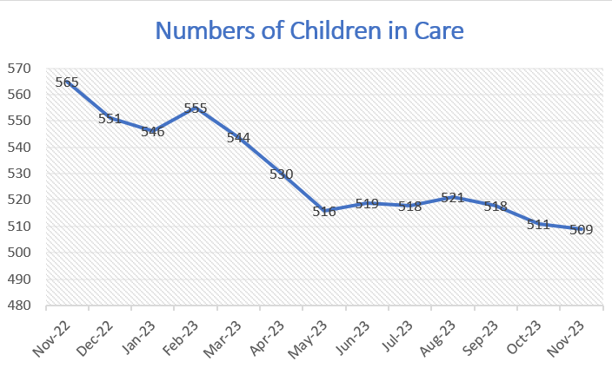

The graph below outlines the age profile of our current children in care population (to the left side of the graph), alongside the percentage of children from BME backgrounds, according to each age range (to the right side of the graph).

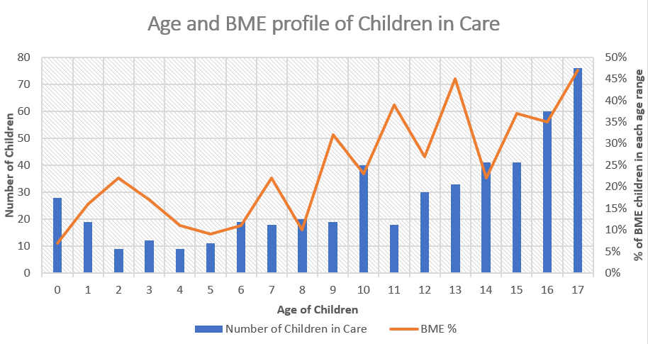

Current legal status for our children in care;

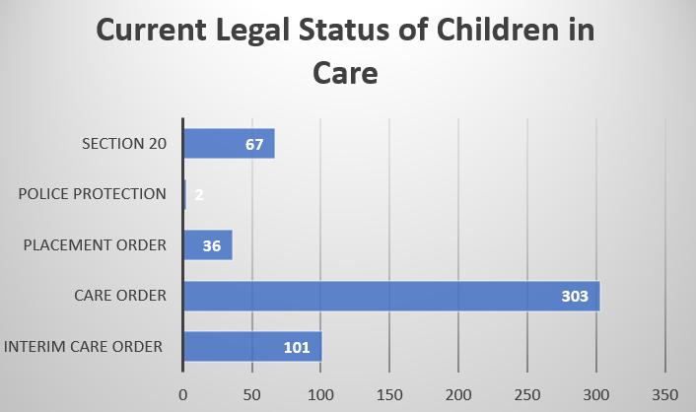

Current placement types for our children in care;

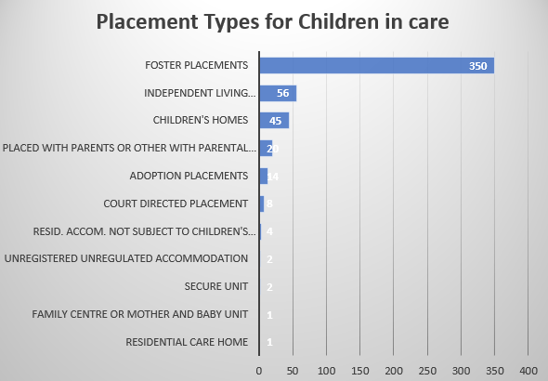

The comparison chart below demonstrates improving placement stability for children in Rotherham. While there is still some progress to be made, this is an improving picture over time.

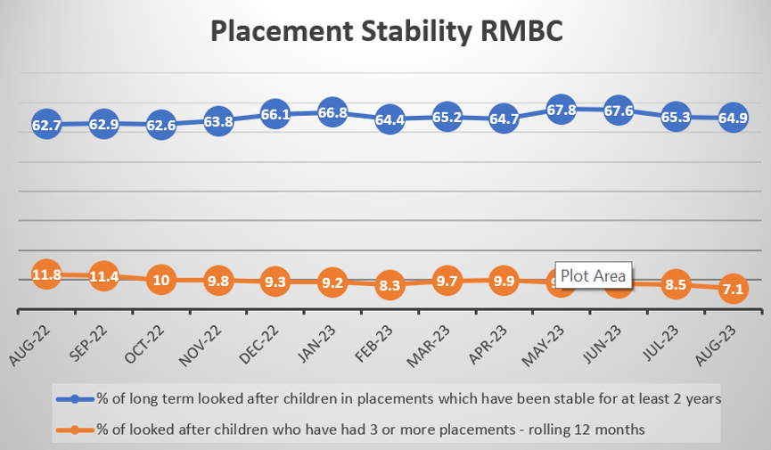

The number of children placed in ‘in house placements’ is shown in the below graph:

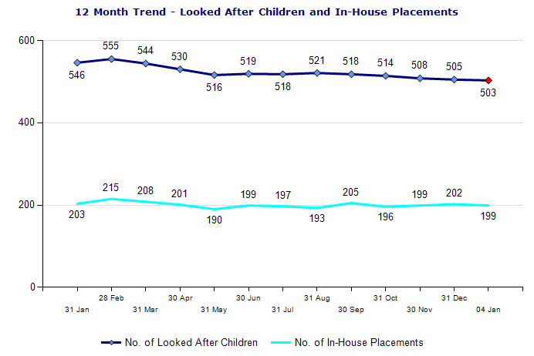

There are currently 323 young people aged 16 and over who are considered to be care leavers. The chart below outlines the numbers of care leavers and their age bracket over the preceding 12 months. This has remained reasonably consistent, though it is to be expected in time that these numbers will reduce in line with the reducing numbers of children in care.

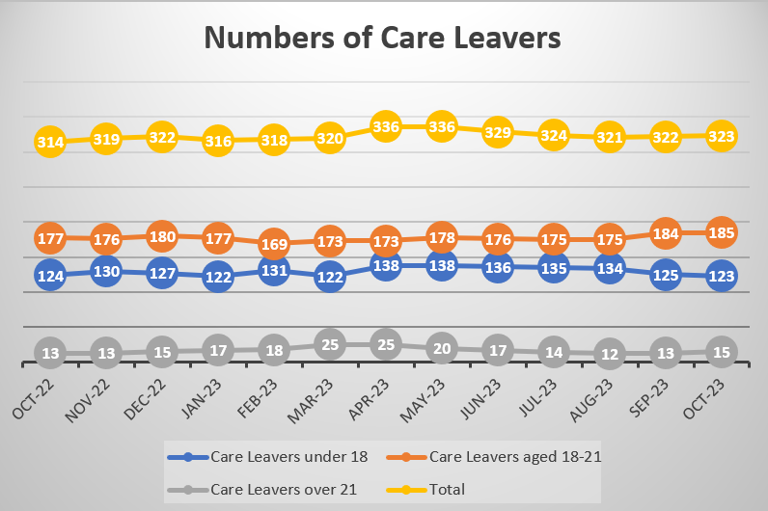

The chart below demonstrates how many of our care leavers are engaged in education, employment and training. It is positive that we know the current status for all of our care leavers and that 70% of young people are engaged in education, employment or training. Our focus is to increase this percentage.

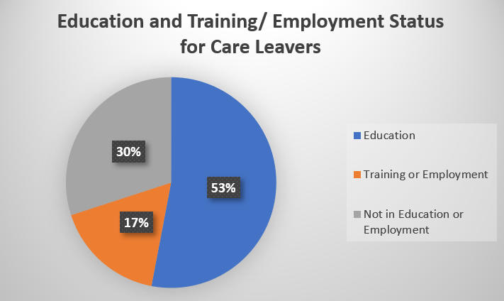

**Strategic Priority One:**

**Children and Young People’s Voice**

Our wish is for all children and young people to be supported to express their wishes, views and feelings and that these influence decisions which are made about their lives. We want to work in partnership with all children and young people, to influence and shape service delivery and review.

**What will we do?**

* Work with managers, the rest of the workforce and partner agencies providing training, advice and guidance around the voice and participation of children and young people.
* Work with care experienced young people to support them to deliver briefing sessions to the workforce around the voice of the child.
* Review the organisation and content of the Looked after Children Council Meetings, alongside children and young people. This will determine how we can improve the experience and attendance at these events.
* Commence a Care Leaver Forum, to support with shaping service delivery and review.
* Review the use of ‘The Journey’ which is the hub to support care leavers to develop new skills, access support and socialise. All of these services will be evaluated to source feedback from young people.
* Continue to and expand on including children in care and care leavers in recruitment and training of foster carers and residential staff.
* Continue to and expand upon children in care and care leavers participation in the Corporate Parenting Partnership Board.
* Arrange regular meetings between the Looked after Children Council (LACC) and the Head of Service for Children in Care to look at how the LACC can influence service delivery and review.
* Develop online surveys to capture the views, experience and feedback of our children in care and care leavers.
* Produce six monthly reports, which evidence good practice across the service and capture the progress of voice and participation for children. These reports will be shared with the Corporate Parenting Panel and the wider workforce.

**What will success look like?**

* The workforce and managers will feel confident about supporting children and young people to express their views, wishes and feelings and to participate in decisions about their plan.
* Children and young people will understand and agree with their care plan.
* Good quality feedback will be collated frequently and used to inform the wider workforce.
* The Council will deliver high quality services, which are led by children in care and care leavers.
* The Corporate Parenting Partnership Board will lead on priorities which are set by children in care and care leavers.

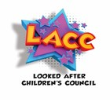

**Strategic Priority Two: Placement Sufficiency**

Rotherham Metropolitan Borough Council have produced a separate Looked after Children and Care Leavers Sufficiency Strategy (2023-2028), which should be viewed alongside this document. It is our intention that every child should live in a stable and nurturing home and that their destination planning is focussed on achieving a plan of permanence as early as possible for each child.

**What will we do?**

* Enhance the quality of services which prevent children coming into the care of the local authority, including Edge of Care, Therapeutic Services, Engage, Evolve.
* Focus intervention on reunifying children with birth parents and family members. A step-down tracking meeting will track young people who may be able to return home, to ensure that plans are progressing effectively.
* Continue to increase the number of in house foster carers with strong recruitment and retention strategies and high levels of support for our foster carers.
* Continue to increase the number of residential homes for children in Rotherham.
* Continue to build strong relationships with providers of children’s homes within a 20-mile radius of Rotherham.
* Actively avoid placing children in emergency and unregulated settings, through registering two children’s homes for emergency use within Rotherham.
* Review children and young people who have had three or more placement moves within 12 months to develop learning, which will be shared via briefing sessions across the organisation.
* Quality assurance and performance monitoring will focus on the quality and progression of care plans, pathway plans and timeliness of intervention.
* In partnership with Housing Services, we will forecast the numbers of single and multi-occupancy housing for young people and ensure advance planning for this.
* Consider an initiative focusing on enhancing a programme of developing independence for young people and sourcing appropriate independent accommodation for them, where they can remain.
* Focus on strengthening pathways with partner agencies for our children in care and care leavers.

**What will success look like?**

* Less children will enter the care of the local authority by being supported to remain in the care of their family where it is safe to do so.
* More children and young people will return to the care of their birth parents or wider family members, when it is safe for them to do so.
* Children and young people will have access to a range of local homes (internal and external options) that meet their needs and support them to achieve their potential.
* Plans of permanence will be progressed quickly for children and young people.
* Less children and young people will be placed outside of the Rotherham.
* All children will be engaged with appropriate support services and education, which reduce the risk of family or placement breakdown.
* When young people leave our care, they will have a range of accommodation options which meet their needs.
* All services will take the Rotherham Family Approach to ensure all Rotherham children and young people are “resilient, successful and safe”, evidenced by Quality Assurance activity.
* Children and young people will be able to access the support they need when they need it because Health, Education and Care Services will share a joint understanding of the needs of children and young people in Rotherham and use this to inform commissioning and service delivery.

**Strategic Priority Three: Education and Attainment**

Nationally we know that children who are looked after do less well in school. Care leavers are less likely to be in further education or employment. This creates disadvantage into adulthood and adults with a history of care are likely to have poorer outcomes later in life. It is our intention that all children in care and care leavers have access to good quality education and training and have opportunities to achieve.

**What will we do?**

* Track attendance for all children in care and take steps to remove barriers to school attendance.
* Focus on raising the attainment and achievements of all children in care and reducing the attainment gap.
* Seek to reduce school exclusions for children in care.
* Work with young people that are disengaged to reconnect them to training, further education and employment.
* Ensure that all children in care get the best possible start in life and are ready to attend school and learn.
* With our partners, we will address the variability of Education, Health and Care Plans.
* Focus on improving the quality of education provision for children and young people.
* Focus on increasing exam pass rates for children in care.
* Focus on increasing the number of care experienced young people who attend higher education.
* Provide more apprenticeships for young people who are care experienced.
* Where children and young people are placed out of area, we will source suitable education for our children in care.
* Arrange safeguarding networking meeting and working groups with education settings, which focus on attendance, attainment and progress and shares good practice.
* Establish joint training opportunities with social care and education.
* Enhance the offer around wellbeing, emotional health and school-based anxiety through Educational Psychology
* Utilise the support and expertise of our Virtual Head Teachers to ensure our children receive the best possible support.

**What will success look like?**

* All of our children in care will have high levels of school attendance and be engaged with their education.
* Our children in care and care leavers will meet their learning potential and achieve qualifications.
* Children will access education local to where they live, which is good or outstanding.
* Where children have additional needs, they will be in education settings which can meet these needs.
* More care experienced young people will be in suitable education, employment or training.



**Strategic Priority Four: Well-being and Independence**

It is essential that all children in care and care leavers are prepared for adulthood and have the necessary knowledge, skills and support to live fulfilling and successful lives.

**What we will do**

* Improve the quality of life story work for all children in care to enable them to understand their journey through care and the reasons why decisions were made.
* Ensure that where appropriate all young people have access to their records and are supported to understand these.
* Ensure that when care experienced young people or children in care are expectant parents that they are prepared for parenthood.
* Support young people to have a good understanding as to how to keep themselves safe in adulthood and how to access appropriate support services.
* Support children in care and care leavers to maintain relationships with birth family and wider family or friend networks to ensure that they have sustainable support in adulthood.
* Support children in care and care leavers to establish new and sustainable support networks.
* Utilise family network meetings and family group conferencing at specific points in a child’s journey to promote lifelong links.
* Encourage and support young people to gain qualifications and skills to assist them to access suitable employment and be financially secure in adulthood.
* Offer one to one and group independence sessions to young people, which will give them skills to be able to manage finances, household bills, relationships and employment.
* Continue to keep in touch with our care leavers to offer advice and assistance where required.

**What will success look like?**

* Our children in care and care leavers will have a full understanding of their journey in care and of decisions which are made about them.
* Our children in care and care leavers will grow into successful adults, who achieve their potential and can keep themselves safe.
* As adults, those with care experience will have sustainable family and friend support networks, who will be there long term to support them.
* Our children and care and care leavers will expand their horizons, try out new things, develop wider social experiences and engage in activities.
* Our care leavers will keep in touch with services and share their experiences, seeking support and advice when they need this.
* Our children in care and care leavers will have knowledge, skills and experience to be able to seek training or employment in fields they feel passionate about.
* More of our young people will go on to attend higher education.
* Our care experienced young people and adults will have positive childhood memories and experiences to reflect on, which will shape their experiences as adults.

**Strategic Priority Five: Deliver an Outstanding Leaving Care Service**

We want all of our young people to be successfully supported to move from our care to independence. We intend to ensure this through a strong partnership, who offer a high standard of care and support to young people. Responsibilities as corporate parents will be shared and understood by all partner agencies in Rotherham. We will have a robust care leaver offer, which is easily accessible and well understood. We understand that success is measured in different ways and we want our care leavers to achieve their individual potential in all avenues of their life, however this may look.

**What we will do**

* Support all young people to sustain positive relationships with family and friends, using family network meetings and family group conferences.
* Produce and deliver robust pathway plans, utilising training and guidance to support staff with the creation of these.
* Ensure our Care Leaver Local Offer provides all young people with the support and assistance they need and that they understand how to access this.
* Focus, alongside our partners on ensuring there is affordable and suitable housing for all of our care leavers.
* Allocate a personal advisor to every care leaver when they reach 16 years old.
* Work with education to provide more training opportunities and apprenticeships for our care leavers.
* Work with other agencies to provide more suitable employment offers for our care leavers.
* Ensure that young people’s cultural and identity needs are met and that there are resources available in the local area to support them.
* Review support services that are available to young people who have experienced trauma and processes for accessing support.
* Strengthen our understanding of the offer to our unaccompanied young people, our compliance with statutory guidance and our understanding and use of best practice.

**What will success look like?**

* Our young people will be well prepared to live independently, or to gain as much independence as possible.
* All of our young people will be able to access education, employment or training.
* Our care leavers will feel safe and experience stability in their lives.
* Our care leavers will have strong family links and networks in to adulthood.
* Our care leavers will know how and where to access support services.
* Care leavers will understand and contribute to their plans.
* Care leavers will have good access to health care.
* Our care leavers will have their cultural and identity needs met and be able to access local resources, which are suitable for their needs.
* Care leavers will be supported to achieve financial stability.

**Strategic Priority Six: Workforce Development**

We want our workforce development to focus on the developmental needs of our social workers, personal assistants and managers. It is our intention that the workforce will work jointly with children and young people to create deliverable plans. We want all of our children in care and care leavers to have a consistent social worker and personal assistant, who knows their needs well and understands their journey.

**What we will do**

* Offer our workforce high quality training and guidance to help them to know how to do their job well.
* Focus on recruitment and retention of social workers and personal assistants.
* Have experienced and skilled managers, who promote good quality practice and child focused decisions.
* Undertake frequent dip sampling and auditing, which will help us to promote outstanding practice for all of our children and young people.
* Hold regular performance meetings, which focus on compliance and quality of practice.
* Support social workers and personal assistants to become experts in practice and focus on their continuous professional development.
* Develop strong working relationships between our workforce and partner agencies.

**What will success look like?**

* Our workforce will be competent and confident practitioners who prioritise the needs of children and young people.
* We will offer our children in care and care leavers the highest standard of practice and intervention.
* Social workers and personal assistants will be well supported by managers and offered high quality supervision, which will drive plans and encourage reflective practice.
* Our plans for children and young people will be SMART, robust and focused.
* Our compliance and quality will be outstanding in all areas of practice.
* All partners will work together to be good corporate parents to our children.

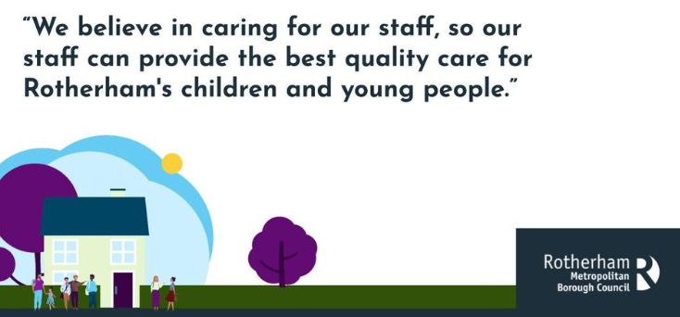

**Three Year Priorities: Summary**



**Working with Rotherham’s children, young people and families to be resilient, successful and safe.**