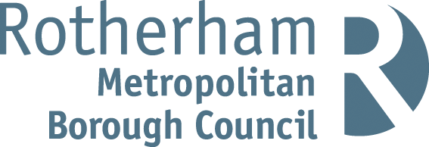

**Rotherham MBC Parking Account 2023 / 24**

Statistical Information

|  |  |
| --- | --- |
| Number of higher-level Penalty Charge Notices (PCNs) issued | 7,847 |
| Number of lower-level PCNs issued | 5,244 |
| Number of PCNs paid | 9,633 |
| Number of PCNs paid within 14 days | 7,369 |
| Number of PCNs against which a formal or informal representation has been made | 2,817 |
| Number of PCNs cancelled (i.e., where an informal or statutory representation is successful) | 1,364 |
| Number of PCNs written off | 674 |
| Number of vehicles impounded | 63 |

The above statistics are accurate as of 22nd October 2024. These statistics can be subject to change on a daily basis due to the ongoing debt collection procedures.

Financial Information

The total income and expenditure of the on-street and off-street parking account for 2023 / 24 was as follows:

**Expenditure £850,382**

**Income**

|  |  |
| --- | --- |
| Income source | £ |
| Penalty Charge Notices | 336,987 |
| Off street paid parking | 454,855 |
| On street paid parking | 301,908 |
| Permits | 119,517 |
| Enforcement Agents (bailiffs) | 30,111 |
| **Total income** | **1,243,378** |

**Net Surplus £392,996**

Note: Income for PCNs issued in 2023/24 may increase because, in cases where PCNs remain unpaid beyond the statutory period, the Council has a policy of registering the debts at the Traffic Enforcement Centre (TEC) at Northampton County Court. This is the Court which deals with all parking debt in England (outside London). Once a debt is registered the debtor is given a further 21 days to settle the debts before Enforcement Agents (formerly known as bailiffs) are appointed. Any income collected after 31/03/2024 from PCNs issued during 2023/24 will be credited to the Parking Account for 2024/25.