OVERVIEW AND SCRUTINY ANNUAL REPORT



2023 / 2024

A NOTE FROM THE CHAIR OF OVERVIEW AND

SCRUTINY MANAGEMENT BOARD, CLLR BRIAN STEELE

I’m delighted to write the foreword to this annual report as the newly elected Chair of Overview and Scrutiny Management Board. I’d like to pay tribute to former Councillor Maggi Clark and all the other members of the Board and Commissions who have steered scrutiny over the past

three years. This report is testament to their hard work and dedication.

In her address to Council in January 2024, former Councillor Clark remarked on the privilege of overseeing scrutiny’s work programme. She focussed on the delivery of scrutiny

recommendations and breadth of activity undertaken in the course of the year, whether that be

reviews, visits, meetings with stakeholders or workshops.

Scrutiny is an important non-politically partisan process carried out by Councillors on behalf of the people of Rotherham. Scrutiny raises standards by challenging the Council’s performance and by checking whether policies and services meet people’s needs. Scrutiny also considers the work of other organisations that partner with the Council to deliver services. Pre-decision

scrutiny maintains strong ties to decision-making by examining the Council’s Cabinet decisions and holding them to account.

In line with the Council’s Constitution, this report presents a summary of the work of the Overview and Scrutiny Management Board (OSMB) and the Select Commissions: Health

(HSC), Improving Lives (ILSC) and Improving Places (IPSC). It also outlines its priorities for the work programmes for 2024-25 and details how, under the stewardship of former Councillor Clark, we have adapted and improved our working processes over the previous twelve months. As with last year’s report, to showcase the impact of scrutiny in helping the Council achieve its goals, this report describes outcomes across all six Council Plan 2022-2025 themes.

I’d like to thank Cabinet Members, partners, senior officers and staff for their contributions and attendance at scrutiny meetings and reviews, the Link Officers for their constructive support and the Governance Team for their commitment and resourcefulness.

As we start a new four year term of office, overview and scrutiny has an opportunity to shape the direction of Council policies and deliver improvements to Rotherham residents. Our work

programme will focus on key priorities and performance, whilst keeping a watching brief on the budget position and service pressures. As in previous years, scrutiny will maintain a degree of flexibility to respond to issues as they arise, whether that be through petitions, Council motions or major events, providing effective and constructive overview and scrutiny.

I’ll give the final words to the Local Government Association Peer Review (2023) which stated:

“There are clear, robust and embedded governance arrangements, accompanied by effective overview and scrutiny mechanisms (…) The peer team received positive feedback on the work carried out by scrutiny through scrutiny reviews, the support Members receive from officers, and the influence scrutiny has on the council's decision-making process, particularly through pre-decision scrutiny – “*there is transparency in decision-making*”.”

# OVERVIEW AND SCRUTINY CHAIRS & VICE-CHAIRS 2023-24

FAQ:

### WHAT IS SCRUTINY?

Scrutiny aims to ensure that public services and policies best meet the

Cllr Maggi Clark, Chair



#### Overview and Scrutiny Management Board

Cllr Taiba Yasseen, Chair



#### Health Select Commission

Cllr Lyndsay Pitchley, Chair

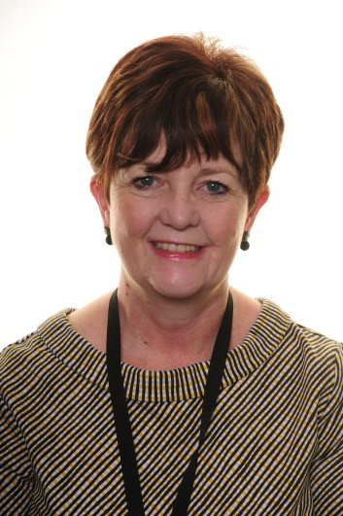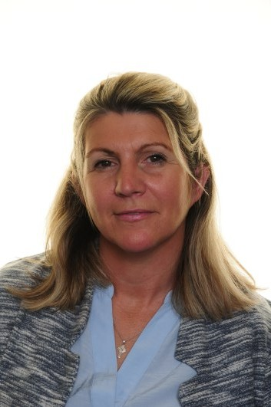

#### Improving Lives Select Commission

Cllr Ken Wyatt, Chair



Cllr Joshua Bacon, Vice-Chair

Cllr Firas Miro, Vice-

Chair

Cllr Wendy Cooksey, Vice- Chair

Cllr Adam Tinsley, Vice- Chair

needs of Rotherham Residents. Scrutiny acts as the check and balance to the Council’s Executive decision makers, the Cabinet, by contributing to policy review and development; holding the Council’s Cabinet and partners to account for decisions and performance; investigating issues that matter to residents; working with Council

officers and partners to improve services.

### WHO IS INVOLVED?

Any Councillor who is not a member of the Cabinet can participate.

Committees also have co-opted members and dedicated officer support. Cabinet Members, Strategic Directors, and representatives of partner organisations are invited to attend meetings to discuss issues.

### WHAT KINDS OF THINGS CAN SCRUTINY LOOK AT?

Councillors and Co-opted Members prioritise issues. The Overview and Scrutiny Management Board manages the overall Work Programme, considering whether

scrutiny can make a real difference by looking at an issue.

### IS THERE ANYTHING SCRUTINY CAN’T EXAMINE?

Individual complaints or regulatory decisions are not appropriate topics for scrutiny.

### IS SCRUTINY POLITICAL?

Councillors across all political groups participate, setting aside party politics to look objectively at issues, basing findings on evidence.

### CAN I SUGGEST A TOPIC?

Yes, contact your ward Councillor to suggest a topic.

**Improving Places Select Commission**

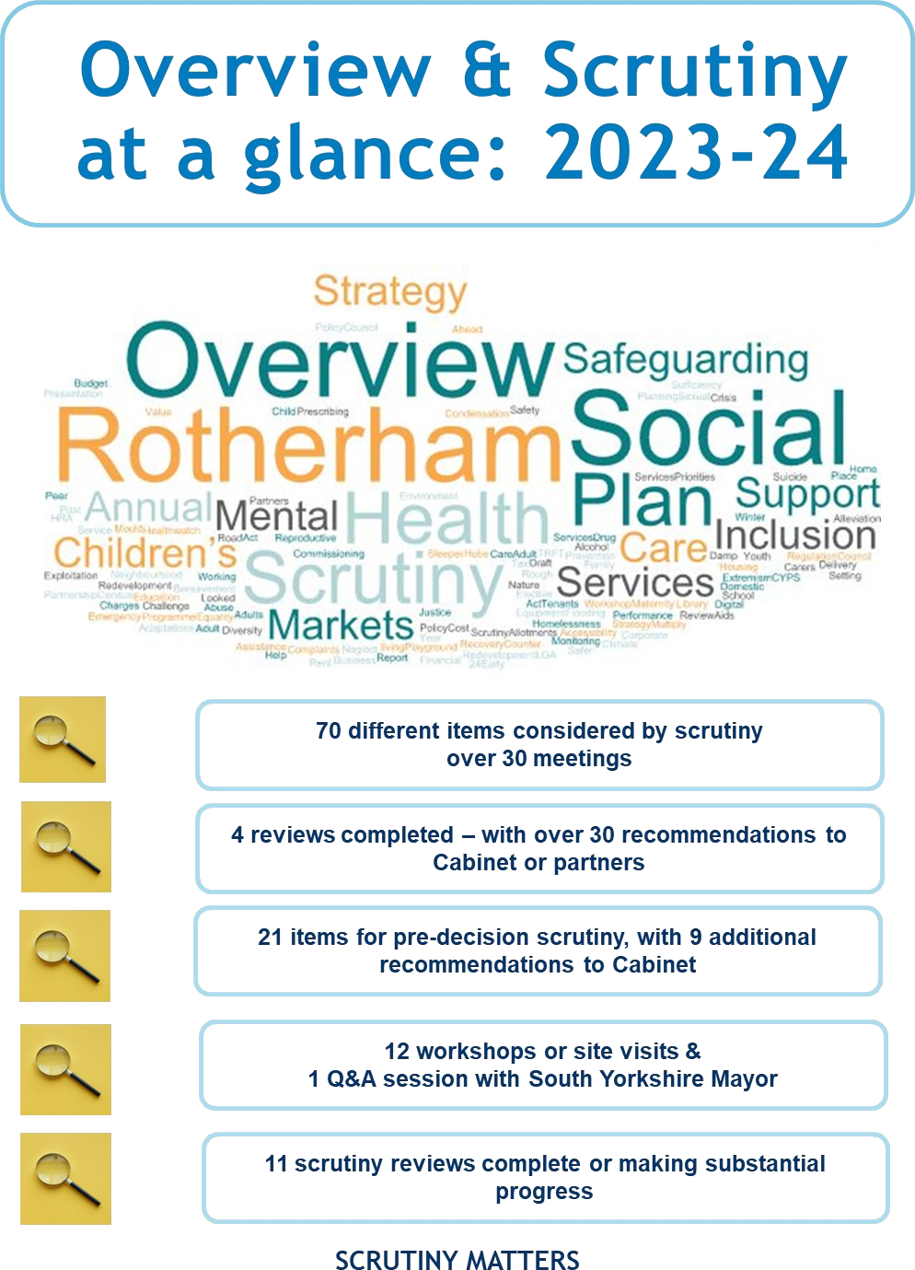

# THEME 1: EVERY NEIGHBOURHOOD THRIVING

## NEIGHBOURHOODS ANNUAL REPORT

As a central theme to the Council Plan, the Rotherham Neighbourhood Strategy articulates what needs to be achieved to make all Rotherham’s neighbourhoods thrive. IPSC has maintained oversight of the annual report and delivery plan and is well placed to comment on progress and impact. Rotherham's model was cited as exemplary in the recent Local Government Association (LGA) peer review.

Members were particularly interested in how the gap between more deprived and less deprived areas was narrowed and how this was evidenced, with a focus on timescales and targets so members could see progress or gaps in provision. Members made proposals to the Safer Rotherham Partnership to support integrated locality working. IPSC was keen to see good practice about enforcement activity and outcomes being shared.

Previous concerns raised by the commission around communications had been addressed

through improvements to the website and creating greater access for officers to post updates directly onto ward web pages. Members requested that inflation and rising costs of materials and labour should be factored into ward delegated budgets going forward.

## BEREAVEMENT SERVICES ANNUAL REPORT

IPSC has closely monitored the delivery of bereavement services through the contract with Dignity Funerals Limited since 2016. As reported last year, the service continues to see a high number local people attending public meetings to articulate their feelings. Whilst examples were given of how Dignity was actively engaging with the community to seek feedback and host events over the course of the year, there were still concerns that some issues relating to burials remained unresolved.

Recent improvements to performance were reported, corresponding with a decline in complaints. Members asked for further details on financial penalties as a result of poor performance and recommended that this be included in future annual reports. An update was requested on current performance, with timescales for resolution for those issues raised by the local people. In reviewing performance, Scrutiny noted that Dignity had provided its Equality Policy, which had been developed in collaboration with the Council. IPSC recommended that religious awareness

training be provided annually.

## CONSULTATION AND ENGAGEMENT

Mindful that effective consultation and engagement was essential to service delivery and community buy-in, OSMB challenged how the Council’s approach to this worked in practice and if improvements could be made. In an informal session, OSMB met with officers from the Assistant Chief Executive's Directorate and considered case studies on projects across different services.

The refreshed consultation and engagement framework was explicitly linked to key strategies such as Equality, Diversity and Inclusion and Customer Experience. Members explored the new framework and how training was being rolled out to embed consistency. Drawing on a strengths- based approach, each of the case studies outlined innovative approaches to consultation, demonstrating how the views of service users, local people and businesses were taken into account.

Outcomes from the session included amending the training and online guidance to stress the importance of informing Members of consultations in their ward. The frequency of training, was increased from quarterly to bi-monthly. Following feedback from OSMB that the current consultation software on the Council Website was not user-friendly or fully accessible to disabled people, proposals were made for a tailored digital software package.

# THEME 2: PEOPLE ARE SAFE, HEALTHY AND LIVE WELL

## DAMP, MOULD AND CONDENSATION POLICY

IPSC considered the draft Damp, Mould and Condensation policy developed in response to the proposed 'Awaab's Law'. The law, drawn up as a result of the tragic death of a two-year boy who suffered prolonged exposure to damp and mould, would require social landlords to fix reported health hazards within specified timescales. Officers outlined how they had engaged with tenants to raise awareness, for example through easy-read leaflets and newsletters.

Further work had also been rolled out with contractors to report and signpost problems early.

As a result of publicity surrounding Awaab's death, there had been a 238% increase in referrals to the service from Council tenants although no additional resources had been allocated by

Government to address greater demand. It was noted, that private sector housing was not covered by the proposed legislation. Whilst advice could be given to private rented tenants to address hazards within the home, there were limited enforcement powers available to the local authority. The Commission highlighted that training should be rolled out to frontline staff, e.g.

Early Help workers, to signpost private tenants. It was also suggested that an easy-read leaflet be developed for private renters and owner occupiers. IPSC requested a further update once

the policy had been implemented to better understand its impact and potential gaps.

## ORAL HEALTH SCRUTINY REVIEW

The purpose of the review, undertaken by members of HSC, was to consider place-based strategic approaches to improve oral health amongst Rotherham residents, including children

and young people, working age adults, and older people. Contributing information considered in this review was prepared by Rotherham’s Public Health team, with input from key services and with an overview from NHS England’s Consultant in Dental Public Health for Yorkshire and the Humber. This outlined many areas of good practice including stressing the importance of oral health to new parents as part of a universal health review. Other examples included the provision of teeth cleaning packs available from food-banks and targeted oral health schemes

for people at risk of greater social exclusion or vulnerability.

The reviews recommendations included taking a prevention-first approach in respect of oral health and seeking expansion of targeted, evidence-based interventions that develop good oral hygiene habits for school age children, such as tooth brushing clubs. As part of a system-wide approach to promoting oral health awareness among all communities, it was recommended that oral hygiene guidance and support should be prioritised to make every contact count.

Although this review specifically focussed on oral health, Members undertaking the review found that improving oral health also relies in part upon improved access to dental care. Members were keen to ensure Rotherham voices continue to be heard in ongoing discussions of reforms designed to increase access for complex and high needs patients.

A the time of writing, the Oral Health Review was progressing through the Governance process

and would be considered further by Health Select Commission.

## MATERNITY SERVICES UPDATE

Maternity Services across England had come under considerable scrutiny in recent years. HSC invited senior nursing and midwifery staff to provide assurance on local services provided by The Rotherham NHS Foundation Trust (TRFT) following the recommendations of the Oakenden and May reviews. In the latest Care Quality Commission results, TRFT maintained a “good” position, evidenced through performance data. Service developments were outlined including links to the Family Hubs initiative. Following concerns raised by Healthwatch and the HSC in previous years, details were given on targeted antenatal provision. Trends from hospital re- admissions of women and babies, alongside data relating to ethnicity and deprivation, were also being monitored to inform improvements to care pathways. HSC explored how the parent’s voice was included and how themes from complaints were triangulated to identify concerns.

# THEME 3: EVERY CHILD ABLE TO FULFIL THEIR POTENTIAL

## EARLY YEARS DRAFT STRATEGY WORKSHOP

ILSC had the opportunity to scrutinise the draft Early Years strategy before its submission to Cabinet. Members recognised the work undertaken by the service to develop the strategy. It was felt that it was clear and understandable and strongly reflected the commitment to co- production and partnership working across Childrens and Young Peoples Services (CYPS), schools, private provision, health partners and the third sector. It was evident that the team had comprehensive knowledge of the sector and understood its strengths and challenges, particularly in respect of workforce development and recruitment (e.g. the extension of the free childcare offer up to 30 hours from September 2025). ILSC recommended that measures to address these pressures were detailed in the action plan accompanying the strategy.

Members were assured that the service was working proactively with families and had good oversight of the children within the early years’ cohort. It recommended that the take-up of services from families at risk of poorer outcomes was monitored and reported. Members were also assured that there were clear inclusive pathways for children with SEND needs to access services and transition to other provision at key stages.

A particular concern of ILSC has been how early years development has been affected by the pandemic. It asked that this activity was captured in the action plan and progress/barriers were identified and mitigated against. Members were supportive of initiatives and events such as Tiny Talkers and recruitment campaigns and agreed to publicise events within their wards and community spaces. It was felt that using their local knowledge, Members could be a good conduit for sharing information and raising awareness of the early years offer.

## PREPARATION FOR ADULTHOOD FOR CHILDREN AND YOUNG PEOPLE WITH SPECIAL EDUCATIONAL NEEDS AND DISABILITIES (SEND)

Following the SEND inspection in 2021, Preparation for Adulthood (PfA) has been an ongoing

area of interest for ILSC and it agreed to hold a spotlight review along with HSC members, to identify the support in place and any gaps in provision. In preparation, ILSC met with Rotherham Parent Carers Forum (RPCF) to better understand the work that the forum have delivered over the past year and learn more about it’s vision and strategic priorities. Their work was impressive and nationally recognised as good practice. As such, their expert voice was a real asset to the borough.

The review focussed on partnership working, school effectiveness and education pathways, inclusion and communications. Overall, members were assured that there were robust partnership arrangements in place. An example of this was the clear focus on the voice of children and young people with SEND, throughout the development of both the Learning Disability Strategy and the Autism Strategies. The strength of these arrangements was

testimony to the commitment of all the agencies involved. In relation to school effectiveness and education pathways, it was acknowledged that there should be a greater emphasis on PfA in mainstream settings, with a recommendation that gaps in provision for academically-abled children and young people be strengthened. Areas for development included how children and young people with SEND could be supported to feel safe in their communities, with a recommendation on how inclusion can be incorporated into ward plans. It was also recognised

that whilst the RPCF had extensive networks of over 2000 families, the majority of SEND families were not currently engaging with services.

Recommendations focussed on ensuring that pathways were clearly communicated to parents and carers; improving engagement levels with SEND families in marginalised communities and ensuring that the voice and aspirations of children and young people in relation to their move into adulthood was reflected. These were to be submitted to Cabinet in the autumn.

# THEME 4: EXPANDING ECONOMIC OPPORTUNITY

## ROTHERHAM MARKETS & LIBRARY REDEVELOPMENT UPDATE

The IPSC review was completed in 2022 with the Cabinet Response presented in early 2023. This update gave an overview of progress since the review was completed. The Cabinet Member welcomed the review and recommendations, outlining that it had been a positive process and the service had taken the recommendations on board which had heavily influenced the project approach.

Since the review, the service had prioritised face to face engagement with market traders and reinstated the voice meetings, prioritising their needs for the duration of the construction phase. As a result of the review, the service altered its approach to accommodate a temporary market rather than work being undertaken in and around vendors. A support package was offered to new traders along with rent concessions to mitigate the impact of construction.

Design plans embraced the recommendation to optimise space for inclusivity and accessibility, with engagement with user groups being key. Rotherham College was seen as a major stakeholder as increasing student and pedestrian footfall was crucial to development of the complex. Progress was also reported such as implementing cashless payments, (alongside continued cash use) and improving IT networks, linking it to the Council’s digital programme. In considering the update, IPSC commented on the communication plans and asked that social media platforms and signage be better used to alert the public and traders of disruption and how these could be mitigated.

## DIGITAL INCLUSION STRATEGY AND ACTION PLAN

OSMB has reviewed digital inclusion over a number of years, recognising that lack of digital access could have a detrimental impact on residents, contributing to educational and economic disadvantage, health inequalities and increased social isolation.

OSMB questioned how local people had contributed to the digital inclusion strategy. The exercise highlighted that older people, people with long-term health conditions and younger people were more at risk of digital exclusion. It was also highlighted that certain locations in the borough faced greater challenges, e.g. East Herringthorpe, Central Rotherham and Maltby. This could relate to lack of access to devices, poor access to reliable broadband or affordability.

OSMB established that the programme would be rolled out in areas of greater deprivation with work underway with health and third sector partners to identify suitable venues for delivery, particularly in those areas which did not have libraries or customer service centres.

The committee requested details of the programme’s long-term sustainability and how existing infrastructure or gaps in provision was mapped. Assurance was given that digital safety was a key part of the programme in place to protect vulnerable people from digital exploitation (e.g. scams). It was also highlighted that the programme would help residents to access online information and improve access to education, job searching or leisure activities.

## MULTIPLY PROGRAMME (YEAR 2 AND 3 APPROVAL).

The Multiply programme was a national scheme to improve numeracy skills, focusing on supporting people aged 19+, without a Level 2 Maths qualification. Over £1 million of funding had been allocated to Rotherham. Benefits included improvements to functional skills levels and labour market outcomes. OSMB established that the programme was targeting providers based within communities as these were best placed to identify learners. In the first eight weeks of the programme, over 500 learners had been engaged. OSMB welcomed the programme and were keen to see how the Council’s recruitment and selection processes recognised and promoted successful completion of the Multiply programme as evidence of an applicant’s numeracy skills.

# THEME 5: A CLEANER GREENER LOCAL ENVIRONMENT

## NATURE RECOVERY REVIEW

Following the Council declaring a nature crisis, the IPSC undertook a wide ranging review, starting its work in March 2023, concluding later in the year. The nature recovery motion committed the Council to a range of activities, including ensuring its response to tackling climate change was extended to compliment the aligned cause of nature crisis. It also committed the Council to continue its work to enhance biodiversity by adopting innovative approaches to support wild flowered areas and ecological approaches to grounds maintenance.

The work included visits to nature sites, discussions with groups and expert witnesses as well as presentations and discussions with officers to understand the challenges of nature recovery. This included Sheffield and Rotherham Wildlife Trust, members of the Rotherham Local Wildlife Sites Panel, South Yorkshire Police as well as our Green Spaces Team, Ecology and Climate Change staff. Members looked closely at the Environment Act and the enhanced duties for local authorities to conserve and enhance biodiversity and report on their actions. Alongside this, Members examined measures to address the impact of climate change and to promote and protect biodiversity.

The recommendations included that consideration to be given to what resources were required to coordinate the Council’s response to the Environment Act 2021 and other statutory reporting, expanding the Councillors’ role as nature champions and how the Council’s estate could

contribute to the Council’s Enhanced Biodiversity Duty. The Cabinet’s response to the report was expected in early autumn 2024.

## FLOOD ALLEVIATION

As part of its annual review of flood management, the IPSC received an update on priority flood defences. It noted that substantial progress had been made to deliver the work, with several projects around the town centre and Parkgate being completed. Members had visited some of the developments including the recently completed improvements to Ickles Lock.

A matter of weeks later, following a period of heavy rain, the River Rother flooded homes and businesses in the Catcliffe and Treeton areas. Having just considered the flood alleviation report, the IPSC were able to comment on what had worked well. In particular, mobilising staff and volunteers to support crisis centres was seen to be effective as was the response of parish councils. Members said that communications were positive and helped them to brief residents on key information.

Other agencies responded speedily to the flood. Learning lessons from 2019, Network Rail removed signalling and electrical components at a much earlier stage, minimising disruption and closure to the station. Defences and improvements to areas that had previously flooded (Kilnhurst) had been effective, with minimal damage compared with previous incidents. However, it was felt that residents were not informed early enough by the Environment Agency that the flood defences in Catcliffe would breach. This led to extensive damage to property and vehicles which may have been less severe had more notice been given.

At a subsequent Council meeting, OSMB was asked to hold a further review into flood defences, with a particular focus on those areas where flood defences were breached in the October 2023 floods.

# THEME 6: ONE COUNCIL

## FINANCIAL MONITORING

OSMB continued to maintain a ‘big picture’ view of financial pressures affecting the Council and provided challenge as to how these might impact on existing budgets and budget setting for

future years, as well as understanding the proposals about prudent levels of reserves. Budget pressures continued to be experienced in children’s residential placement costs and home-to- school transport, with the economic climate remaining turbulent and inflationary challenges adding to costs. OSMB received assurance that there was prudent oversight of expenditure and efficiencies made to maintain spend within agreed budgets.

## BUDGET AND COUNCIL TAX REPORT

OSMB undertook detailed scrutiny of budget proposals in February 2024 ahead of formal budget and council tax setting by the Council in March. In reviewing the Cabinet’s proposals, Members noted the extent of budget savings since 2010 and their impact on services. It was noted that there were no saving proposals in this budget round with the budget focussing on investment in services across each of the directorates. The Cabinet had been able to propose a balanced budget for 2024/25, although faced a projected, potential £6.6m funding gap in

2025/26. The challenge of setting a balanced budget in light of financial austerity and economic conditions were noted, with OSMB commenting that this was due to careful management, and

the prudent financial choices the Council had made were noted.

Scrutiny Members endorsed the budget proposals whilst seeking reassurance in respect of deliverability. Areas for additional investment across each of the Council Plan themes were outlined, with examples including baby packs for new parents and extending cleansing and maintenance of principal towns across the borough. OSMB asked that a report on the impact

and take-up of the baby pack scheme be submitted to OSMB (or nominated select commission)

at a future point when meaningful data had been gathered.

Capital investments were welcomed, in particular the development of a special educational needs and disabilities hub in the town centre. Further investment in flood defences were proposed to make the borough more resilient to a changing climate (£9.8 million), with further consideration given to what measures were required to protect the Catcliffe community from the devastating impact of flooding.

## COUNCIL PLAN AND YEAR AHEAD PROGRESS REPORT

As with previous years, OSMB held Cabinet Members and the Strategic Leadership Team to account for performance against the Council Plan and the Year Ahead Delivery Plan. There had been a decline in performance with 82% of measures being on target, compared with 88% in 2022/23. In respect of unmet targets, it was clarified that as part of management action, key

themes were examined to review and identify areas of challenge. Members had the opportunity to explore key delivery targets such as reducing CO2 emissions, perceptions of safety, capital programmes and investments in neighbourhoods, towns and villages.

## SOCIAL VALUE MID-YEAR REPORT

Following its recommendation for case studies to be provided to communicate successes,

OSMB were pleased to see how the policy had a positive impact on people across the borough. It was noted that the Council had received its annual accreditation for the real living wage, with further work underway with partners to support this initiative. This would make a real difference to household income. It was highlighted that the Council had received the Public Sector Leadership award for its work on social value.

# THEME 6: ONE COUNCIL

## EQUALITY, DIVERSITY & INCLUSION ANNUAL REPORT

OSMB maintained oversight of the Council’s performance in respect of equality, diversity and inclusion through scrutiny of the annual report and challenge of the way equality impact assessments contribute to decision making. OSMB questioned if the Council could achieve “excellent” status under the Equality Framework by 2025. It was outlined that equalities were embedded in each of the Council’s key strategies, with practical examples of how this translated into service delivery (e.g. Rotherham’s hosting of a Women’s Euros football tournament stage). Other examples included co-production of the Learning Disability Strategy with those with lived experience as service users or parents/carers. OSMB interrogated data underpinning service assumptions. Examples included its scrutiny of the draft Early Help strategy, making a recommendation to accurately reflect the number of households with children to target resources effectively and ensuring that statistical data referenced in EIAs were the most up-to- date, including working age population and long-term sickness. Scrutiny also provided challenge to understand the impact of initiatives which had a direct effect on people with protected characteristics e.g. the mental health review and aids/adaptations assistance policy.

## COMPLIMENTS AND COMPLAINTS REPORT 2022-23

Each year OSMB had the opportunity to review annual complaints data and performance in respect of complaints referred to the Local Government Ombudsman (LGO). The focus in considering the report in 2022 was to identify improvements in the recording of compliments, as well as making more effective use of complaints data to inform service improvements. Given the issues raised by the LGO in previous years, OSMB was pleased to note that improvements had been made. The report also reflected that a greater emphasis had been placed on the themes emerging from complaints, actions taken and the impact that this has had on trends as requested by OSMB.

## SAFER ROTHERHAM PARTNERSHIP ANNUAL REPORT 2022-23

Under law, annual scrutiny was required of the decisions and actions taken in connection with the discharge of crime and disorder functions. The Safer Rotherham Partnership (SRP) annual report was presented to OSMB to assist with this requirement.

Detailed scrutiny of SRP’s priorities and performance was undertaken. Clarification was sought about the correlation between child exploitation and deprivation and assurance was sought that this was reflected in the approach taken by SRP. It was highlighted that the partnership adopted an intelligence-led approach to its work which informed the allocation of resources. The development of a strategy to address neglect was also cited as an example of this approach. Increased intelligence reporting was cited as an indicator that training and awareness raising activities were making a difference, particularly in respect of child exploitation. This has been validated in independent reports and reviews which had been considered by OSMB.

Further details were sought on issues identified with the CCTV network and if these issues had been resolved. There has been a significant growth in the number of fixed CCTV assets available in Rotherham. It was expected that issues with deployable units would be resolved later. Assurance was sought that the technical issues were understood and that the partnership would be better placed to anticipate system upgrades in the future.

# REVIEW OF SCRUTINY PROCESSES—WORK PROGRAMMING

### Establish as a starting point: Develop a consistent shortlisting

Following the successful scrutiny strategy day held in April 2023, OSMB reviewed how it

prioritised its work programme to ensure that it looked at issues that matter whilst making sure it remained dynamic and responsive to items which may arise.

**OSMB endorsed the following prioritisation process:**

T

O P I C

criteria

* What are the key issues?
* What is the outcome that we want?

### Agree principles for longlisting:

* Can scrutiny add value or influence?
* Is it being looked at elsewhere?
* Is it a priority – council or community?

⇒ **Time**: is it the right time, enough resources?

⇒ **Others**: is this duplicating the work of another body?

⇒ **Performance**: can scrutiny make

a difference?

⇒ **Interest** – what is the interest to the public?

⇒ **Contribution** to the Council Plan?

### Scrutiny work programme

⇒ provides a framework for scrutiny activity—not a full list

###  should be member led

⇒ is selective—can't focus on everything

###  has regards to what resources available to support—time and information

⇒ usually determined at the start of each municipal year

###  is a living document-reviewed and revised regularly

How does this work in practice?

There is an opportunity for scrutiny members to comment on the work programme at each meeting, with a specific item on the agenda summarising issues to be considered over the course of the year. Members can amend, suggest other items or reprioritise as necessary.

Members can also suggest items for future agendas using the form on the member portal, through the 'Councillor call for action' process or by submitting motions to Council.

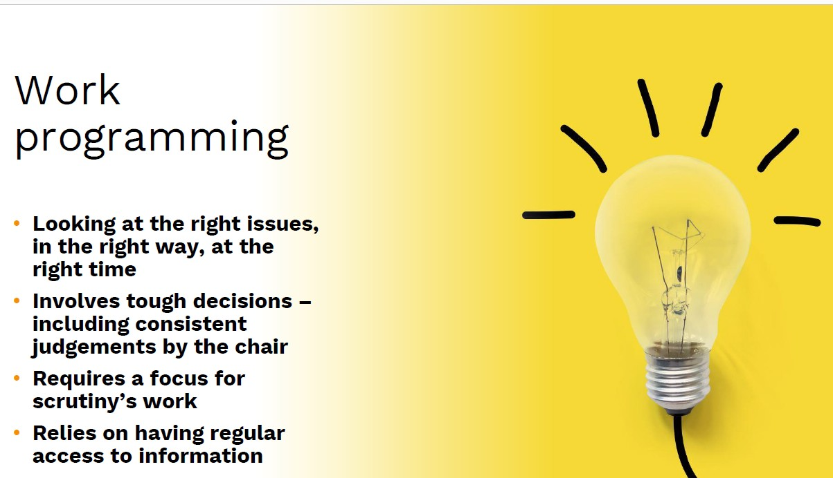In its co-ordinating role, OSMB receives regular updates from each of the scrutiny Chairs or Vice-Chairs on their respective work programmes at each meeting. This keeps a watching brief on the work of scrutiny as a whole, to making the best use of resources and minimising any duplication.

# REVIEW OF LINK OFFICER ROLE

### What are link officers?

Link Officer are senior officers, either Strategic or Assistant Directors, who are assigned to OSMB or a commission to be a champion of scrutiny across the Council and with partners.

To clarify and strengthen the link officer role, Jo Brown, Assistant Chief Executive, led a recent review which came up with the following proposals.

### Purpose

* To champion the importance of scrutiny across the Council and with partners.
* To support the provision of high quality and timely information to aid the scrutiny process.
* To act as a sounding board for the Chair and Vice Chair of Scrutiny Committees based on working knowledge and experience.
* To support the Chair and Vice Chair to focus on improved outcomes for the

borough in all the activity undertaken by Scrutiny.

* To meet regularly with the respective Chair, Vice-Chair and Governance Advisor to assist in work programming and prioritisation.

### Role

⇒ To liaise with the Governance Advisor to identify partners and external witnesses to support Scrutiny enquiries and be a point of contact for external attendees as needed.

⇒ To provide strategic advice to scope reviews, to clarify expectations, anticipated impact and added value of Scrutiny involvement and support wider discussions with Chair/Vice Chair and Select Commission members ahead of adding items onto working programmes.

⇒ To support Governance Advisors and Scrutiny members to align work programmes and scrutiny reviews to Council Priorities and Year Ahead Delivery targets.

⇒ To offer advice and guidance to commissions on the timing of work programme items, par- ticularly if they’re also to be considered in more than one arena.

⇒ To work with officers supporting scrutiny where they might require advice and support. .

⇒ To work with officers across the Council as required to enable their effective participation in scrutiny.

⇒ To undertake early resolution if issues arise.

Link Officers meet with the respective Chair, Vice-Chair and Governance Advisor on a quarterly basis to assist scrutiny’s management of its programme and prioritisation. They also are ex- pected to attend, where possible, meetings of the OSMB and Select Commissions

|  |  |  |
| --- | --- | --- |
| Committee | **Link Officer** | **Position** |
| Overview and Scrutiny  Management Board | Jo Brown | Assistant Chief Executive |
| Health Select Commission | Ben Anderson | Director of Public Health, Adult Care, Housing & Public Health |
| Improving Lives Select Commission | Kelly White | Interim Assistant Director, Early Help and Family Engagement,  Children and Young Peoples Services |
| Improving Places Select Commission | Andrew Bramidge | Interim Strategic Director, Regeneration and Environment |

# SCRUTINY REVIEW PROCESS

### What is a scrutiny review?

A scrutiny review is a detailed investigation gathering evidence to make recommendations for change. It can be a short “spotlight” review taking place over one or two meetings or depending on the complexity, a longer, more in-depth review. It can be undertaken by a full committee, or more usually, by a small task and finish group of councillors. Residents, experts or people with lived experience can be co-opted onto the task and finish group or invited to give evidence on

the issue under scrutiny. This is how the process in Rotherham works in practice:

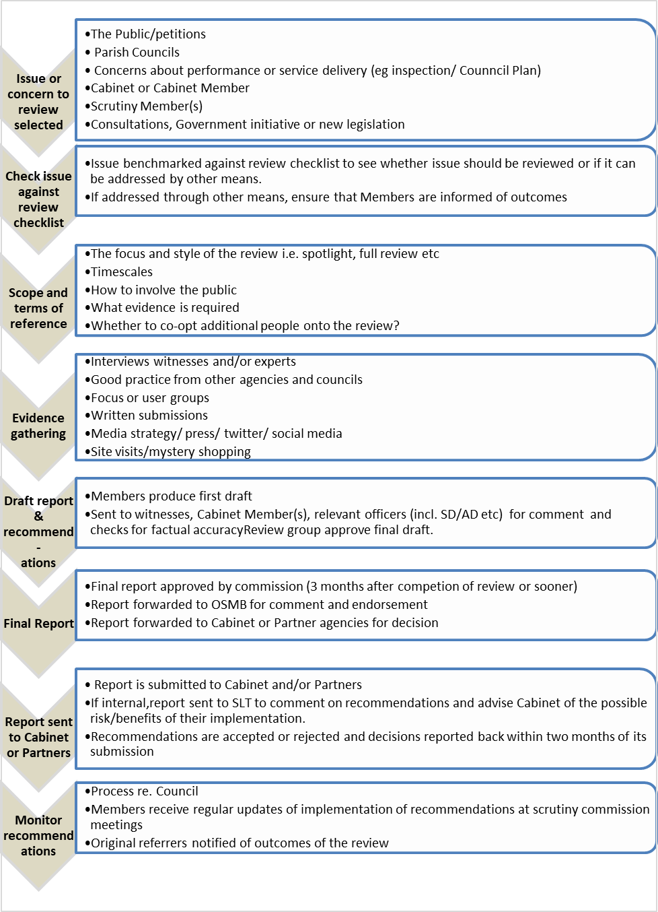

# SCRUTINY REVIEW TRACKER

Scrutiny recommendations to Cabinet have been reported over many years. In order to monitor the progress of the implementation of accepted review recommendations and their impact, a review tracker has been developed to capture the following information:

Details of key information and dates

What prompted the review (member request, Council motion, call for action etc),

Evidence of progress,

Accountable directorate and/or external body

Link to Council Plan theme.

The tracker is reported to the Strategic Leadership Team on a quarterly basis, in order that progress is maintained on the implementation of agreed actions and any barriers can be overcome at an early stage.

Reporting to OSMB for the first time in December 2023, the tracker provides updates on the status of reviews and specific recommendations completed. It is intended that an annual update is provided on completed reviews in order that the long-term impact of scrutiny reviews and recommendations can be captured.

Of the reviews reported to Council, the majority of recommendations are substantially complete or ongoing. All scrutiny recommendations considered by Cabinet have been accepted.

**Post Abuse Support** - Status Complete (6 recommendations complete and 2 ongoing).

**External Funding** – Status Complete (4 recommendations complete).

**Community Hub** – Status Complete (3 recommendations complete).

**Young Carers** – Status In Progress (1 recommendation complete; 1 ongoing and 1 in progress).

**Climate Change** – Status Complete – (5 recommendations complete).

**Market engagement and recovery** – Status ongoing (8 recommendations ongoing).

**Cultural Strategy** – Status Complete (3 recommendations complete; 1 ongoing).

**COVID-19 Care Home Safety** – Status Complete (4 recommendations complete).

**Access to primary care** – awaiting response.

**Modern Slavery** – Status in progress.

**Impact of Selective Licensing** - Status in progress.

# RMBC’S CALL-IN PROCESS

The Council’s Constitution requires that OSMB monitors the procedures relating to scrutiny, call-in and urgency annually, making recommendations to Council for review as necessary. What is call-in?

There may be instances when the Cabinet takes a decision that some councillors believe should be changed. Call-in allows councillors who do not sit on Cabinet to ask that such decisions are reconsidered by the decision maker.

Under the Local Government Act 2000, Councils operating an ‘executive’ (or Cabinet) model of governance are required to establish arrangements which allows for executive decisions made but not yet implemented to be 'called in' for consideration by an overview and scrutiny committee.

### How does it work?

Each council will have its own processes for how call-in operates, including timescales, what

decisions can or can’t be called in and the number of councillors needed to support a request.

Rotherham’s call-in process is set out in the [Overview and Scrutiny Procedure Rules,](https://moderngov.rotherham.gov.uk/documents/s130366/Appendix%202%20-%20Overview%20Scrutiny%20Procedure%20Rules%20-%20November%202020.pdf) Appendix 2, Part V of the Constitution. The Overview and Scrutiny Management Board is the designated committee to receive call-in requests.

There have been very few call-in requests in Rotherham historically. Over the term of the last Council (2021-24), no call-in requests were received.

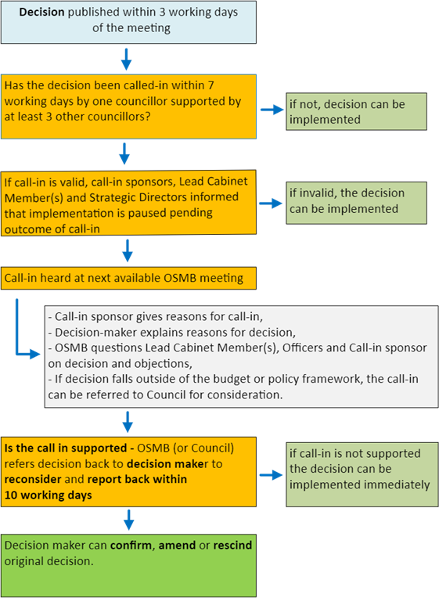Call-in is one of many tools at scrutiny’s disposal to influence decision making and should be regarded as a measure

that is only needed in

*exceptional* circumstances.

In 2016, Rotherham adopted a system of ‘pre-decision’ scrutiny which allows OSMB

to review Cabinet reports prior to decisions being made and report back its

recommendations directly to Cabinet.

This means OSMB has the opportunity to question proposals and make additional recommendations, prior to the decision being made. To date, all recommendations on pre- decision reports have been accepted by the Cabinet.

**Summary of Rotherham’s Call-in Process**

# Overview and Scrutiny Chairs & Vice-Chairs 2024-25

Cllr Brian Steele, Chair, Overview and Scrutiny Management Board



Cllr Joshua Bacon,

Vice-Chair, Overview and



Scrutiny Management Board

Cllr Eve Keenan, Chair, Health Select Commission

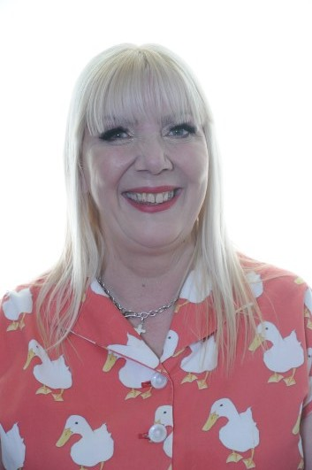

Cllr Taiba Yasseen, Vice-Chair, Health Select Commission

Cllr Lyndsay Pitchley, Chair, Improving Lives Select Commission

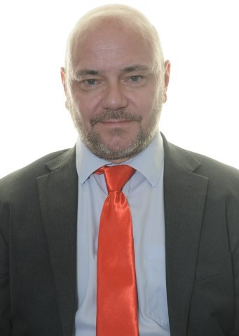

Cllr Stuart Knight, Vice- Chair, Improving Lives Select Commission

Cllr Cameron McKiernan, Chair, Improving Places Select Commission



Cllr Adam Tinsley, Vice- Chair, Improving Places Select Commission



# Overview and Scrutiny Work Programme 2024-25

|  |  |
| --- | --- |
| **OSMB**  Children Commissioner’s Takeover Challenge  – meeting with Youth Cabinet  Flood Defences (following motion No confidence in the ability of the Environment Agency to protect Rotherham residents from flooding)  Spotlight Review - Byelaws/Life saving  equipment  Referral from Council – Petition “Rotherham's Commitment to a Permanent Ceasefire and To Promote Peace in Palestine and in the Region”  Council Plan and Year Ahead Delivery Plan Safer Rotherham Partnership Annual Report | **Health**  Oral Health Review  LGA Adult Care Peer Review  The Rotherham NHS Foundation Trust (TRFT) Annual Update  Place Partners Winter Planning Annual Update  Sleep Pathways  Social Prescribing (Following Scoping)  Healthwatch Update |
| **Improving Lives**  CYPS Performance Elective Home Education  Early Help Strategy Update- Year 1 Carers Strategy Update  Corporate Parenting Partnership Board Annual Report  SEND Sufficiency Update  Rotherham Safeguarding Childrens Annual  Report  Child Criminal Exploitation | **Improving Places**  Housing Strategy Update Road Safety  Flood defences (with OSMB)  Thriving Neighbourhoods Annual Report Bereavement Services Annual Report  Tenant Scrutiny Report: How Rotherham Council Supports New Tenants  Nature Recovery Strategy  Allotments Annual Update  Roads Maintenance Budget Reduction Impact  Ten Year Plan for Rotherham Town Centre  ‘Awaab’s Law’ Impact Update |