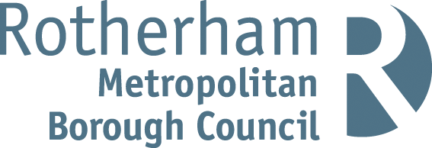**­­**

**ROTHERHAM RESIDENT SATISFACTION SURVEY**

**Wave 14**

**2024**

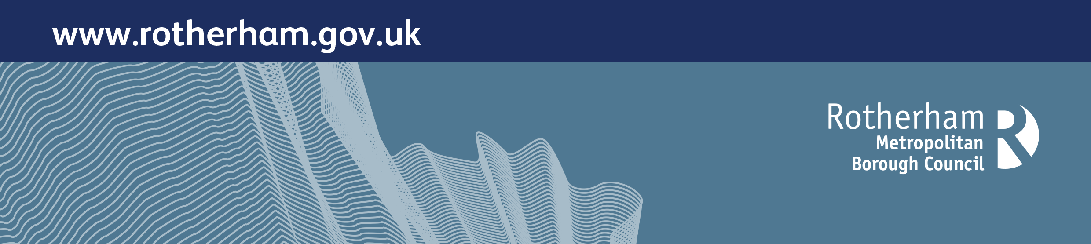

**ACKNOWLEDGEMENTS**

The Council would like to thank Yonder for conducting this polling, the participants in Rotherham who took part in the local survey and those who took part in the LGA national survey.

**CONTENTS**

Introduction ................................................................................................................ 4

Methodology .............................................................................................................. 5

Key findings ............................................................................................................... 6

Resident satisfaction measures ...................................................................... 6

Confidence in the Council ............................................................................... 11

Feelings of safety, optimism and cohesion ..................................................... 11

Rotherham’s Survey Results ......................................................................................13

Satisfaction with local area as a place to live .................................................. 13

Satisfaction with how the Council runs things ................................................. 13

Provision of value for money by the Council ................................................... 14

Responsiveness of the Council ....................................................................... 14

Keeping residents informed ............................................................................. 15

Trust in the Council .......................................................................................... 15

Confidence in the Council ................................................................................ 16

Feelings of safety ............................................................................................. 17

Feelings of optimism ........................................................................................ 18

Community cohesion perceptions .................................................................... 19

Satisfaction with Rotherham as a place to live ………………………………….. 20

Satisfaction with specific services ………………………………………………… 21

Annex A: Polling questions …...................................................................................... 22

**INTRODUCTION**

During 2015 and 2016, the LGA undertook four polling surveys to find out what residents of Rotherham thought about Rotherham Metropolitan Borough Council (the Council) and the borough in general. The survey formed part of the improvement activity within the authority which began in May 2015, with the first survey taking place in June 2015. The survey asked about satisfaction with the Council, perceptions of value for money, responsiveness, trust and confidence in the Council, and satisfaction with aspects of life in Rotherham.

Following the LGA’s support related to resident satisfaction ceasing, the Council has continued the surveys to monitor satisfaction levels and the extent to which the views of residents have changed over time. The Council has also wanted to explore residents’ perceptions of safety, optimism about the future of the borough and town centre, and views on community cohesion.

This report details the findings of the most recent residents’ satisfaction survey (Wave 14). It makes comparisons with the previous thirteen waves of the survey in Rotherham and with the LGA’s most recent national survey of British residents. The latest national poll was made up of a representative random sample of 1,000 British adults (aged 18 or over) and was carried out by telephone by Yonder between 18th June and 3rd July 2024. The Rotherham survey sample was made up of 500 adults who were polled between 11th July and 14th August 2024.

Comparing Rotherham’s results to the national picture provides useful context although many additional factors will influence resident views of councils at a local level. These include local demographics, social and economic factors, and media coverage prior to the survey. Therefore, whilst the results of the polling provide a good high-level indication of resident views of Rotherham and its council, it is important that they are seen as complementary to a wider approach to understanding and responding to communities at the local level.

The polling this year took place against a national backdrop of a recent general election and subsequent change in government, alongside challenging economic circumstances for many (including the cost-of-living, higher interest rates and inflation leaving a legacy of increased food, energy, mortgage and rental costs). There were also tensions around community cohesion, with incidences of public disorder taking place across the UK and in Rotherham in early August. Globally, the lasting effects of the pandemic together with international conflicts continue to impact society and the economy.

As noted in the Methodology section, the relatively small sample size in Rotherham means that small variations from one survey wave to another should not be interpreted as indicating a significant change in opinion. The results of this survey should be seen in the wider context provided by the patterns of the previous thirteen surveys since 2015.

**METHODOLOGY**

In July and August 2024, a statistically representative random sample of 500 Rotherham residents (aged 18 or over) was polled mainly by landline telephone using quotas set by age and gender. The data was further weighted to reflect the age, gender, and social grade profile of Rotherham. This ensures that the sample is as representative of adults in the borough as possible, as there is often a bias in the profile of people who respond to any survey. The use of landline telephones has become increasingly problematic in surveying young adults aged 18-34, so additional people were polled by mobile phone to boost the number of younger respondents. Previous surveys took place in June 2015, December 2015, June 2016, December 2016, June 2017, February 2018, June 2018, December 2018, June 2019, June 2020, June 2021, June 2022 and June 2023.

The questions used in the Rotherham survey are outlined in Annex A. Most of the questions also feature in the LGA’s regular national polling on resident satisfaction. These questions were developed and tested by the LGA and Ipsos MORI, then modified and agreed via consultation with wider local government. Core questions have been repeated across all fourteen Rotherham surveys. Additional questions about perceptions of safety, community cohesion and optimism have also been asked since June 2017. A local question about satisfaction with Rotherham as a place to live has been asked in each survey apart from Wave 5. In Wave 13, a new question was introduced that asked about satisfaction with specific council service areas, and this question has been continued into Wave 14.

Where tables and figures report the base number, this description refers to the whole group of people who were asked the question. The number provided refers to the unweighted number of respondents who answered each question.

As mentioned, this report includes comparisons with the LGA’s national results, where the questions asked are the same. Differences between the national survey and Rotherham’s results are only highlighted within the report where they are statistically significant. The relatively small sample size of the Rotherham surveys means that only a difference of five per cent or more between different survey results indicates a statistically significant change. Caution is needed when comparing the results of individual surveys and interpreting small variations between waves. Where results fluctuate it can be useful to consider the average of several waves combined to provide a larger sample size and reduce the effect of random variation.

Please note the following when reading this report:

* Throughout the report, percentages in figures and tables may add up to more than 100 due to rounding.
* The following conventions are used in tables: ‘*’ - less than 0.5 per cent; ‘0’ – no observations; ‘-’ – category not applicable/data not available.
* Where percentage increases or decreases are mentioned, this is in relation to percentage points rather than overall percentage increases or decreases (unless otherwise stated).

**KEY FINDINGS**

The Council commissioned a fourteenth survey (known as Wave 14) to capture what residents of Rotherham currently think about their local area, the wider borough, and the Council. The questions included six measures of resident satisfaction, which also feature in the LGA’s regular national polling. Additional questions were also asked about residents’ feelings of safety, optimism about the future of the borough and town centre, their views on community cohesion and (from Wave 13 onwards) satisfaction regarding specific council service areas.

From the initial survey in 2015 (Wave 1) to August 2024 (Wave 14), the direction of travel locally across the survey questions is mixed, with fluctuating responses showing some improvements and some decline in satisfaction levels. On some measures, gaps between Rotherham’s results and the national average have tended to narrow over recent surveys where comparison is possible. This is mostly as a result of a continued decline in levels of satisfaction in local councils at a national level, together with satisfaction levels staying the same or improving slightly at a local level. This is most notable on the national measures for acting on resident’s concerns (with a local improvement between Waves 12 and 14 of ten percentage points compared to a decline of five percentage points nationally) and value for money (with a national decline of fourteen percentage points between Waves 11 and 14). Between Waves 11 and 14, the national measure for trust in local councils has fallen by 13 percentage points, whereas locally it has remained the same.

**Resident satisfaction measures**

The results from Wave 14 point to four key features of resident satisfaction (see also Figure 1).

* **Satisfaction with local area as a place to live**: The great majority of Rotherham residents are satisfied with their local area as a place to live (75 per cent of respondents were ‘very’ or ‘fairly’ satisfied). However, in Wave 14, satisfaction levels have declined in Rotherham and are now the same as the national average (75 per cent).
* **Satisfaction with the way the Council runs things**: 50 per cent reported feeling ‘very satisfied’ or ‘fairly satisfied’ with the way the Council runs things – this represents a fall of 9 percentage points between Wave 13 and Wave 14 and is below the Rotherham average of 53 per cent across all fourteen surveys. Nationally, levels of satisfaction with councils have been consistently falling over recent surveys (from 67 per cent in June 2021 to 55 per cent in June 2024).
* **Trust in the Council**: In Wave 14, 51 per cent said they trusted the Council ‘a great deal’ or ‘a fair amount’ (similar to the figure from Wave 13). While nationally the figure for trust in the council is slightly higher than in Rotherham, it has been consistently falling over recent surveys, from a high of 66 per cent in June 2021 (Wave 11 to 53 per cent in June 2023 (Wave 14). The average level of trust in the Council has increased from 46.5 per cent across the first five Waves, to 52.4 per cent across the most recent five Waves (10-14).
* **Provision of value for money**: 38 per cent of Rotherham residents agreed that the Council provides value for money, a slight increase on the Wave 13 figure of 36 per cent. This is the same percentage as the national figure (38 per cent in June 2024) and the first time that the Rotherham and national data has aligned on this measure. Nationally, the figure on value for money has fallen consistently from 52 per cent in June 2021 to 38 per cent in June 2024.

Satisfaction levels on how **well-informed** the Council keeps residents have decreased between Wave 13 and Wave 14 (from 50 per cent in June 2023 to 45 percent in August 2024) and remain lower than the national figure of 52 per cent. Positive responses on this measure have fluctuated by up to fifteen percentage points across the polls.

Views on the **responsiveness** of the Council in Wave 14 at 52 per cent showed a small improvement of one percentage point from Wave 13 (51 per cent) and were better than the national average of 47 per cent (which had decreased by five percentage points from 52 per cent in January 2023).

**Figure 1 Rotherham key findings (Waves 1-14)**

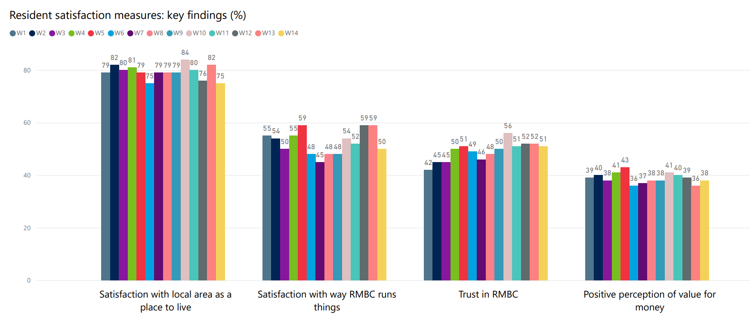

Base (all respondents – figure includes only those who gave a positive reply): June 2015: 531; Dec 2015: 528; June 2016: 520; Dec 2016: 520; June 2017: 520; Feb 2018: 517; June 2018: 515; Dec 2018: 515; June 2019: 515; June 2020: 504; June 2021: 503; June 2022: 501; June 2023: 500; August 2024: 500

**Figure 1** summarises the survey results for four indicators of resident satisfaction used in the Rotherham survey, combining the positive results achieved for each question (e.g. ‘a great deal’ and ‘a fair amount’).

**Figure 1** shows a consistently high level of satisfaction with residents’ local area as a place to live and people remain far more satisfied on this measure than any other. Satisfaction with the way the Council runs things has fallen by 9 percentage points between Waves 13 and 14. Trust in the Council has increased since 2015-16 (Waves 1 to 3). Positive perceptions of value for money are consistently the lowest of the four measures, averaging 39 per cent across all surveys.

**Polling results for key indicators (Rotherham and GB)**

**Figures 2a, 2b and 2c** summarise the results for three indicators of resident satisfaction used in the Rotherham survey, combining the positive results for each question (e.g. ‘a great deal’ and ‘a fair amount’). The results are presented alongside those from the LGA’s national polling survey for the nearest comparable time period.

**Figure 2a.**

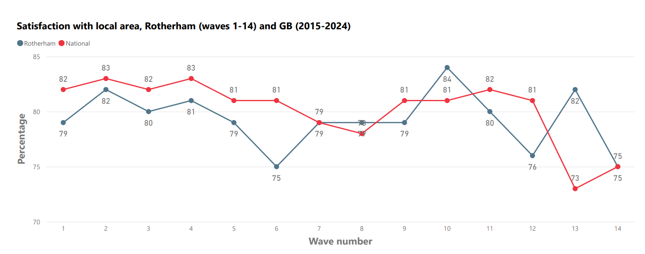

Base (all respondents – figure includes only those who gave a positive reply): Rotherham June 2015: 531; Dec 2015: 528; June 2016: 520; Dec 2016: 520; June 2017: 520; Feb 2018: 517; June 2018: 515; Dec 2018: 515; June 2019: 515; June 2020: 504; June 2021: 503; June 2022: 501; June 2023: 500; August 2024: 500. GB: between 1,000 and 1009

**Figure 2a** shows consistently high and relatively stable satisfaction with residents’ local area as a place to live, with this measure generally seeing Rotherham levels similar to the national average. In the previous wave (Wave 13) satisfaction with the local area in Rotherham was better than the national average, however in Wave 14, satisfaction levels have declined in Rotherham and are now the same as the national average.

**Figure 2b.**

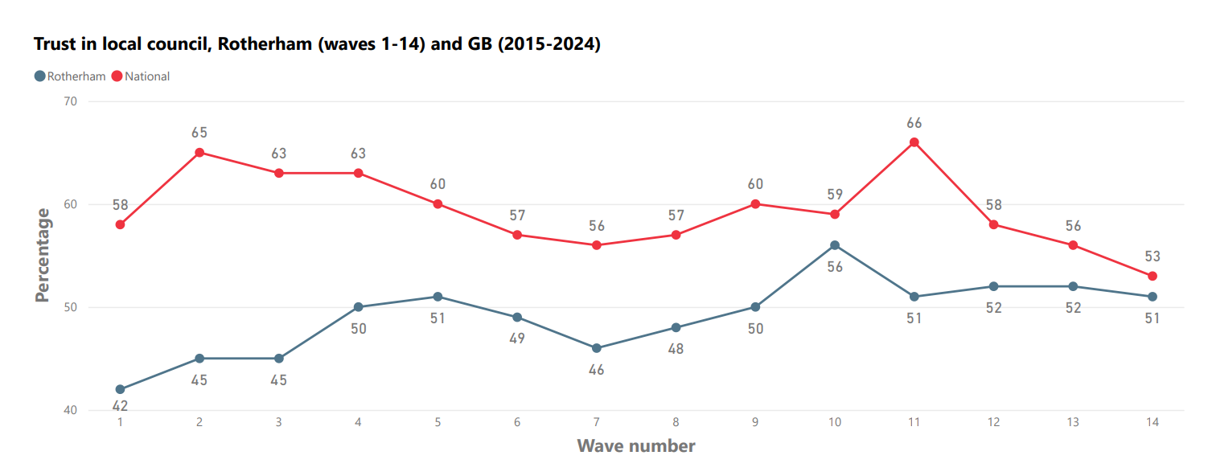

Base (all respondents – figure includes only those who gave a positive reply): Rotherham June 2015: 531; Dec 2015: 528; June 2016: 520; Dec 2016: 520; June 2017: 520; Feb 2018: 517; June 2018: 515; Dec 2018: 515; June 2019: 515; June 2020: 504; June 2021: 503; June 2022: 501; June 2023: 500; August 2024: 500. GB: between 1,000 and 1009

**Figure 2b** shows that trust in the Council has tended to be higher since 2016 (Wave 4) than previously. There is a pattern of declining trust in councils nationally, and the gap between Rotherham and the national figures in Wave 14 was the narrowest across all surveys at two percentage points.

**Figure 2c.**

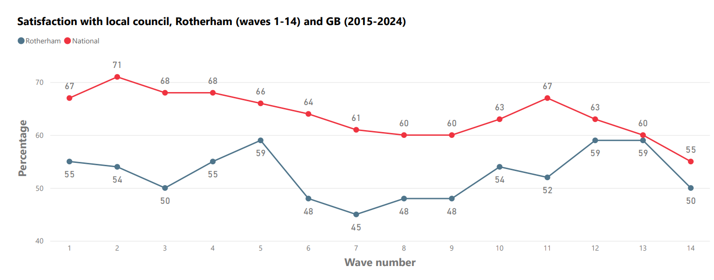

Base (all respondents – figure includes only those who gave a positive reply): Rotherham June 2015: 531; Dec 2015: 528; June 2016: 520; Dec 2016: 520; June 2017: 520; Feb 2018: 517; June 2018: 515; Dec 2018: 515; June 2019: 515; June 2020: 504; June 2021: 503; June 2022: 501; June 2023: 500; August 2024: 500. GB: between 1,000 and 1009

**Figure 2c** shows a decline in satisfaction levels with the council in Rotherham between Waves 13 and 14 of nine percentage points. There is a pattern of declining satisfaction with local councils on a national level, and in the most recent national survey satisfaction with local councils were at their lowest ever level.

**Polling results for Council indicators (Rotherham and GB)**

**Figures 3a, 3b and 3c** summarise the results for three indicators in the Rotherham survey relating to how the Council keeps residents informed, acts on concerns and provides value for money, combining the positive results for each question (e.g. ‘a great deal’ and ‘a fair amount’). The results are presented alongside those from the LGA’s national polling survey for the nearest comparable time period.

**Figure 3a.**

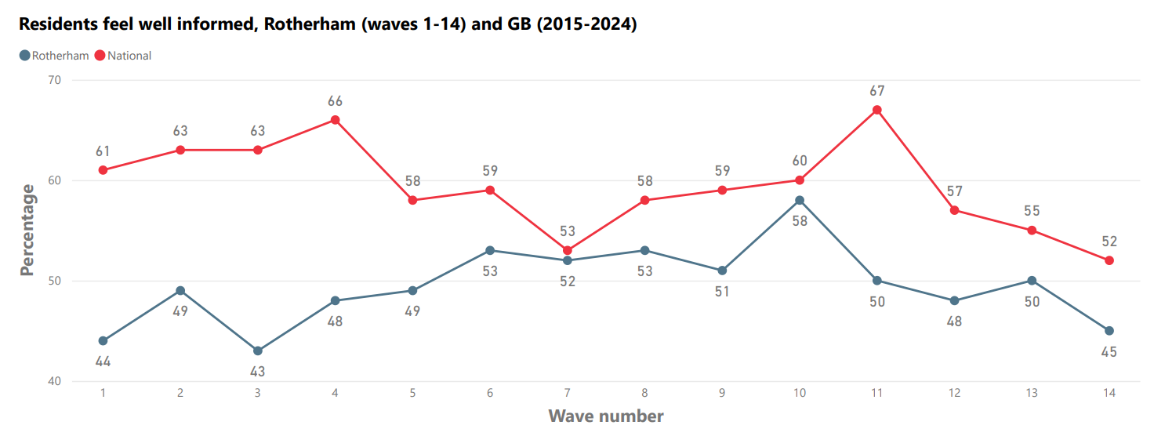

Base (all respondents – figure includes only those who gave a positive reply): Rotherham: June 2015: 531; Dec 2015: 528; June 2016: 520; Dec 2016: 520; June 2017: 520; Feb 2018: 517; June 2018: 515; Dec 2018: 515; June 2019: 515; June 2020: 504; June 2021: 503; June 2022: 501; June 2023: 500; Aug 2024: 500. GB: between 1,000 and 1,009.

**Figure 3a** shows that people in Rotherham feel less well informed about council services than national respondents. There has been a decline nationally in residents feeling well informed about council services since Wave 11 (June 2021).

**Figure 3b.**

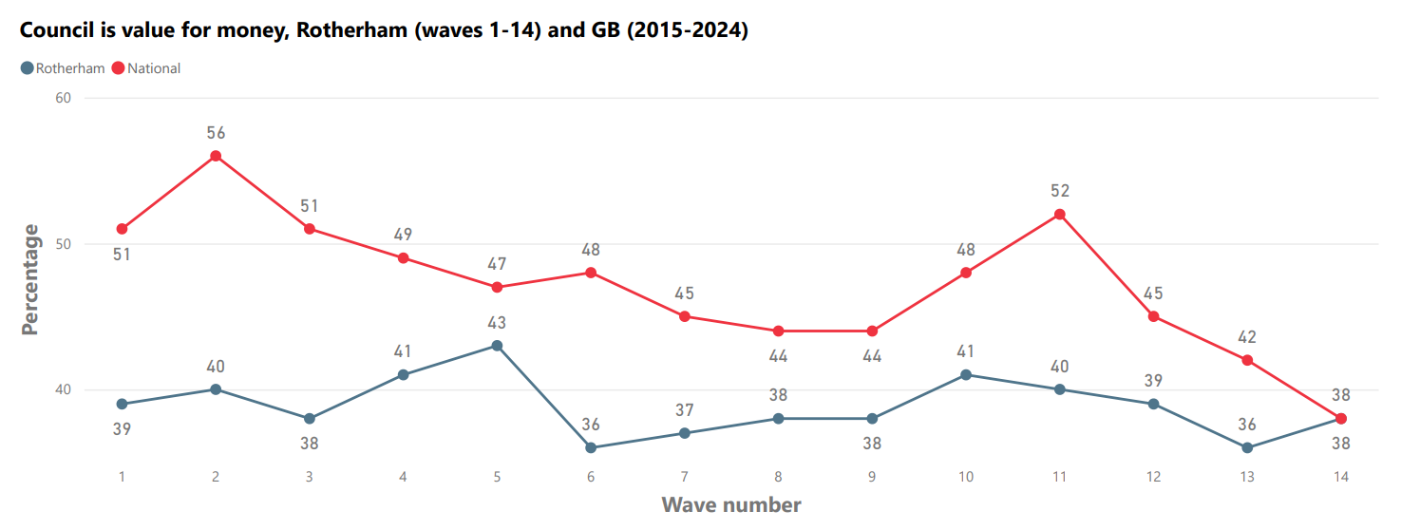

Base (all respondents – figure includes only those who gave a positive reply): Rotherham: June 2015: 531; Dec 2015: 528; June 2016: 520; Dec 2016: 520; June 2017: 520; Feb 2018: 517; June 2018: 515; Dec 2018: 515; June 2019: 515; June 2020: 504; June 2021: 503; June 2022: 501; June 2023: 500; Aug 2024: 500. GB: between 1,000 and 1,009.

**Figure 3b** shows that nationally, the proportion of people who think their council provides value for money has been falling consistently since Wave 11 (June 2021) and is now the same as the Rotherham percentage.

**Figure 3c.**

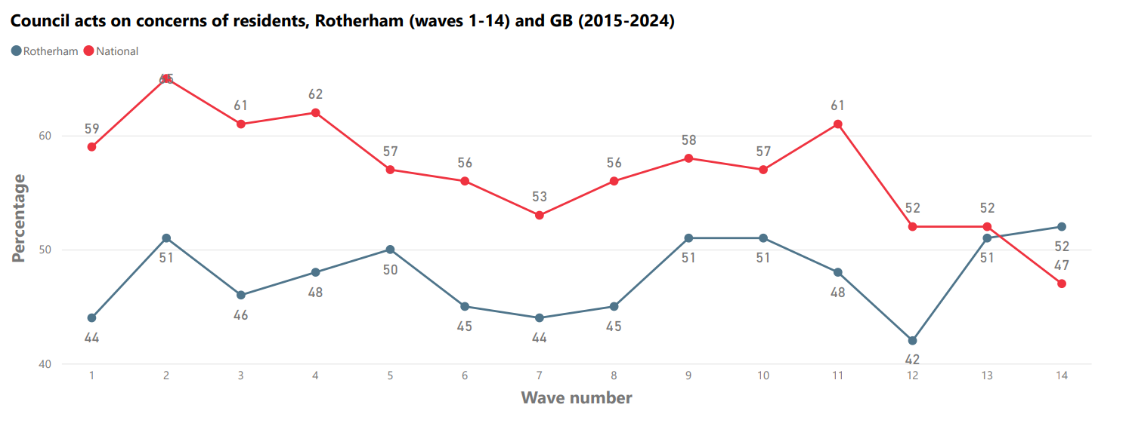

Base (all respondents – figure includes only those who gave a positive reply): Rotherham: June 2015: 531; Dec 2015: 528; June 2016: 520; Dec 2016: 520; June 2017: 520; Feb 2018: 517; June 2018: 515; Dec 2018: 515; June 2019: 515; June 2020: 504; June 2021: 503; June 2022: 501; June 2023: 500; Aug 2024: 500. GB: between 1,000 and 1,009.

**Figure 3c** shows that satisfaction levels for councils acting on residents’ concerns have fallen to the lowest ever level nationally in Wave 14. In Rotherham the patterns are mixed on this measure, although the most recent survey recorded the highest satisfaction level for the council acting on residents’ concerns since the survey began, and five percentage points higher than the national level.

**Confidence in the Council**

In each survey wave, respondents were asked to state the extent to which they had confidence in the Council. In Wave 14, 56 per cent said they had a ‘great’ or ‘moderate’ amount of confidence in the Council. This is the highest percentage recorded across all waves and an increase of five percentage points from Wave 13 (51 per cent). There is no national comparator for this question.

**Feelings of safety, optimism and cohesion**

The following results were obtained in relation to three additional questions that were added to the polling survey from Wave 5 onwards:

**Feelings of safety:** 85 per cent of Rotherham respondents reported feeling ‘very’ or ‘fairly’ safe in the local area during the day compared to 91 per cent nationally. Feelings of safety in the local area after dark were worse in Rotherham than nationally (57 per cent in Rotherham and 71 per cent nationally). There was a significant gender difference in feelings of safety after dark – 62 per cent of men but only 54 per cent of women said they felt ‘very safe’ or ‘fairly safe’.

**Feelings of optimism:** Optimism among respondents about the future of Rotherham as a place to live was 53 per cent, down from 56 per cent in Wave 13 (either ‘very optimistic’ or ‘fairly optimistic’), and slightly below the average percentage across all surveys of 54 per cent. However, only 27 per cent of respondents felt the same about the future of Rotherham town centre (either ‘very optimistic’ or ‘fairly optimistic’), this was the same figure as in Wave 13. There is no national comparator for these questions.

**Community cohesion perceptions:** 41 per cent of Rotherham respondentsagreed that Rotherham is a place where people from different backgrounds get on well together (41 per cent agree, 33 per cent gave a neutral response/did not know and 25 per cent disagree in Wave 14). People aged 35-54 were more likely to agree that Rotherham is a place where people from different backgrounds get on well together, than younger or older people. There is no national comparator for this question.

**ROTHERHAM’S SURVEY RESULTS**

This section outlines the full set of results for the fourteenth Rotherham survey which took place in August 2024 (Wave 14).

**Satisfaction with local area as a place to live**

Satisfaction with the local area within Rotherham as a place to live has remained high and fairly stable since the first satisfaction survey in June 2015 (see Table 1). Across the fourteen waves, the average level of satisfaction has been 79 per cent and no previous survey result has varied from this by more than five per cent. The proportion of respondents who were either ‘very satisfied’ or ‘fairly satisfied’ across all previous polls was similar to the national average over the same time period.

Seventy-five per cent of respondents in Wave 14 reported feeling ‘very satisfied’ or ‘fairly satisfied’ which is below the average recorded level across all waves. People aged 18-24 years were the *least* likely to report being ‘satisfied’ (54 per cent). People aged 65+ years are the *most* likely to be satisfied with their local area (83 per cent).

It should be noted that the ‘local area’ refers to the local neighbourhood or village where residents live and not the whole of Rotherham. Residents’ satisfaction with their local area far exceeds their satisfaction with Rotherham Borough, which was 66 per cent in Wave 14 (see Table 11).

**Table 1: Overall, how satisfied or dissatisfied are you with your local area (within a 15-to-20-minute walk from your home) as a place to live?**

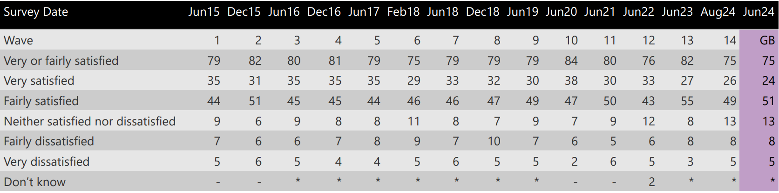

Base (all respondents): June 2015 Rotherham: 531; Dec 2015: 528; June 2016: 520; Dec 2016: 520; June 2017: 520; Feb 2018: 517; June 2018: 515; Dec 2018: 515; June 2019: 515; June 2020: 504; June 2021: 503; June 2022: 501; June 2023: 500; Aug 2024: 500; Jun 2024 GB: 1,000

**Satisfaction with how the Council runs things**

Fifty per cent of respondents in Wave 14 were ‘very satisfied’ or ‘fairly satisfied’ with the way the Council runs things (see Table 2). This was lower than the response in Wave 13 of 59 per cent. Respondents aged 65+ were most likely to report being satisfied with the way the Council runs things (64 per cent). Residents aged 18-34 were most likely to be dissatisfied (31 per cent).

Satisfaction with local councils nationally has declined over the most recent survey waves, from 67 per cent in June 2021 to 55 per cent in June 2024.

**Table 2: Overall, how satisfied or dissatisfied are you with the way Rotherham Metropolitan Borough Council runs things?**

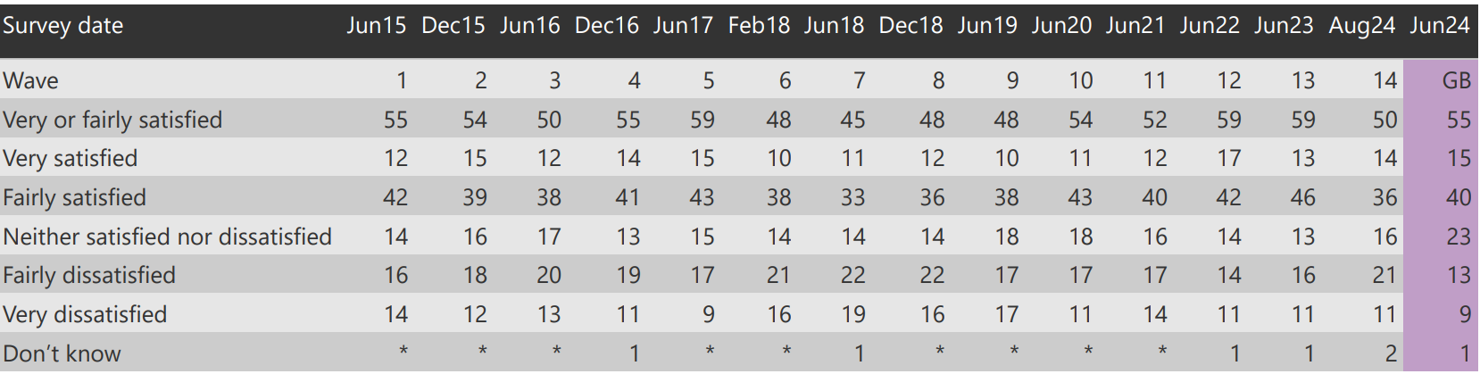

Base (all respondents): June 2015 Rotherham: 531; Dec 2015: 528; June 2016: 520; Dec 2016: 520; June 2017: 520; Feb 2018: 517; June 2018: 515; Dec 2018: 515; June 2019: 515; June 2020: 504; June 2021; 503; June 2022: 501; June 2023: 500; Aug 24: 500; Jun 24 GB: 1,000

**Provision of value for money by the Council**

Thirty-eight per cent of respondents would ‘tend to agree’ or ‘strongly agree’ that the Council provides value for money (see Table 3). The result is the same as the percentage observed nationally (38 per cent).

It is notable that 32 per cent of respondents expressed a neutral opinion (or did not know) and 29 per cent expressed a negative view. Older people aged 65+ (47 per cent) were most likely to agree that the Council provides value for money, whilst people aged 25-34 years (37 per cent) were most likely to disagree.

**Table 3: To what extent do you agree or disagree that Rotherham Metropolitan Borough Council provides value for money?**

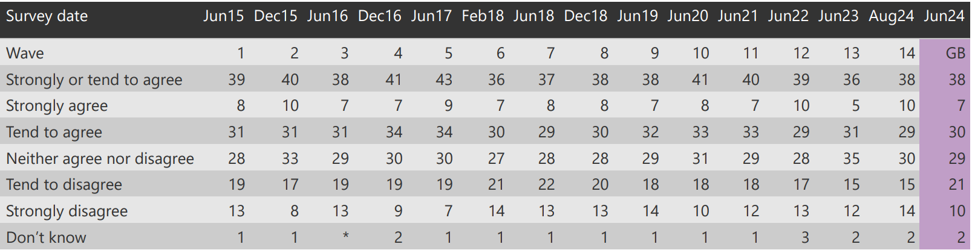

Base (all respondents): June 2015 Rotherham: 531; Dec 2015: 528; June 2016: 520; Dec 2016: 520; June 2017: 520; Feb 2018: 517; June 2018: 515; Dec 2018: 515; June 2019: 515; June 2020: 504; June 2021: 503; June 2022: 501; June 2023: 500; Aug 2024: 500; Jun 2024 GB: 1,000

**Responsiveness of the Council**

Council responsiveness is an important measure of local accountability as it relates to whether councils are perceived to be receptive to local issues and problems raised (see Table 4). Residents were asked for their opinion about services provided by the Council to the community as a whole, as well as to their own household.

Fifty-two per cent of respondents in Rotherham answered positively when asked about the extent to which the Council acts on the concerns of residents (i.e. ‘a great deal’ or ‘a fair amount’). This is the highest response across all surveys and better than the national result (47 per cent). Locally there was an increase of ten percentage points in satisfaction levels between Waves 12 and 14. Respondents aged 25-34 were most likely to think that the Council acts on the concerns of local residents (60 per cent responded positively) whilst those aged 55-64 were least likely to have this view.

**Table 4: To what extent do you think that Rotherham Metropolitan Borough Council acts on the concerns of local residents?**

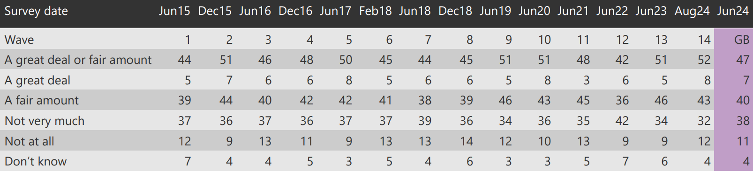

Base (all respondents): June 2015 Rotherham: 531; Dec 2015: 528; June 2016: 520; Dec 2016: 520; June 2017: 520; Feb 2018: 517; June 2018: 515; Dec 2018: 515; June 2019: 515; June 2020: 504; June 2021: 503; June 2022: 501; June 2023: 500; Aug 2024: 500; Jun 2024 GB: 1,000

**Keeping residents informed**

Forty-five per cent of Rotherham respondents in Wave 14 said that the Council keeps residents ‘very well’ or ‘fairly well’ informed about the services and benefits it provides (see Table 5). This is lower than the most recent national result (52 per cent) and below the average percentage across all Rotherham surveys (50 per cent). Younger respondents (aged 18-24) and respondents aged 65+ were the cohorts most likely to think that the Council keeps residents well informed. It should be noted that this measure covers not only corporate communications but could also refer to face to face or any other types of council touchpoint that the customer experiences.

**Table 5: Overall, how well informed do you think Rotherham Metropolitan Borough Council keeps residents?**

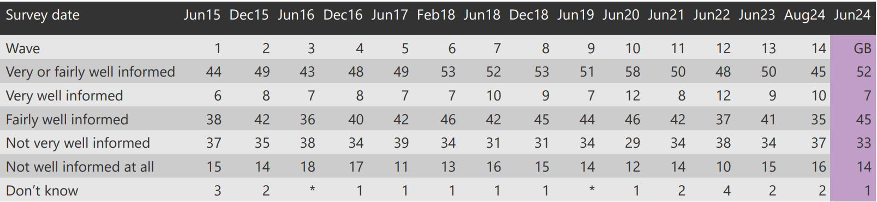

Base (all respondents): June 2015 Rotherham: 531; Dec 2015: 528; June 2016: 520; Dec 2016: 520; June 2017: 520; Feb 2018: 517; June 2018: 515; Dec 2018: 515; June 2019: 515; June 2020: 504; June 2021: 503; June 2022: 501; June 2023: 500; Aug 2024: 500; Jun 2024 GB: 1,000

**Trust in the Council**

Fifty-one per cent of respondents said they trusted the Council ‘a great deal’ or ‘a fair amount’ (see Table 6). Trust in councils nationally has been steadily falling in recent years - from 66 per cent in Wave 11, to 58 per cent in Wave 12, to 56 per cent in Wave 13 and now to 53 per cent in Wave 14.

The four most recent local survey results show that levels of trust in Rotherham have stabilised (since June 2021), averaging around 52 per cent and show an improvement in trust compared to the first three polls (average 44 per cent). In Wave 14 the level of trust in the Council is highest amongst people aged 35-44 (66 per cent) and lowest amongst those aged 25-34 years. Women (55 per cent) had higher levels of trust than men (48 per cent).

Residents’ trust in their council is an important aspect of reputation, which is likely to impact on issues such as democratic legitimacy and engagement. In terms of what the word ‘trust’ means to residents, it is useful to look at the results of the cognitive testing carried out as part of the review to develop this question.

The testing indicated that respondents based their answers on criteria including transparency and openness, upholding promises, responding to residents, reliability, and recollection of ‘scandal’. Recollection of the past failings of the Council in relation to child sexual exploitation is likely to be one factor which contributes to trust in the Council being slightly lower than the national average, although in Wave 14, the gap between Rotherham and the national figure is smaller than it has ever been across all surveys.

**Table 6: How much do you trust Rotherham Metropolitan Borough Council?**

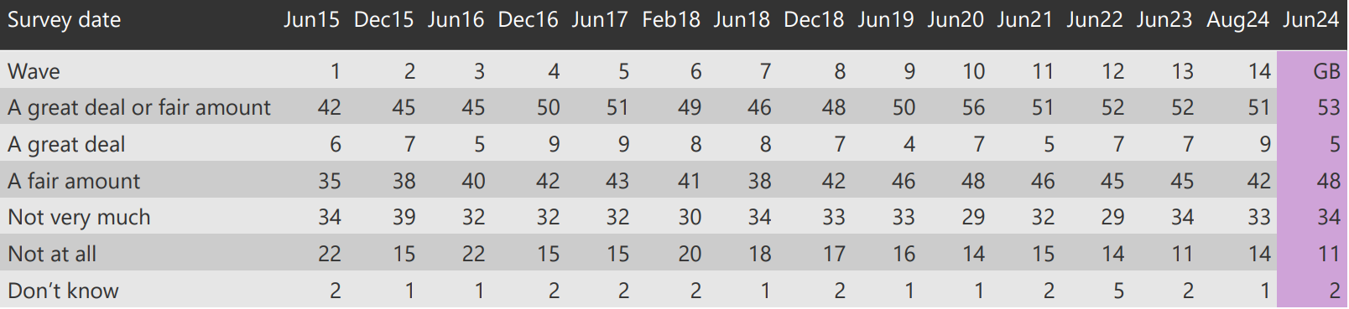

Base (all respondents): June 2015 Rotherham: 531; Dec 2015: 528; June 2016: 520; Dec 2016: 520; June 2017: 520; Feb 2018: 517; June 2018: 515; Dec 2018: 515; June 2019: 515; June 2020: 504; June 2021: 503; June 2022: 501; June 2023: 500; Aug 2024: 500; Jun 2024 GB: 1,000

**Confidence in the Council**

As Table 7 shows, 56 per cent of respondents in Wave 14 stated that they have confidence in the Council (either ‘to a great extent’ or ‘to a moderate extent’). This is five percentage points higher than in Wave 13 and is the highest figure across all surveys. Respondents aged 18-24 have the highest confidence in the council (73 per cent). There is no national comparison for this question.

The results for trust (Table 6) and confidence (Table 7) in the Council show a very close alignment which demonstrates a strong association between the two in the public mind. People who trust the Council are almost certain to have confidence in the organisation.

**Table 7: To what extent would you say that you have confidence in Rotherham Metropolitan Borough Council?**

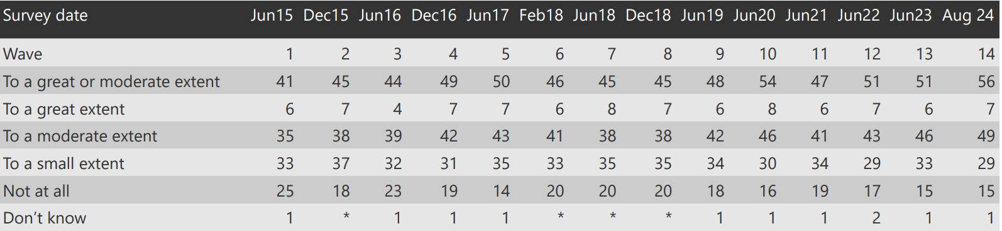

Base (all respondents): June 2015 Rotherham: 531; Dec 2015: 528; June 2016: 520; Dec 2016: 520; June 2017: 520; Feb 2018: 517; June 2018: 515; Dec 2018: 515; June 2019: 515; June 2020: 504; June 2021: 503; June 2022: 501; June 2023: 500; Aug 2024: 500

**Feelings of safety**

From Wave 5 onwards, the Rotherham surveys asked two questions about feelings of personal safety, which also feature in the LGA’s national survey. In Wave 14, 85 per cent of respondents in Rotherham said they felt ‘very safe’ or ‘fairly safe’ during the day when outside in their local area (lower than the figures observed nationally at 91 per cent). However, only 57 per cent reported the same feelings of safety after dark and this is significantly lower than the figures observed nationally at 71 per cent.

In Rotherham, a slightly higher percentage of women (88 per cent) than men (84 per cent) felt very or fairly safe during the day. There was a significant difference between men and women’s feelings of safety after dark, with 62 per cent of men reporting feeling ‘very safe’ or ‘fairly safe’ compared to only 54 per cent of women. Young people aged 18-24 are least likely to feel safe after dark and those aged 45-54 most likely to feel safe. People with low skilled, manual occupational backgrounds are least likely to feel safe.

**Table 8a:** **How safe or unsafe do you feel when outside in your local area during the day? Please consider your local area to be the area within 15-20 minutes walking distance from your home.**

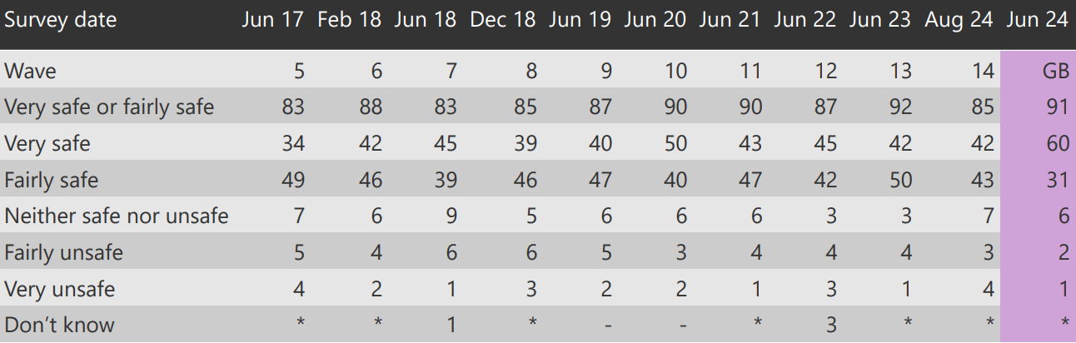

Base (all respondents): Rotherham June 2017: 520; February 2018: 517; June 2018: 515; December 2018: 515; June 2019: 515; June 2020: 504; June 2021: 503; June 2022: 501; June 2023: 500; Aug 2024: 500; Jun 2024 GB: 1,000

**Table 8b: How safe or unsafe do you feel when outside in your local area after dark? Please consider your local area to be the area within 15-20 minutes walking distance from your home.**

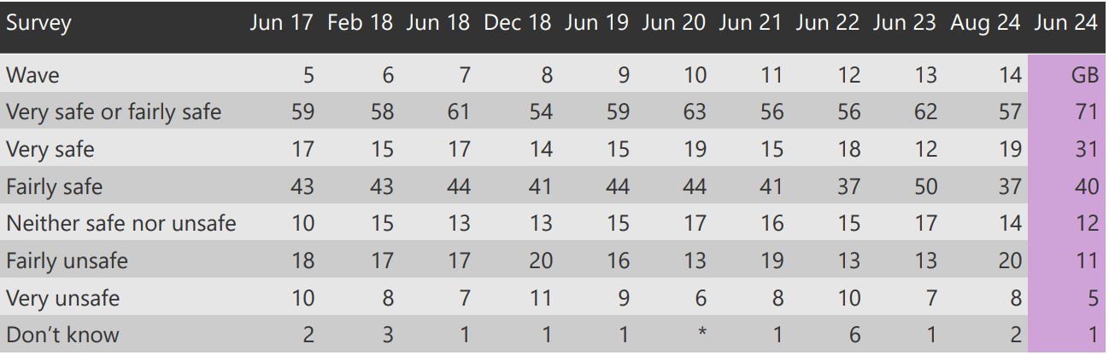

Base (all respondents): Rotherham June 2017: 520; February 2018: 517; June 2018: 515; December 2018: 515; June 2019: 515; June 2020: 504; June 2021: 503; June 2022: 501; June 2023: 500; Aug 2024: 500; Jun 2024 GB: 1,000

**Feelings of optimism**

The last ten Rotherham surveys have asked two questions about people’s feelings of optimism about both Rotherham as a place to live (**table 9a**) and Rotherham town centre (**table 9b**). Fifty-three per cent of respondents reported feeling ‘very optimistic’ or ‘fairly optimistic’ about the future of Rotherham as a place to live, similar to the 54 per cent average across all surveys. People aged 18-24 were the most likely to be optimistic about the future of Rotherham as a place to live (70 per cent) and women were more optimistic than men overall.

Far fewer respondents felt as positive about the future of Rotherham town centre as they did about the future of the wider borough (27 per cent of respondents across the borough felt ‘very optimistic’ or ‘fairly optimistic’). The figure has remained consistent at 27 per cent for the last three surveys, which is above the average of 23 per cent across all ten surveys. Thirty-five per cent of respondents were not optimistic at all about the town centre. Young people aged 18-24 years were the most optimistic about the future of Rotherham town centre (46 per cent were optimistic), whereas people aged 55-64 were most likely to not be optimistic. When considering the results of this question it should be noted that the polling was completed in advance of the opening of Arc Cinema at Forge Island. There is no comparable national data for these questions.

**Table 9a: How optimistic do you feel about the future of Rotherham as a place to live?**

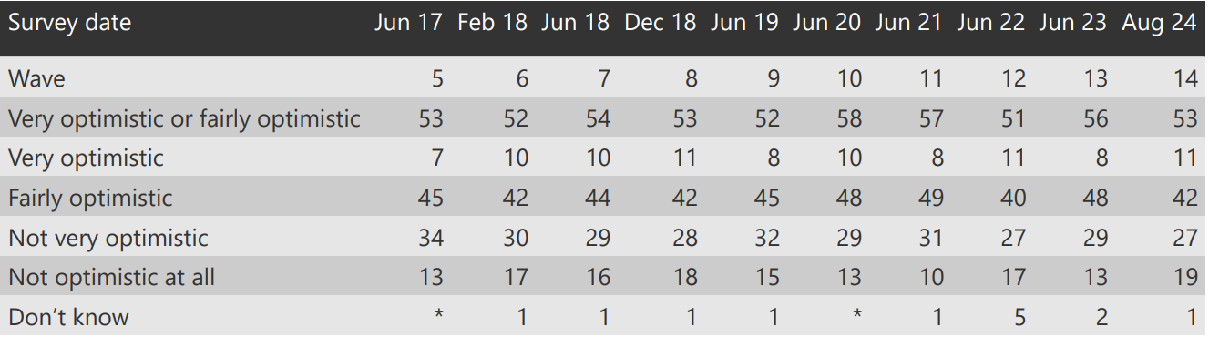

Base (all respondents): Rotherham June 2017: 520; February 2018: 517; June 2018: 515; December 2018: 515; June 2019: 515; June 2020: 504; June 2021: 503; June 2022: 501; June 2023: 500; Aug 2024: 500

**Table 9b: How optimistic do you feel about the future of Rotherham town centre?**

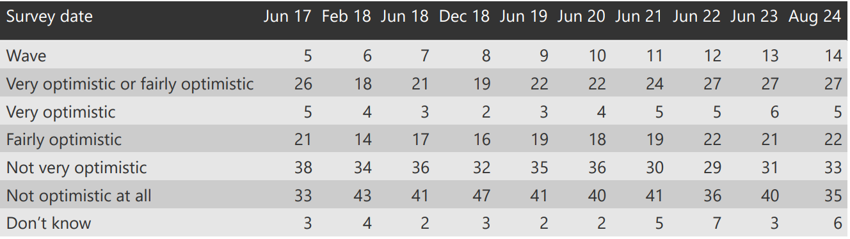

Base (all respondents): Rotherham June 2017: 520; February 2018: 517; June 2018: 515; December 2018: 515; June 2019: 515; June 2020: 504; June 2021: 503; June 2022: 501; June 2023: 500; Aug 2024: 500

**Community cohesion perceptions**

The last ten Rotherham surveys have asked for views on whether people from different backgrounds get on well together. This is a question commonly used to measure community cohesion and the survey has consistently generated mixed responses. Interpretation of the question could relate to views about residents’ local areas and/or perceptions about Rotherham as a whole, but views about community relations since the question was first asked in June 2017 had generally been becoming more positive. It is possible that responses may have been influenced in Wave 14 by the public disorder that took place both in Rotherham and across the UK in early August 2024.

In Wave 14 (41 per cent) there was a fall of 6 percentage points from Wave 13 (47 per cent) in respondents who agreed that people from different backgrounds get on well together, with 28 per cent giving a neutral response and 25 per cent disagreeing. People aged 35-44 were the most likely to agree that people from different backgrounds get on well together (58 per cent). People with higher and intermediate managerial, administrative and professional occupations were most likely to agree that people from different backgrounds get on well together. There is no national comparator for this question.

**Table 10: To what extent do you agree or disagree that Rotherham is a place where people from different backgrounds get on well together?**

The following explanation was added after this question: “By getting on well together, we mean living alongside each other with respect.”

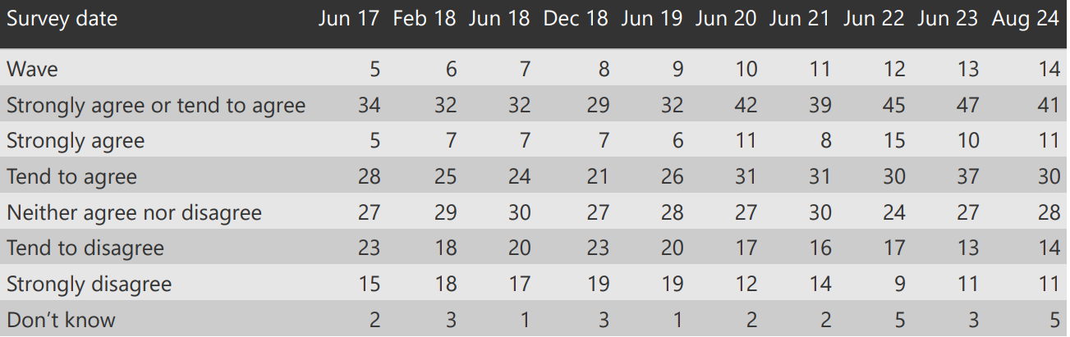

Base (all respondents): June 2017: 520; February 2018: 517; June 2018: 515; December 2018: 515; June 2019: 515; June 2020: 504; June 2021: 503; June 2022: 501; June 2023: 500; Aug 2024: 500

**Satisfaction with Rotherham as a place to live**

Respondents were asked, all things considered, how satisfied or dissatisfied they were with Rotherham borough as a place to live (Table 11). Sixty-six per cent of respondents said that, overall, they were satisfied. This was above the average across all of the previous surveys (61.5 per cent), although results have tended to fluctuate between waves.

The variation in satisfaction with the borough as a place to live differs from residents’ more consistent satisfaction with their local area as a place to live (Table 1). Residents are significantly more satisfied with their own local area (average 79 per cent across all surveys) than the borough as a whole (average 62 per cent), although this gap has narrowed in the most recent Wave.

Within Wave 14, respondents aged 35-44 were most likely to feel satisfied with Rotherham as a place to live, with 74 per cent satisfied. Respondents aged 25-34 had the lowest level of satisfaction with Rotherham as a place to live, with only 52 per cent satisfied. Dissatisfaction with Rotherham as a place to live was highest amongst people aged 45-54.

This question was not asked in Wave 5 so there is no data for this in Table 11. There is no national comparator for this question.

**Table 11: Overall, all things considered, how satisfied or dissatisfied are you with Rotherham Borough as a place to live?**

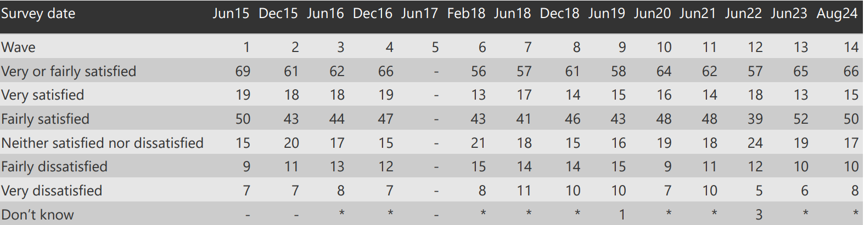

Base (all respondents): June 2015 Rotherham: 531; Dec 2015: 528; June 2016: 520; Dec 2016: 520; Feb 2018: 517; June 2018: 515; December 2018: 515; June 2019: 515; June 2020: 504; June 2021: 503; June 2022: 501; June 2023: 500; Aug 2024: 500

**Satisfaction with specific Council services**

In Wave 13, nine service specific questions were introduced, and these questions have been repeated in Wave 14. The survey questions asked respondents how satisfied or dissatisfied they were overall with the Council’s:

* Waste collection
* Street cleaning
* Road maintenance
* Pavement maintenance
* Sport and leisure services
* Services and support for older people
* Services and support for children and young people
* Parks and green spaces.

Residents were most satisfied with their waste collection (89 per cent satisfied) and with parks and green spaces (65 per cent satisfied). The service areas with the lowest satisfaction levels were road maintenance (29 per cent satisfied) and services and support for children and young people (33 per cent satisfied). The service areas with the highest total neutral responses (‘neither satisfied nor dissatisfied’ combined with ‘don’t know’) were sport and leisure services (44 per cent), services and support for children and young people (43 per cent), services and support for older people (41 per cent) and library services (37 per cent) suggesting that respondents had no experience of using these services and were therefore not inclined to give an opinion on them.

There are no national comparators for these questions.

**Table 12: How satisfied or dissatisfied are you overall with your Council’s….**

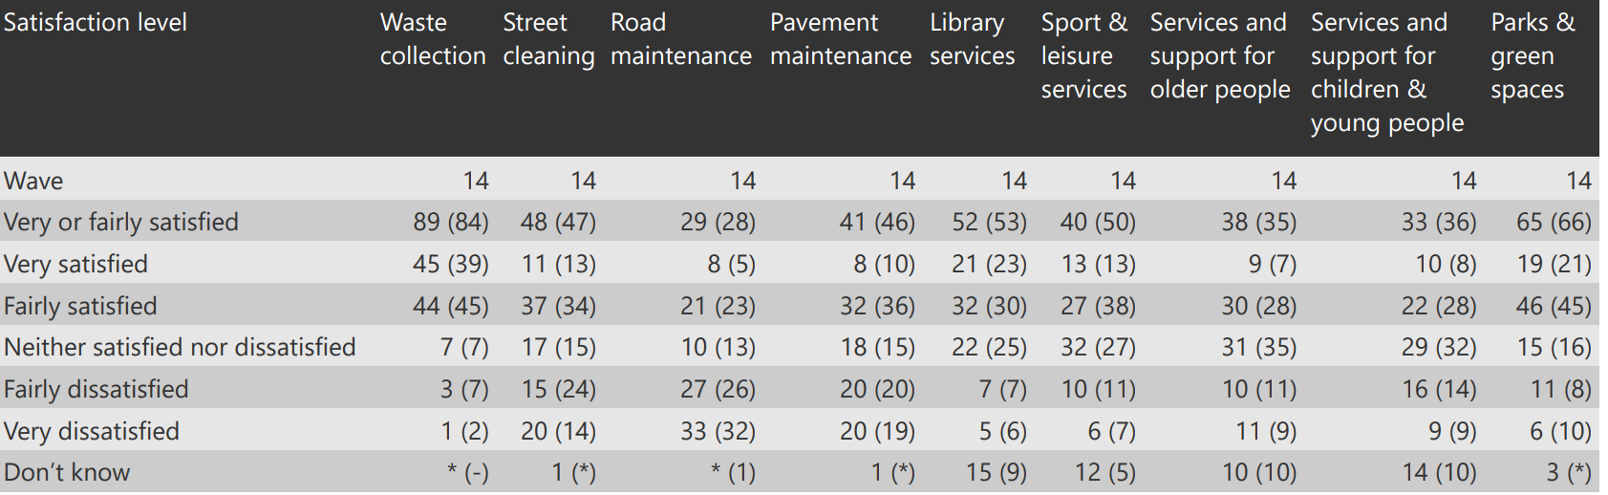

The figures contained in brackets in the above table relate to Wave 13.

**ANNEX A: POLLING QUESTIONS**

**1. Overall, how satisfied or dissatisfied are you with your local area as a place to live?** *Please consider your local area to be the area within 15-20 minutes walking distance from your home.*

Very satisfied

Fairly satisfied

Neither satisfied nor dissatisfied

Fairly dissatisfied

Very dissatisfied

Don’t know

*Your local area receives services from Rotherham Metropolitan Borough Council. Rotherham Metropolitan Borough Council is responsible for a range of services such as refuse collection, street cleaning, planning, education, social care services and road maintenance.*

**2.Overall, how satisfied or dissatisfied are you with the way Rotherham Metropolitan Borough Council runs things?**

Very satisfied

Fairly satisfied

Neither satisfied nor dissatisfied

Fairly dissatisfied

Very dissatisfied

Don’t know

*In considering the next question, please think about the range of services Rotherham Metropolitan Borough Council provides to the community as a whole, as well as the services your household uses. It does not matter if you do not know all of the services Rotherham Metropolitan Borough Council provides to the community. We would like your general opinion*.

**3. To what extent do you agree or disagree that Rotherham Metropolitan Borough Council provides value for money?**

Strongly agree

Tend to agree

Neither agree nor disagree

Tend to disagree

Strongly disagree

Don’t know

**4. To what extent do you think Rotherham Metropolitan Borough Council acts on the concerns of local residents?**

A great deal

A fair amount

Not very much

Not at all

Don’t know

**5. Overall, how well informed do you think Rotherham Metropolitan Borough Council keeps residents?**

Very well informed

Fairly well informed

Not very well informed

Not well informed at all

Don’t know

**6. How much do you trust Rotherham Metropolitan Borough Council?**

A great deal

A fair amount

Not very much

Not at all

Don’t know

**7. To what extent would you say that you have confidence in Rotherham Metropolitan Borough Council?**

To a great extent

To a moderate extent

To a small extent

Not at all

Don’t know

**8. How safe or unsafe do you feel when outside in your local area during the day?**  *Please consider your local area to be the area within 15 – 20 minutes walking distance from your home*

Very safe

Fairly safe

Neither safe nor unsafe

Fairly unsafe

Very unsafe

Don’t know

**8a. How safe or unsafe do you feel when outside in your local area after dark?**  *Please consider your local area to be the area within 15 – 20 minutes walking distance from your home*

Very safe

Fairly safe

Neither safe nor unsafe

Fairly unsafe

Very unsafe

Don’t know

**9. How optimistic do you feel about the future of Rotherham as a place to live?**

Very optimistic

Fairly optimistic

Not very optimistic

Not optimistic at all

Don’t know

**10. And, more specifically, how optimistic do you feel about the future of Rotherham town centre?**

Very optimistic

Fairly optimistic

Not very optimistic

Not optimistic at all

Don’t know

**11. To what extent do you agree or disagree that Rotherham is a place where people from different backgrounds get on well together?** *By getting on well together, we mean living alongside each other with respect.*

Strongly agree

Tend to agree

Neither agree nor disagree

Tend to disagree

Strongly disagree

Don’t know

**12. Overall, all things considered, how satisfied or dissatisfied are you with Rotherham Borough as a place to live?**

Very satisfied

Fairly satisfied

Neither satisfied nor dissatisfied

Fairly dissatisfied

Very dissatisfied

Don’t know

**13. I am going to read out a number of different types of services that are provided by your council in your area. I would like you to tell me how satisfied or dissatisfied you are with your councils…**

* **Waste collection**
* **Street cleaning**
* **Road maintenance**
* **Pavement maintenance**
* **Library services**
* **Sport and leisure services**
* **Services and support for older people**
* **Services and support for children and young people**
* **Parks and green spaces**

Very satisfied

Fairly satisfied

Neither satisfied nor dissatisfied

Fairly dissatisfied

Very dissatisfied

Don’t know



**Rotherham Council**

Riverside House

Main Street,

Rotherham S60 1AE

© Rotherham MBC