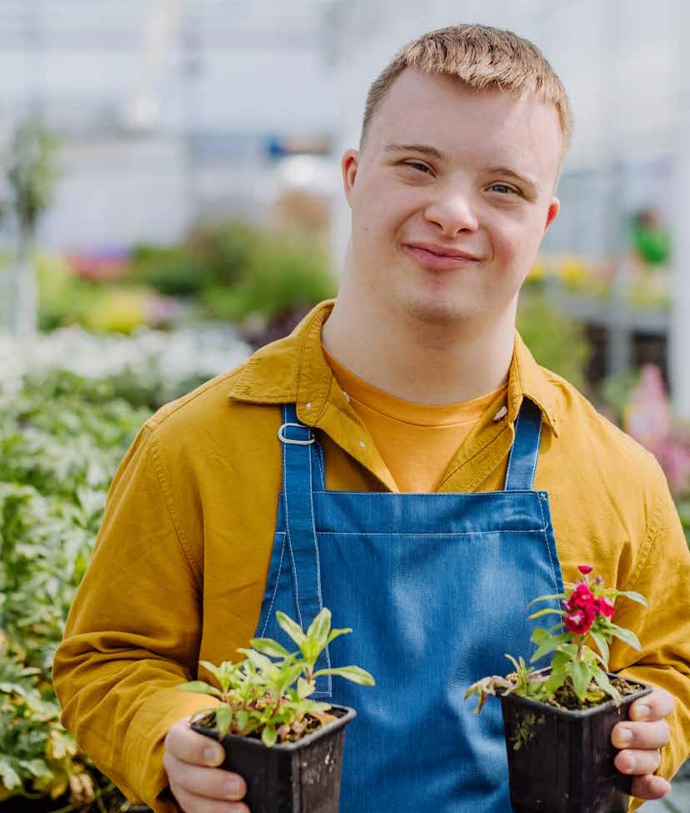Rotherham Learning Disability Strategy 2024-2027
People are safe, healthy, and live well.

www.rotherham.gov.uk

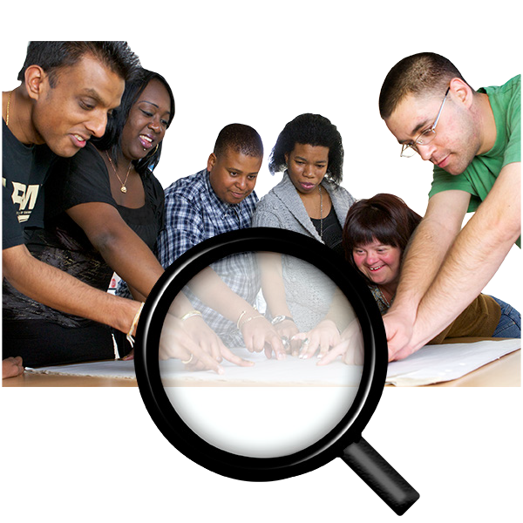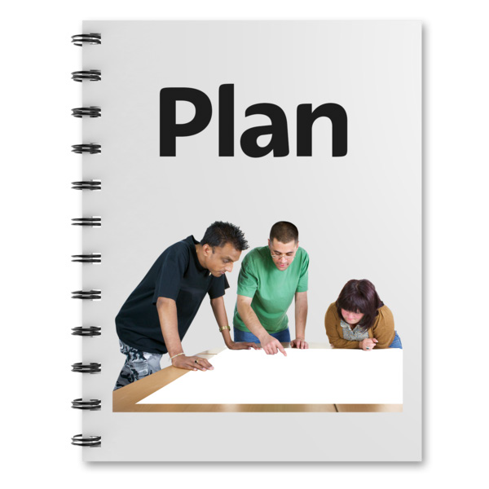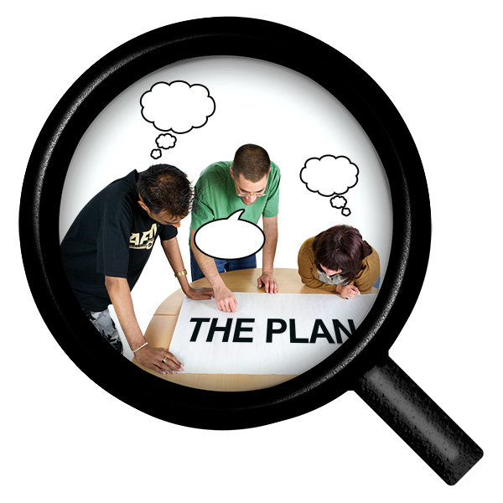

Our Plan

This plan tells you about our vision for how we will make a real
difference to people with a learning disability.

We have made this plan by talking with:
- Adults and young people with a learning disability
- Autistic people
- Families
- Unpaid carers
- Organisations that support people in health, social care, and voluntary groups.

We have four things we would like to work on that we think are important for making sure people trust they will be involved in making decisions about their lives:
- Welcome and Care
- Communicate
- Value and include
- Working together

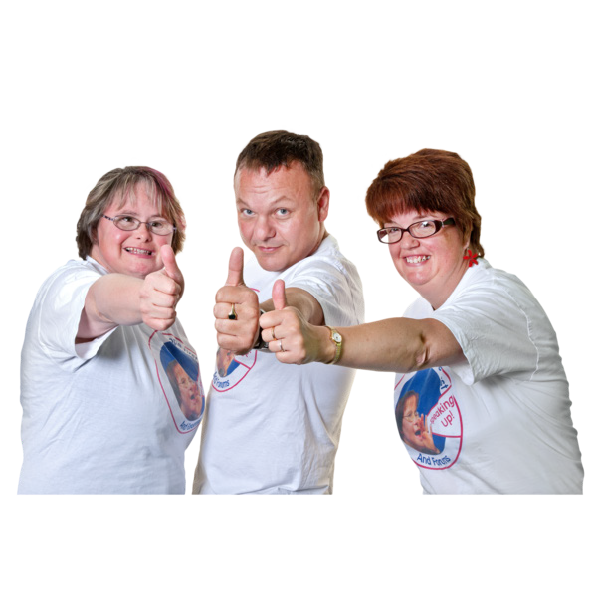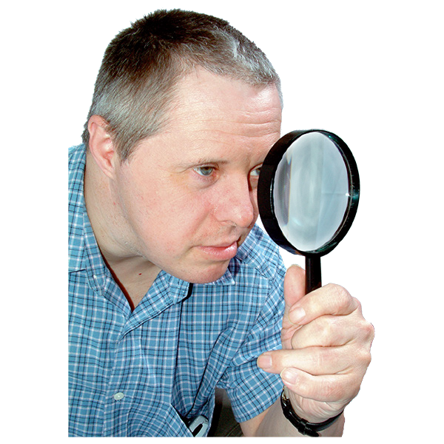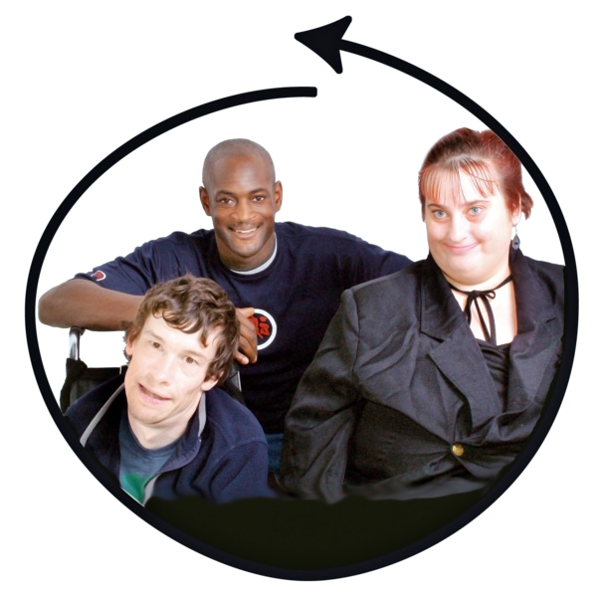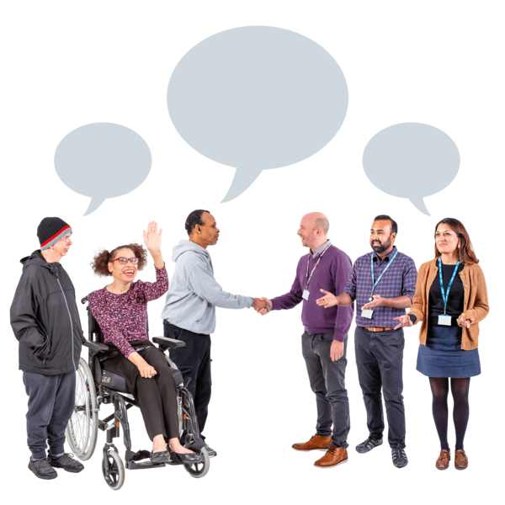

For this plan to work, we will make sure we are looking at other national plans.

We want to make sure people with a learning disability live their best lives. People should be listened to and reach their life goals.

We will do this plan by:

- Having the right information at the right time to make important decisions and choices.

- Helping people to feel safe, welcomed and included.

- Making sure people are listened to and have a voice.

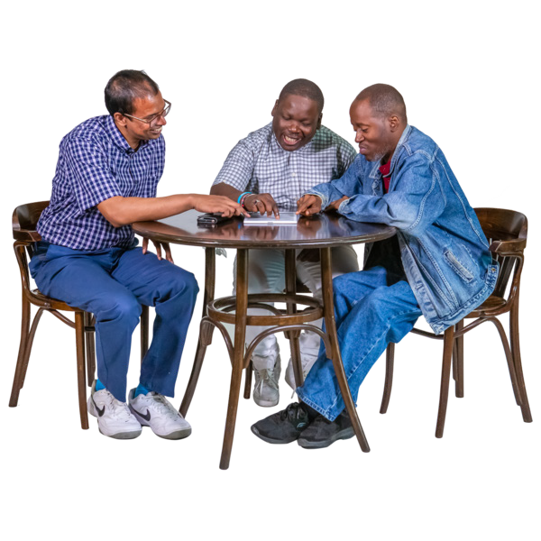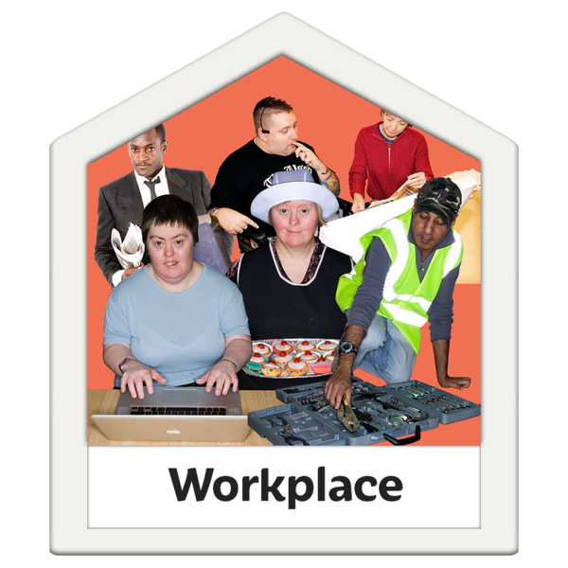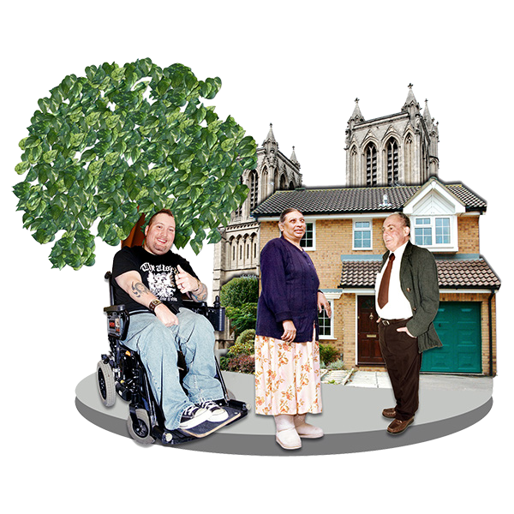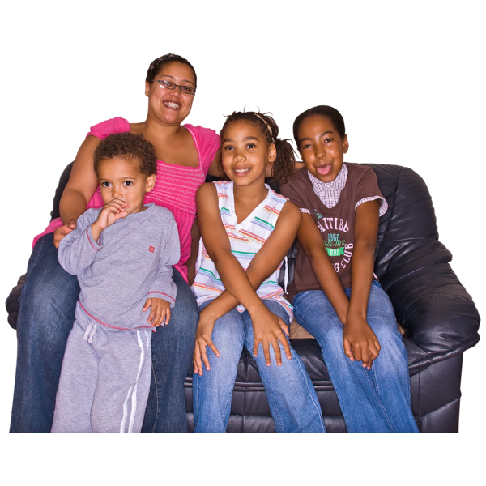

- Making sure people can be independent and reach their goals.

- Helping people to get life skills, access education, work and have their own home to live as independent as possible.

- Help people to access their local communities and to build and keep healthy relationships that are important.

- Making sure young people and their families know what is happening when moving from children to adult services.

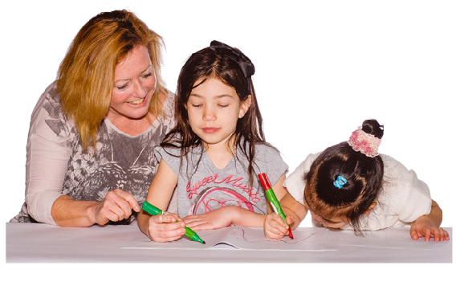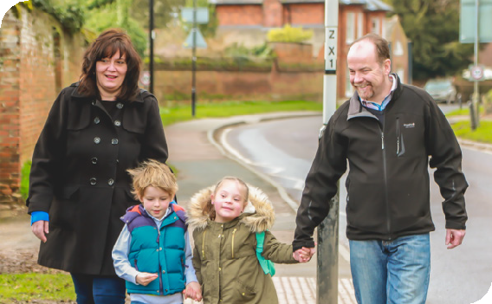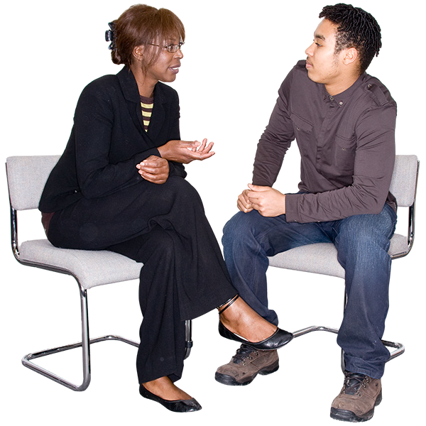

- We will make sure that young people know what support they will get from adult services before turning 18.

- We will work on making new changes so that young people get the right support at the right time and from the right services.

- We will make sure the voices of young people are at the centre of planning for their future.

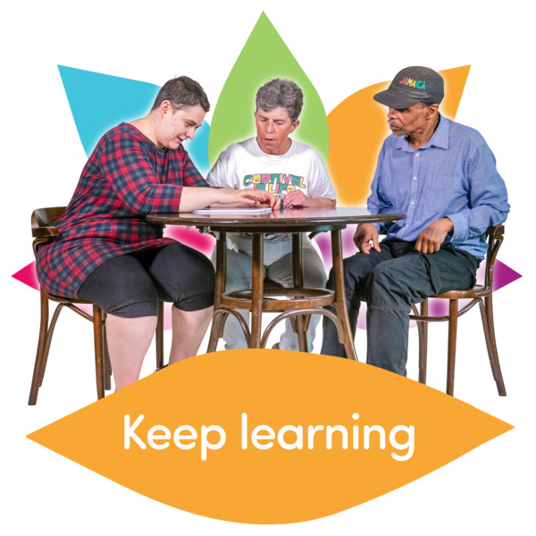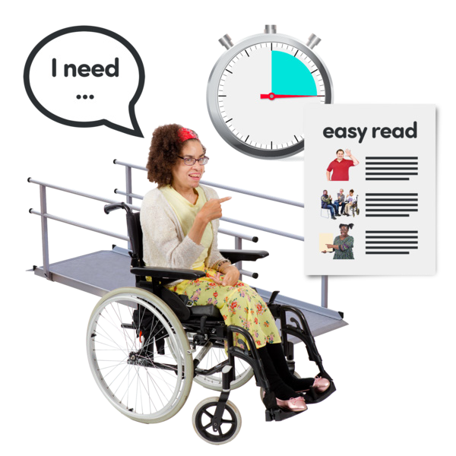

- We will create services that will support people’s independence and help people to gain new life skills. This will support people to have their own homes and jobs to have as much independence as possible.

- We will make sure we work with people when planning and making new services.

- For people who need more support with their physical or mental health, we should be able to change the support we provide.

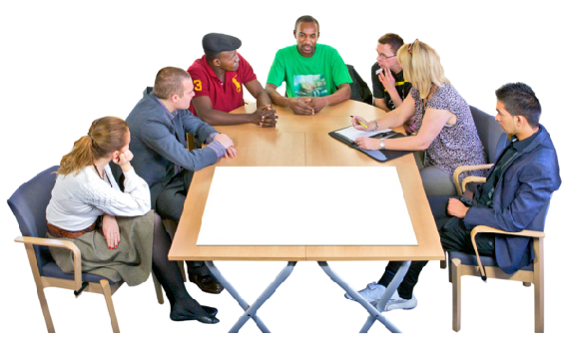

- We will work with people, their families, carers, and support services to help people get a good education, skills training, and work skills.

- We will make a new learning disability employment service .

- This will support people to understand what their skills are and match them with employers; this will support the person to continue with their employment

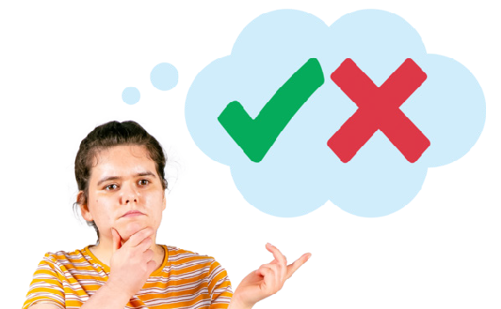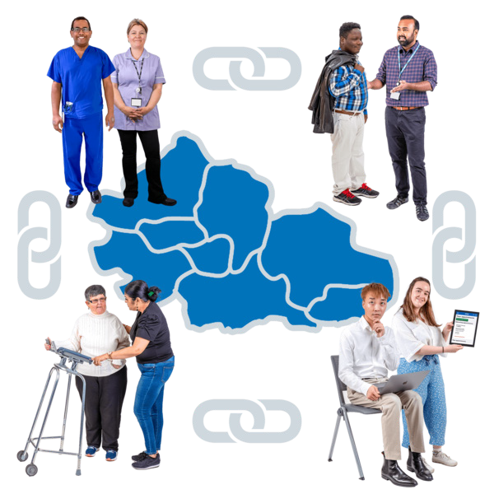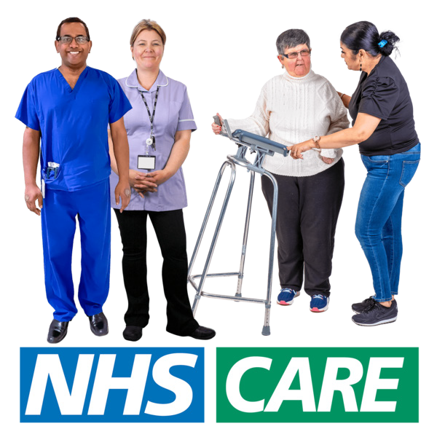

- We will work with people to find out what the problems are when people use health and mental health services.

- We will also work with health organisations and others to make sure people can access physical and mental health services.

- We will make sure there is accessible information about physical and mental health needs.

- We will work with GPs and nurses to make sure people can get health screenings and appointments.

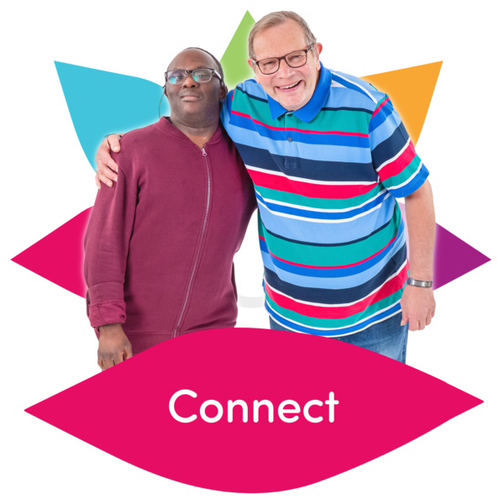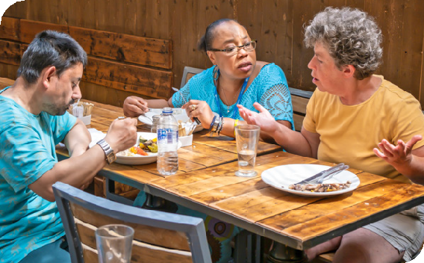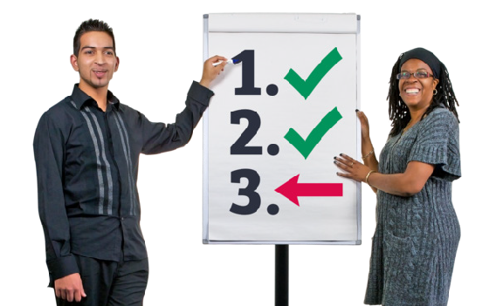

- People want to feel welcomed, connected and part of the community or friendship group. We can do this by giving people the chance to try new things.

- We will work with communities and people with other communication needs to make sure everyone can use their local community services.

- We will support people to give their opinions to make services in Rotherham better and easier to use.

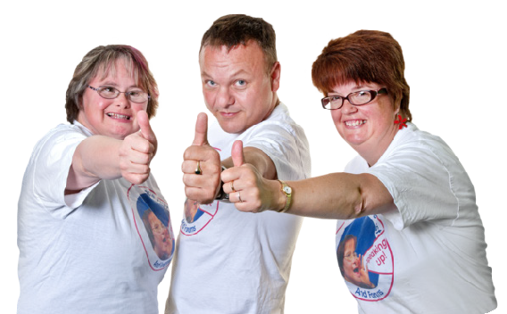

We will work with people and other support organisations to make sure we know what people with learning disabilities think about:
  - Travel
  - Information
  - Access to health appointments
  - Access to mental health support

  - We will work with people and other services to make sure that we understand the challenges that people with learning disabilities experience when accessing housing.

  - We use this information to change things so they work well for people with learning disabilities.

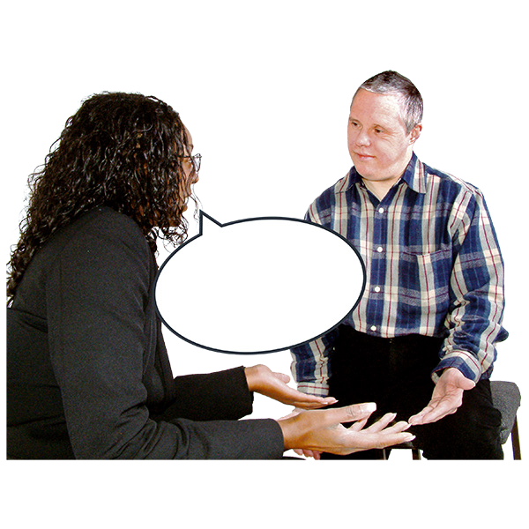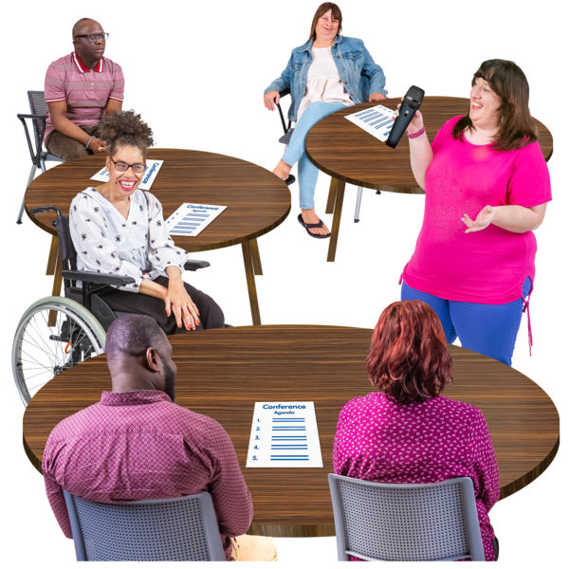

  - Rotherham now has two adult social care teams. Helping support adults with a learning disability.

  - Having a local transitions team will help young people with an Education and Care and Health Care Plan (EHCP). This will support young people moving from children’s support to adult support.

  - We will work closely with people and organisations and make sure peoples voices are at the centre of everything.

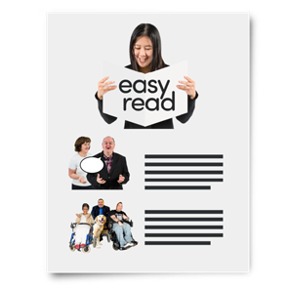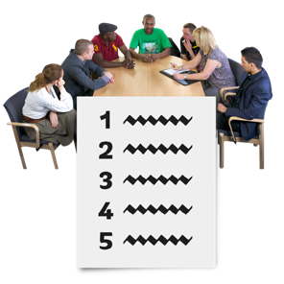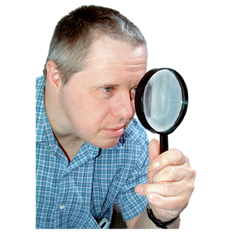2024

Provide accessible information and advice to support information choices.

- Make sure all information, including this plan, is easy to read.

- Make sure the information on our website about adult social care is easy to use; this includes the MY Front Door website.

Strengthen the voice of the person

- Work together in co-production to make sure we are checking that we understand and know how well we are meeting people’s needs.

- Look at new ways of how we communicate with people who have other communication needs.

- Look at how we work with communities in Rotherham

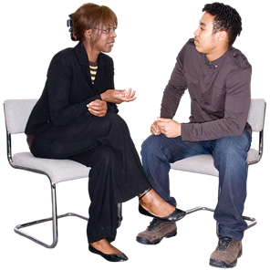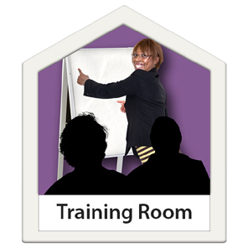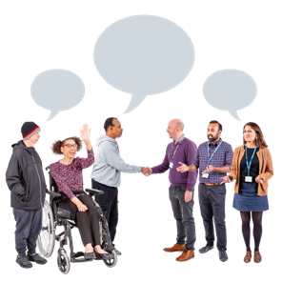2025

Support young people with care and support needs to prepare for adulthood (in line with ASC strategy)
- Create a new plan to support children moving from children to adult services.

- Making sure we are listening to what children and young adults need in their support.

- Having better job opportunities for people with care and support needs

Provide needs lead support

- Create a new training programme to make sure we are meeting people’s needs.

- Making sure we are working closely with adult, children’s, health and education services.

- Creating more Assistive Technology (AT) and digital technology this will be supported by a new Assistive Technology plan.

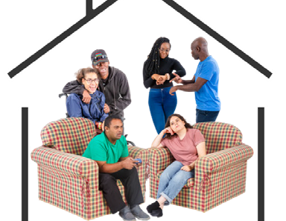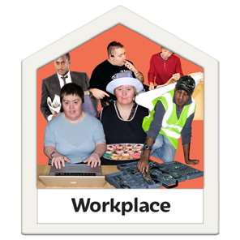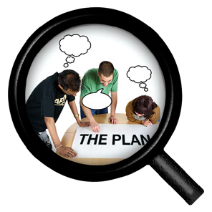2026

Provide more meaningful opportunities

- Getting better housing for people and having better support services.

- Work with people to understand what support services they need and what services they can access.
- Getting more choices and better options in employment.

- Having better options with transport, travel training and community access.

- Create more plans to support people to build on their independence and life skills.

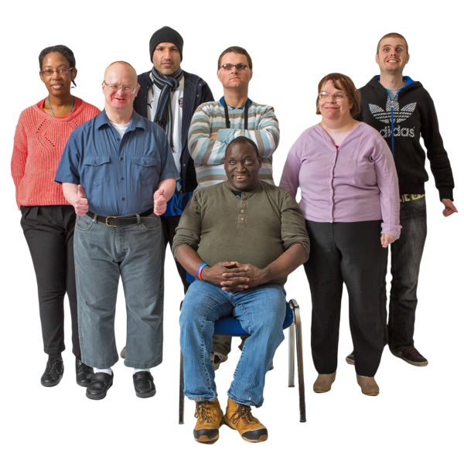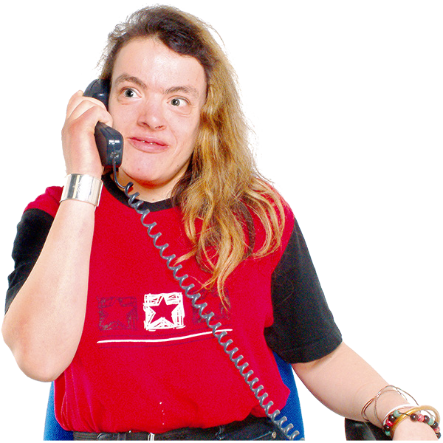

Safeguarding Adults
Safeguarding is about keeping people safe from abuse or neglect. It’s important to teach people about the signs of abuse and how to report it if you or someone else you are supporting is experiencing abuse.

Adult Social Care has a Safeguarding Adult plan to protect vulnerable young people and make sure we make safeguarding personal to the person at risk of harm or abuse.

There are lots of reasons why people are at risk of neglect, harm or abuse.

If you are worried about an adult you can report a concern on our website, call 01709 822330 or 999 in an emergency.

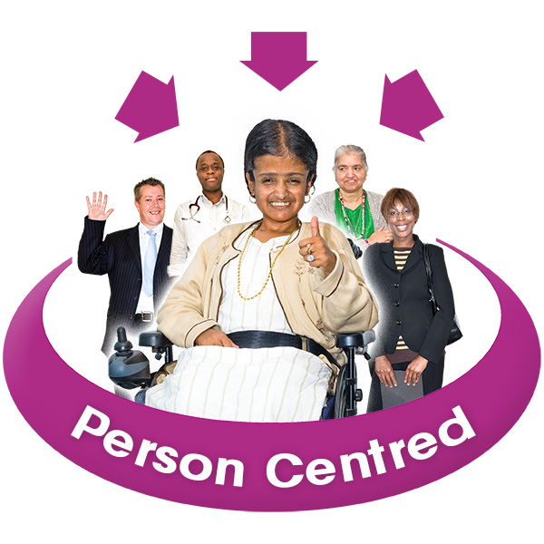

Have Your Say
Adult Social Care understands how important it is to put the person at the centre of everything we do to get the best results for people.

That means involving people in what matters to them and making sure we design our services based on the voices of people who need our support.

Please let us know if you would like to be part of our work on this plan. Let us know how much you want to do; it’s up to you.

Please email:

genuinepartnerships@rotherham. gov.uk.
You could also ask someone to help you to do this on your behalf.



Get in touch
You can find out more information about learning disability support in Rotherham by visiting the My Front Door website.

My Front Door: https://www.rotherham.gov.uk/ homepage/33/my-front-door

Support for children with special educational needs and disabilities (SEND):
https://www.rotherham.gov.uk/ homepage/399/support-for- children-with-special-educational- needs-and-disabilities-send
Adult Social Care https://www.rotherham.gov.uk/ adult-social-care
You can also look at how well RMBC is doing by looking at ‘How did we do’:
https://www.rotherham.gov.uk/ downloads/download/547/adult- social-care-local-accounts

This document was made by Speakup forRMBC. April 2024. Graphics by Photosymbols

