**HOUSING SERVICES FIRE SAFETY POLICY**

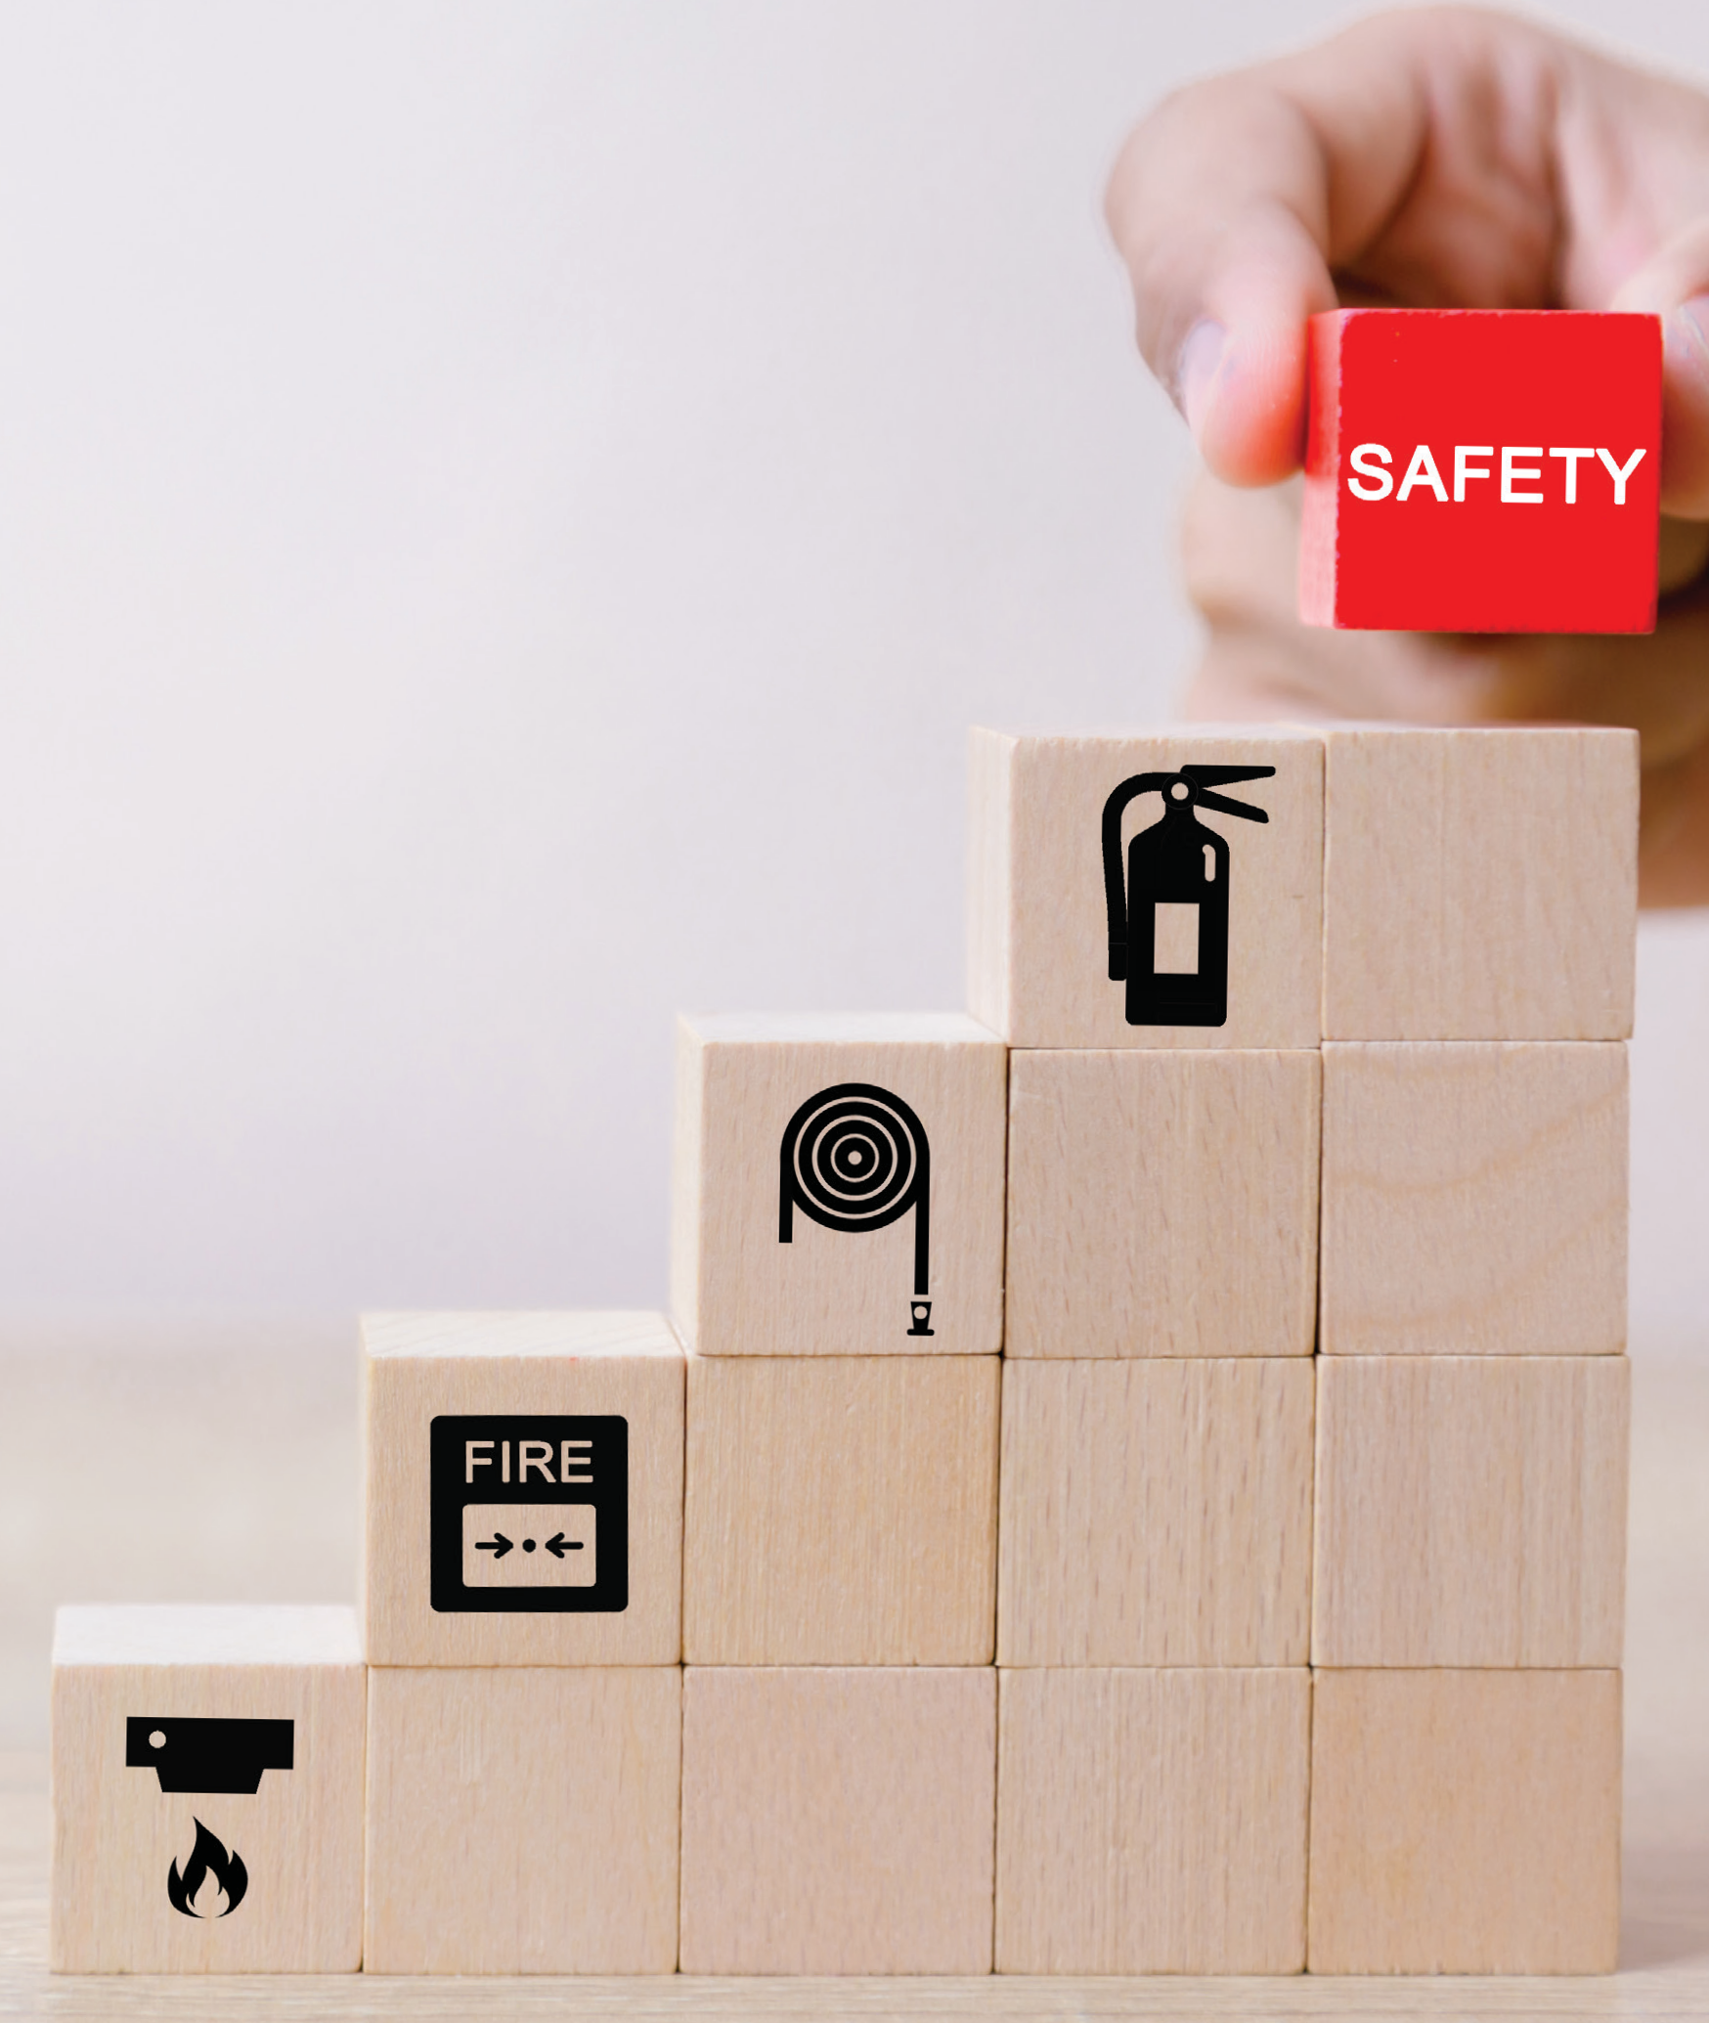

February 2024

[**www.rotherham.gov.uk**](http://www.rotherham.gov.uk/)

## INTRODUCTION 3

**CONTENTS**

## SCOPE OF THE POLICY 4

## ROLES AND RESPONSIBILITIES 6

## OUR APPROACH TO MANAGING FIRE SAFETY 11

## EQUALITY, DIVERSITY AND INCLUSION 18

## AUDIT, COMPLIANCE AND REVIEW 19



## The health and safety of tenants, residents, visitors, staff and contractors is of paramount importance to the Council. The risk of fire presents a significant hazard to the safety of buildings and their occupants and it is imperative that there are robust management systems in place to prevent potential risks.

**INTRODUCTION**

The Policy outlines the Council’s approach to identifying, managing and mitigating the risks associated with fire in council owned housing properties.

The delivery of this policy is an integral part of the Council’s holistic management of Fire Safety across its portfolio of assets as detailed within the Council’s Corporate Health and Safety Policy. This document in particular focuses on the roles and responsibilities of the Council in managing fire safety in line with legislation and the Council’s responsibility as the landlord.

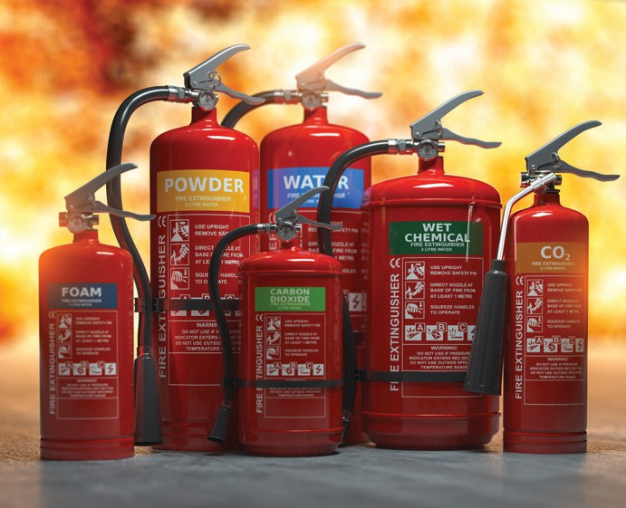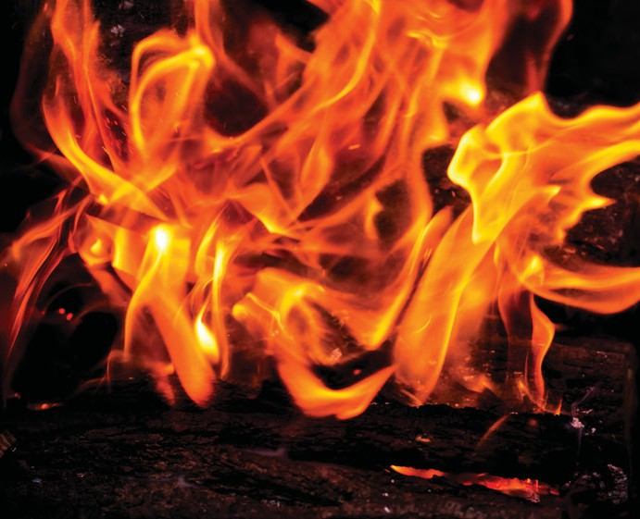



4

## The Policy aims to demonstrate that the Council has relevant measures in place to comply with the Regulatory Reform Order 2005, Fire Safety Act 2021, Building Safety Act 2022 and other relevant codes of practice and good practice guidance.

**SCOPE OF THE POLICY**

It covers assets within the responsibility of the Council’s housing service including residential properties, neighbourhood centres, garages and boiler houses but does not apply to managing fire risks within non-council owned dwellings or other council assets such as schools, care homes, offices or commercial properties.

The policy applies to all employees who are involved with the management and maintenance of housing services including contractors or visitors to buildings for the purpose of carrying out their work duties.

The Policy is underpinned by the following principles:

* Ensuring compliance with legal and statutory requirements including carrying out, updating, and regularly reviewing fire risk assessments of all relevant accommodation in line with the level of risk.
* Ensuring as far as is reasonably possible that the risk of fires igniting and spreading in properties is minimised.
* Ensuring residents and staff know what to do when a fire does occur – in partnership with emergency services
* In the event of any fire or a fire safety incident, ensuring that an investigation is undertaken to review the causes and that control measures are implemented in order to minimise any potential re- occurrence.
* Ensuring all fire safety, electrical and mechanical equipment on the Council’s estate is regularly maintained, and records kept in line with legal requirements. This includes in respect of cyclical servicing and inspections of gas and electrical installations within flats.
* Defining roles and responsibilities within the Council and contractors for fire safety
* Collaborative working with the local fire authority, and the Councils Health & Safety Team, including complying with any orders they issue in writing and seeking advice as to the severity of the risks identified.
* Maintaining accurate record keeping which will be shared with the local fire authority, as appropriate.
* All staff receiving training appropriate to their duties under the Fire Safety Order and those with delegated responsibility for fire safety complete specific training to assure and demonstrate competency to undertake required duties.

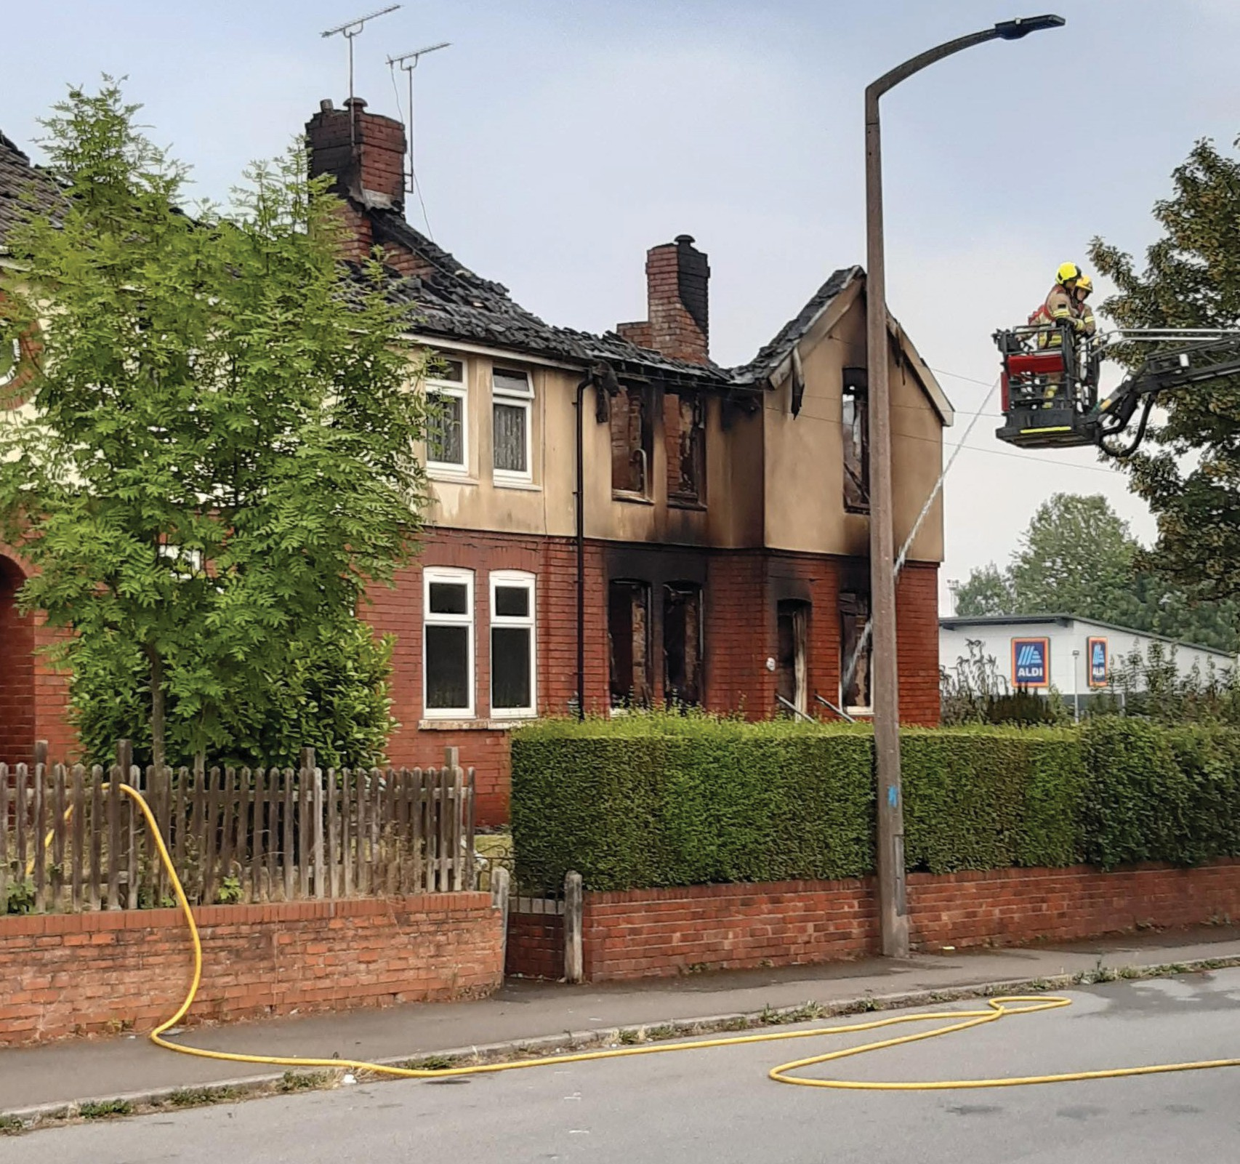

# The Council

**ROLES AND RESPONSIBILITIES**

The Council has overall responsibility for fire safety to ensure that legal requirements are being met and that sufficient numbers of competent staff are employed to meet the Council’s statutory responsibilities.

# Chief Executive (responsible person)

The statutory role of the Responsible Person (Duty Holder) as outlined within the Fire Safety Order is held by the Chief Executive who is accountable for fire safety and ensuring delivery of the Policy objectives. Operational duties are discharged to the Assistant Director

of Housing and Head of Housing Property Services with oversight over progress and performance.

# Assistant Director of Housing Services

Has overall responsibility for fire safety within Council owned residential properties ensuring that resources and staff are in place to deliver the policy.

# Head of Housing Property Services

Has operational responsibility for fire safety within Council owned residential properties ensuring that adequate resources are allocated to managing fire risk, including:

* Appointing a designated deputy – the **Compliance Manager** who is responsible for day-to-day delivery.
* Formulate and keep under review this Policy.
* Provide assurance that the controls in the Policy are working and that the Council’s approach complies with legislation.
* Maintaining an up-to-date property register.
* Ensuring up-to-date fire risk assessments are in place for all relevant assets.
* Ensuring adequate processes and procedures are in place to manage fire risk.
* Ensuring sufficient information, instruction and training is carried out.
* Minimising the risk to members of the public, staff and contractors
* Ensuring that works being undertaken are done so by competent contractors and personnel.
* Ensuring that fire risk has been considered as part of a construction phase health and safety plan and that adequate precautions are in place to prevent fire (e.g. safe methods of working)
* Ensuring annual maintenance and servicing arrangements are in place and provision of timely reactive repairs services if faults are reported.

# Compliance Officer

Is the accountable officer for fire safety in housing services taking a lead role in delivering fire related compliance including;

* Arranging fire risk assessments for all relevant assets.
* Conducting audits to ensure that the provisions within the Fire Safety Policy are being enforced to the standard required.
* Ensuring sufficient information, instruction and training is carried out.
* Ensuring that fire precautions are maintained effectively.
* Organising the investigation of fires and introducing controls to reduce the risk of such incidents recurring.
* Undertaking quality assurance checks of works to ensure standards are being achieved.

# Fire Safety Surveyor

The surveyor is responsible for undertaking fire risk assessments, surveys within communal areas and to fire doors including:

* Providing expert specialist fire safety support and advice regarding fire risk assessment, fire prevention and general fire safety management across the Housing Service
* Technical specialist for fire prevention works, including compartmentation and fire doors/remediations to ensure we maintain compliance on fire safety in line with legislation.
* Producing bespoke Fire Safety Management Strategies for all relevant buildings and blocks with clear evacuation plans and improvement plans.
* Developing and maintaining a fire risk register on all buildings and blocks requiring fire risk assessments, recording and reporting findings in accordance with fire safety legislation
* Preparing and undertaking a programme of fire risk assessments in accordance with relevant legislation ensuring all fire related risks are identified, remedied and rectified within reasonable timescales.
* Undertaking site audits pre-works, in works and post works inspections.
* Undertaking desk top reviews of Fire Risk assessments at planned intervals as per policy requirements.
* Undertaking quality assurance checks of fire safety works and new build developments to ensure that works completed by contractors meet the required standards.

# Managers

Managers within the housing service are responsible for the detailed arrangements necessary to manage fire risk within their areas of control and to ensure that staff under their control have adequate training and are aware of the Fire Safety Policy.

# Employees

All employees have a responsibility to:-

* Take reasonable care for their own health and Safety and that of others.
* Report immediately any concerns they may have relating to Fire Safety Policy and Procedures.
* Report any hazards they see immediately relating to fire safety.
* Co-operate with its managers to enable compliance with this policy and the legal duties the council holds.

# Contractors

Contractors are required to:

* Follow the Fire Safety Policy requirements
* Ensure that their staff and sub-contractors have received appropriate information, instruction, and training
* Employ competent, suitably qualified staff and sub-contractors ensuring they are able to demonstrate their ability to meet all statutory requirements.
* Ensure that all works relating to fire safety are adequately monitored, controlled and post inspected.
* Complete works in a timely manner prioritised upon the level of risk.
* Maintain records with details of the fire safety works.

# Residents and visitors

It is the responsibility of all tenants and residents to take responsibility for their own household’s safety and to ensure that they do not do anything that might cause a fire within their home or shared areas. There are terms and conditions of the tenancy

agreement in place to prevent potential fire risks and ensure that fire evacuation routes are not obstructed which state:

* You must co-operate with the Council and your neighbours to keep any communal areas clean and free from obstructions. You must not place rugs, carpets, plants, furniture or rubbish in communal areas.
* You must not park mobility scooters in communal areas.
* You, other residents of your home, or your visitors must use any communal areas and lifts in a reasonable manner, not causing any nuisance or annoyance to other people.
* You, other residents of your home, or your visitors must not use any communal areas to store items or deposit rubbish.
* You, other residents of your home or your visitors must not smoke in any enclosed communal areas.
* You must not keep or use any flammable or other dangerous materials in your home or in any communal areas. This includes petrol, paraffin and bottled gas.
* Leaseholders are also required to comply with the terms and conditions set by the landlord as stated in the lease agreement.

**The Council has a range of measures in place to prevent the risk of fire and to ensure that any potential fire hazards are dealt with in a timely manner.**



**OUR APPROACH TO MANAGING FIRE SAFETY**

# Fire risk assessments

Fire risk assessments are undertaken within blocks of flats which have communal areas on a regular basis to identify potential risks and put measures in place to mitigate/remove the risks. They are not undertaken within flats with their own separate entrance, houses or bungalows.

The fire risk assessments take into consideration the effect a fire may have on anyone in or around the premises plus neighbouring property and will be kept under regular review. The building fire risk assessment concentrates on the following areas:

* Elimination or reduction of risks (ignition sources)
* Suitable means of detecting & raising the alarm in the event of fire
* Adequate emergency escape routes and exits.
* Adequate fire compartmentation (fire & smoke spread and the protection of escape routes)
* The appropriate type and sufficient number of fire extinguishers
* Correct type and sufficient number of fire signs and notices
* Provisions for the correct maintenance of installed fire equipment
* Suitable provisions for the protection of Fire Brigade personnel
* To ensure that occupants receive the appropriate instructions

The fire risk assessments will assess for fire hazards, evaluate the risk of the hazards, and advise on action that should be taken to remove, reduce or manage the risk. Each hazard identified will be categorised as follows:

* **Low** - Work or action to be carried out within a reasonable time frame as soon as soon as staff resources allow.
* **Medium** - Maintenance action or new works required to be initiated as soon as reasonably practicable depending upon budget and staff resources within 3-6 months.
* **High** - Items that should be resolved immediately or work initiated within 7-14 days.

The assessor will task actions to relevant officers, track and monitor progress to ensure completion within the required timescale.

The frequency and type of inspection depends upon the level of risk. Smaller blocks under 11 metres are considered as lower risk which will have an annual desktop review and a fire risk assessment in person in the block at least once every four years.

Higher risk blocks which are above 11 metres or have higher occupancy levels will have a fire risk assessment in person, in the block at least once every twelve months.

In addition, we will undertake a physical inspection fire risk assessment **no matter what the risk category** is:

* following a fire, near miss or threat of arson;
* whenever there has been any structural or material changes to the building or its use.

Employees undertaking fire risk assessments will demonstrate they are “competent” to do so, being able to evidence they have the appropriate skills, knowledge, and experience.

# New development and acquiring new properties

Where a new asset is being developed by or on behalf of the Council the Project Lead will ensure that the requirements of the Fire Safety Order and Building Safety Act 2022 have been addressed within the design, and that the building maintenance, health and safety file, and regulation 38 information is provided at handover of the building.

Where the purchased property is an existing new/or older asset the acquiring officer shall ensure that the requirements of the Fire Safety Order have been addressed as part of the acquisition process and that a fire risk assessment is undertaken.

# Fire evacuation

All tenants and leaseholders will be notified on an annual basis of the fire safety guidance for their block, how to report a fire, a reminder

of what the evacuation strategy is for that building, and any other instruction that tells residents what they must do once a fire has occurred, based on the building’s evacuation strategy.

Each residential building with a communal area will have a clearly defined evacuation policy determined by the fire risk assessment which will be communicated to tenants on new lettings as well as issuing a general reminder on an annual basis. Posters will also be displayed in communal areas (such as the building’s lobby or any visible part of the building).

In consultation with South Yorkshire Fire & Rescue service, the Council operates a ‘stay put’ policy when the fire is in another property or within the communal area. Residents who are not directly affected by the fire are encouraged to remain in their flats and telephone 999.

This is because the building is designed to contain the fire in the flat where it starts and means it will usually be safer for residents to stay in their own flats if the fire is elsewhere in the building. However, if the fire is in their own flat they should evacuate immediately via the safest route making other residents know to leave with them and telephoning the 999 emergency service.

# Cyclical maintenance



14

Fire prevention measures are in place to prevent the spread of fire. Some apartment blocks and neighbourhood centres may have additional measures in place where the risk is higher.

The Council is required to undertake regular checks and maintain the equipment to ensure they are functioning correctly. The checks undertaken and frequency are detailed below:

|  |  |
| --- | --- |
| **Fire Prevention Measure** | **Checks undertaken and frequency** |
| Fire Doors (in all council and leaseholder flats with a communal area) | If the top storey of the building is above 11 metres in height (typically, a building of more than four storeys) or has high occupancy levels the Council will:   * Inspect all flat entrance fire doors at least once every 12 months; and * Inspect fire doors in communal areas at least once every 3 months.   For blocks under 11 metres the Council will: Inspect all fire doors at least once every 12 months |
| Sprinklers and smoke detection systems (in communal areas in high-risk blocks) | Checked and serviced every six months. |
| Emergency escape lighting (in communal areas) | Inspected weekly and recorded in the fire book. |
| Fire alarm systems (in communal areas in high-risk blocks) | Tested weekly and recorded in the fire book. |
| Firefighting equipment (Fire extinguishers, fire blankets etc in neighbourhood centres) | Inspected on an annual basis by a specialist fire safety service. |
| Lifts (in high rise blocks and complexes only) | Inspected and serviced on annual basis. |

# Managed use of communal areas

To minimise the potential fire safety risk, the Council operates a ‘managed use’ approach where residents are permitted to personalise communal areas with approved items which do not

present a fire risk or cause an obstruction to the means of escape in the event of a fire or emergency.

These items must be made from non-combustible material and approval should first be obtained from the Area Housing Officer.

We may allow the following items:

* Pictures/paintings on walls (subject to asbestos checks prior to drilling)
* Ornaments/plants/shelves in permitted areas which do not obstruct the hallways.
* Curtains which meet BS5687: Part 2
* Mobility scooters in designated storage areas only

In consultation with South Yorkshire Fire and Rescue, we may amend or exercise our discretion in relation to the above.

However, the following is not permitted within communal areas as there are identified fire risk and other health and safety implications arising.

Households will be provided where necessary with appropriate advice and the reasons for refusal or requests to remove items:

* Rugs, door mats, carpets (e.g. potential tripping hazard and non- fire-retardant materials)
* Christmas decorations (e.g., potential fire risk)
* Bicycles, prams, and scooters in communal hallways (e.g., obstruction)
* Storing flammable items including gas, petrol, barbeques, and any electrical items (e.g., fire risk and obstruction)
* Disposing or storing refuse (e.g., fire risk, health risk and obstruction)
* Charging electrical items from the landlord electric supply (e.g., fire risk and abuse of ‘landlord only’ facilities/installations)
* Leaving footwear outside the door (e.g., potential tripping hazard and obstruction)

# Removing potential risks

The Council takes steps to remove the potential hazards which create a risk of starting a fire. This includes the following:

* Housing officers work with the estate caretaking teams and cleaners, on an ‘eyes and ears’ basis, to identify and arrange immediate removal of any fire hazards identified within communal areas and around the general estate environment. If an item is placed in a communal area, officers will attempt to identify the owner to notify them to remove. Dependent upon

the level of risk, officers will arrange removal/disposal if the owner cannot be located/they do not remove within an acceptable timescale.

* Providing guidance to tenants who are terminating their tenancy which prompts tenants to plan for removal of unwanted items well in advance of leaving the property and not to place unwanted items outside the dwelling until the agreed day of collection.
* Removal of individual household waste bins in communal blocks of flats and replacement with communal bins which are locked onto concrete bin pads, consequently, reducing the fire risk to blocks due to bins not being stored against buildings.

# Neighbourhood centres

Most of the furniture within communal lounge areas is owned by the Council.

Tenants may place items within the communal lounge subject to prior approval by the Area Housing Officer, subject to it meeting the following requirements:

* All furnishing in communal areas and rooms should satisfy the flammability requirements for classification as Type B or C when tested in accordance with BS 5867: Part 2
* All furniture should comply with the medium hazard resistance to ignition classification of BS 7176: 1995
* Any soft furnishing provided by RMBC (carpet, mats, curtains, chairs etc.) will be manufactured to the above standard and have fire labels indicating as such.

# Smoking

Smoking is not permitted in communal areas, doorways, and refuse areas. Signage is displayed informing residents of this.

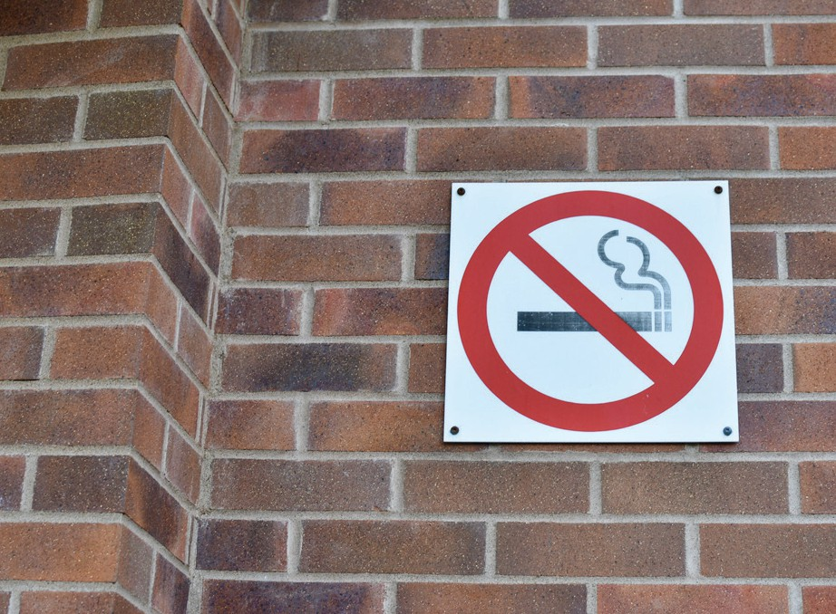

## We will ensure fire safety advice is provided to all residents and is accessible including providing the information in braille, large print, audio or alternative languages.

**EQUALITY, DIVERSITY AND INCLUSION**

We will respond appropriately to meet the needs of residents who inform us they have a disability such as a hearing impairment, visual impairment and mobility issue and will provide appropriate equipment or support to ensure that they are alerted in the event of a fire.

Where we identify an individual with a vulnerability who may be at a high risk of causing a fire within their home a referral will be made to the Fire Service for an assessment for fire protection items such as fire- retardant night wear, blankets and personal misting units.

We recognise that residents with some protected characteristics are over-represented in certain blocks that are higher risk in terms of fire safety, e.g. older people or those with disability/long term health conditions in former sheltered blocks. In these blocks, we will ensure that the communal areas are appropriately equipped with

fire protection equipment such as emergency lighting, fire doors, and safety signs, as advised by a fire risk assessment.

A Personal Emergency Evacuation Plan (PEEP) is a plan for a person who may need assistance, for instance, a person with impaired mobility, to evacuate a building or reach a place of safety in the event of an emergency.Information relating to residents who have a PEEP

is contained within the fire box and will be made available to the fire service in the event of an emergency who will ensure assistance is provided to the resident if there is a fire within the block.

The Compliance Officer will regularly review processes, performance and undertake quality assurance checks to monitor delivery against the policy with oversight by the Compliance Manager and Head of Housing Property Services this includes monitoring the following:

**AUDIT, COMPLIANCE AND REVIEW**

* Number of Fire Risk Assessments in date
* Compliance against fire risk assessment actions
* Number of fire doors checked at least every 12 months
* Number of fire doors checked at least every 3 months within high rise blocks.
* Number of communal area checks undertaken at least once every 3 months
* Information provided to tenants at tenancy sign up
* Information provided to tenants on an annual basis
* Number of complaint fire doors
* Cyclical servicing undertaken within agreed timescales Performance and progress against key performance indicators will be

regularly reported to the Senior Management Team, Senior Leadership Team and Cabinet Member. Information will also be available to tenants and reported to the Housing Involvement Panel.