|  |
| --- |
| **Recruitment Advertising** |
|  |
| Payment via Civica Pay |



Contents

1 Introduction 3

2 Paying via Civica Pay 4

2.1 Making your Purchase 4

2.2 Paying by card 6

2.3 Paying by PayPal 7

2.4 Payment Confirmation 8

3 Notifying Rotherham Recruitment of the Advert Details 9

4 Need a refund? 9

5 Final Note 10

6 Change History 10

Note

**Note:** Don’t forget you can jump to the section you need by clicking any of the Table of Content items listed above.

# Introduction

At the Rotherham HR Service Centre (HRSC) our Rotherham council jobsite attracts a high number of job seekers each day and with the ability to share adverts via social media and your own website it’s the perfect place for you to attract your new talent.

Our knowledgeable and experienced staff are on hand to assist you in getting your advert live in the most effective and efficient way.

The fee payable for this service must be paid in advance using a credit/debit card or PayPal via our Recruitment Advertising Store on Rotherham MBC’s [Civica epay site](https://www.civicaepay.co.uk/RotherhamEstore/estore/default/Catalog/Index?Area=&workflow=register).

The costs for the financial year 2022/23 can be found in the below table.

|  |  |
| --- | --- |
| Rotherham Council Jobsite | |
| Client Type | Cost inclusive of VAT* |
| Rotherham Maintained School | £114.50 |
| Academies, Trusts, Other LEA Schools and Parish Councils | £137.40 |
| External Organisation | £343.50 |

We can handle your external media for an additional cost of £50.00 plus VAT*

# Paying via Civica Pay

Before requesting an advert all you will need to do is visit [Rotherham Council’s Civica Pay Store](https://www.civicaepay.co.uk/RotherhamEstore/estore/default/Catalog/Index?Area=&workflow=Register)

From the ‘**Product’s & Service’s menu’** scroll down and select ‘**Recruitment Advertising’**

The select ‘**Apply’**

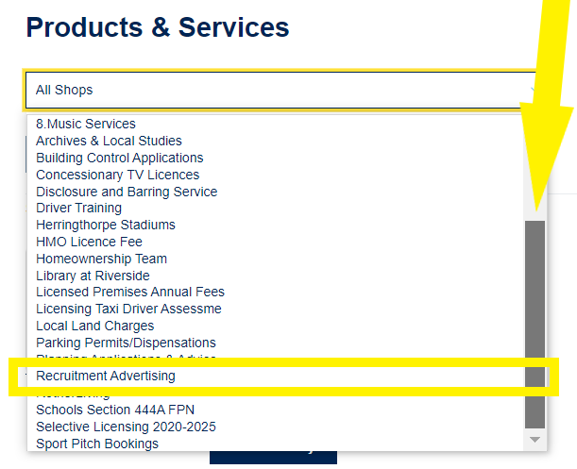

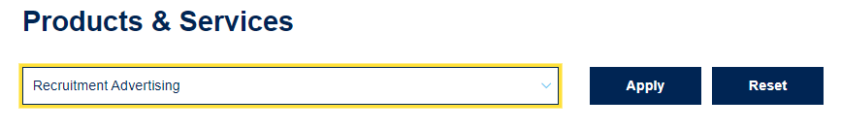

## Making your Purchase

From the items in the store choose the one that reflects your organisation and **‘Select to Pay’**

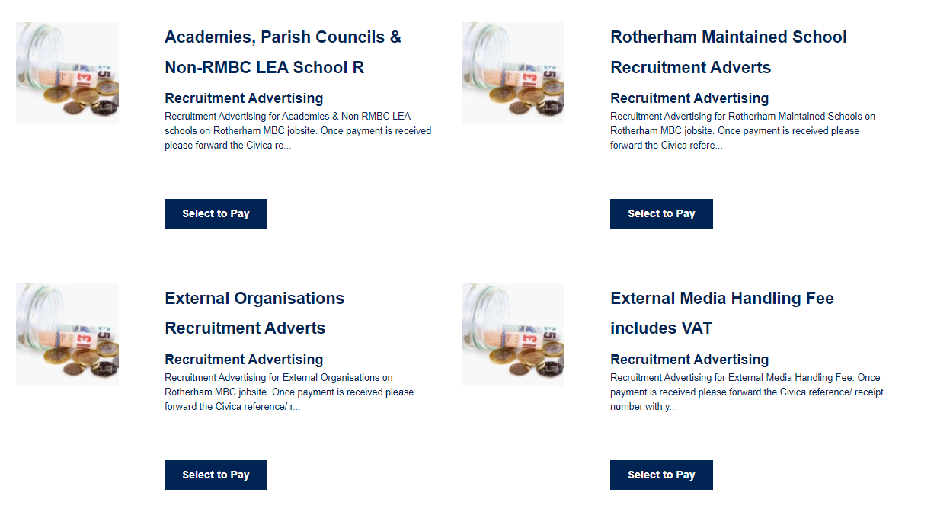

Enter the name of the position to be advertised along with your company/school’s name and your email address then ‘**Add to Basket’**

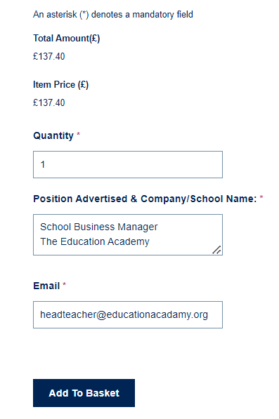

Note

**Note:** You can repeat the process if you have more than one position to advertise.

Once you have added the required items from the top of the page select the **‘shopping basket’**



Review the items within your shopping backet and select ‘**Checkout now’**

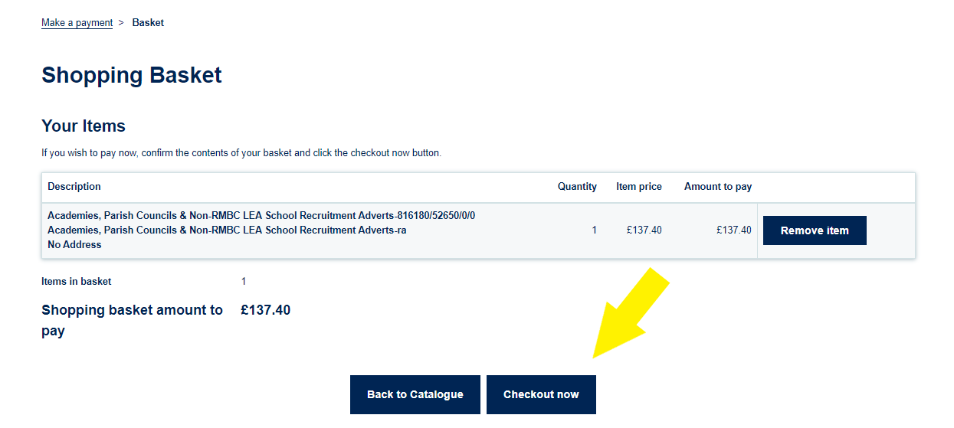

Once at the checkout you will have two payment options **‘Pay with new card’** or **‘PayPal’**

If you have registered for an account, you will also have the option to pay with stored cards

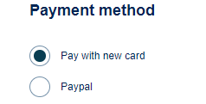

## Paying by card

To pay by card complete the card detail fields and select **‘Continue to checkout summary’**

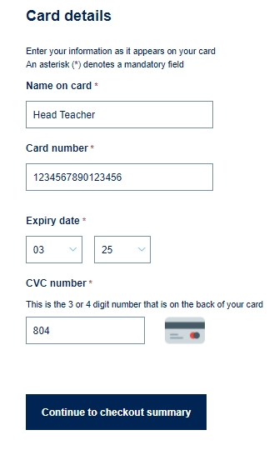

## Paying by PayPal

Paying by PayPal allows you the option to pay via either a credit/debit card or bank account linked to the PayPal account.

If you don’t already have an account, you will need to register with PayPal prior to choosing this option.

To pay by PayPal first select ‘**PayPal’** and select **‘Continue to checkout summary’**

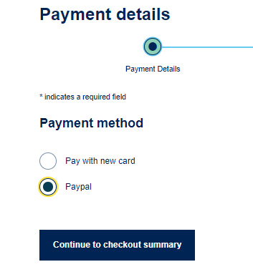

You will then be taken to the payment summary screen to review your purchase if everything is correct select ‘**Confirm Payment’** and you will be redirected to the PayPal site for you to enter your PayPal security information.

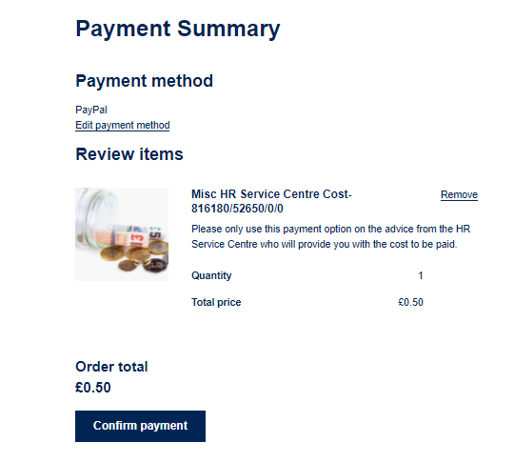

Once payment has been made you will be redirected back to the Civica Pay Site.

## Payment Confirmation

Once payment has been made by your chosen method this will be confirmed on screen along with the ‘**Receipt Number’** that you will need to send along with your advert request.

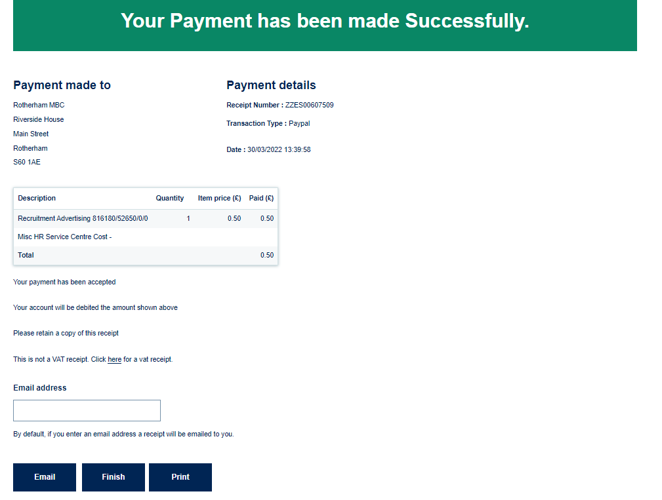

The screen will automatically show’s a standard receipt if your transaction is subject to VAT to you can switch the view to a VAT receipt by selecting ‘**Click here for a vat receipt’**



To email a copy of the receipt add your email address and select ‘**Email’** Alternatively, should you require a hard copy select ‘**Print’**

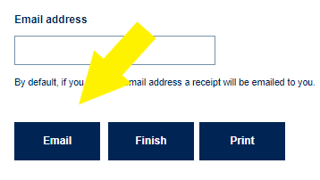

Once complete select finish to return to the main screen or close your browser.

# Notifying Rotherham Recruitment of the Advert Details

Once payment has been made you can complete the form below and sent to the team along with any attachments to be included with the advert such as job descriptions, person specification and application forms.

[](https://www.rotherham.gov.uk/hrdocs/downloads/file/200/rotherham-job-site-advert-request-form)

Once complete return the advert details form along with attachments to [hrpjobadverts@rotherham.gov.uk](mailto:hrpjobadverts@rotherham.gov.uk)

Once your advert details have been reviewed you will receive an email from the team along with a link for you to view live advert.

# Need a refund?

If for any reason you have made an incorrect payment, please complete the table below and copy into an email to [hrpInvoices@rotherham.gov.uk](mailto:hrpInvoices@rotherham.gov.uk)

|  |  |
| --- | --- |
| Position Name |  |
| **Civica Payment Reference** |  |
| **Date Paid** |  |
| **Reason for refund** |  |
| **Contact Email address** |  |

A member of the team will review your request, process any refunds due and email you a copy of your refund receipt.

# Final Note

The HR Service Centre delivers a HR Transactional and Payroll Service via an award-winning secure self-service platform directly to local authorities, ALMO’s, LEA school’s along with multi academy trusts and stand-alone academies.

Our knowledgeable, experienced, and qualified staff can assist your organisation in dealing with all aspects of the Employee Life Cycle, Attraction, Recruitment, Onboarding, Retention, and Separation. Safeguarding compliance with PAYE and Pension regulations.

We are always available should you wish to discuss our Disclosure and Barring or HR Transactional Service email [hraccountmanagement@rotherham.gov.uk](mailto:hraccountmanagement@rotherham.gov.uk)

|  |
| --- |
| Help and Support |
| If you need help with payments, please contact [hrpinvoices@rotherham.gov.uk](mailto:hrpinvoices@rotherham.gov.uk)  For assistance with job adverts please email [hrpjobadverts@rotherham.gov.uk](mailto:hrpjobadverts@rotherham.gov.uk) |

# Change History

|  |  |  |  |
| --- | --- | --- | --- |
| Date Revised | Date Approved | Summary of Changes | Author |
| 31/03/2022 |  | Document Creation | Rachel Elder |